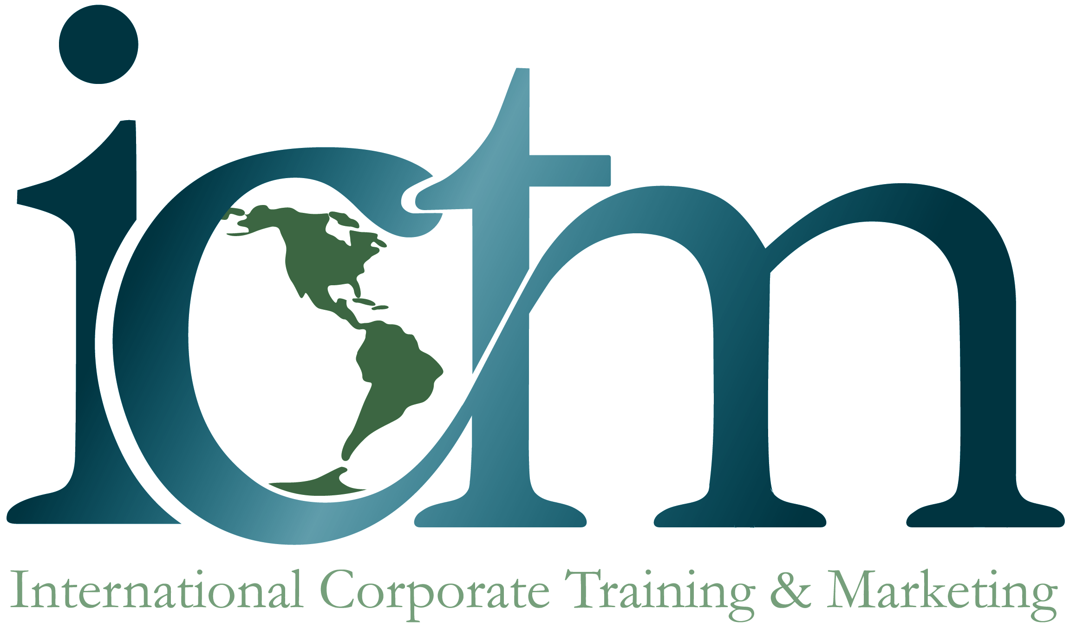

International Corporate Training & Marketing, LLC is looking for:

Chinese Interpreters
Vietnamese Interpreters

ICTM is looking for Chinese and Vietnamese interpreters in the Camp Hill/Mechanicsburg, PA area. We need interpreters for translation and interpretation services in therapy and educational settings.

Job Description:
Interpreter will be assigned jobs that will involve meeting with client and therapist. Most appointments are 1 - 2 hours.

Please call to set up an appointment for your interview. You may also send your resume to:

Elisa Tlanda, Account Executive
ICTM
Technical Innovation Center
20140 Scholar Drive
Hagerstown, MD 21742

