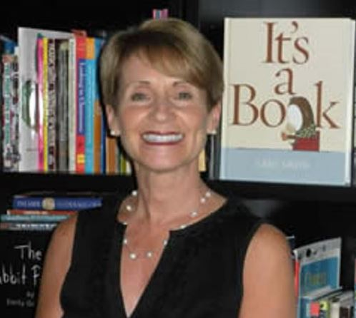

Anita Voelker started teaching at age 6. With a desk, chalkboard, and bookshelf made by her uncle, she opened the doors to her classroom. There was only one rule: she would always be the teacher!

Eventually Anita received a B.S. in Elementary Education from Frostburg State University, an M.S. and a reading specialist certification from The Johns Hopkins University, and a Ph.D. from the University of Maryland. Her dissertation focused on school libraries.

At Messiah University, Anita taught in the Education Department. Literacy and children’s literature were the heart of her classes. She retired in December of 2014 and was awarded Emerita Professor status.

Anita’s favorite quote from Eliot Wigginton explains how she views teaching: “We teach, and at the same time allow ourselves to be taught by those we teach. We talk, and at the same time, listen. We experience the world anew through another’s eyes. And therein lies the secret of renewal . . . we refuel each other.”