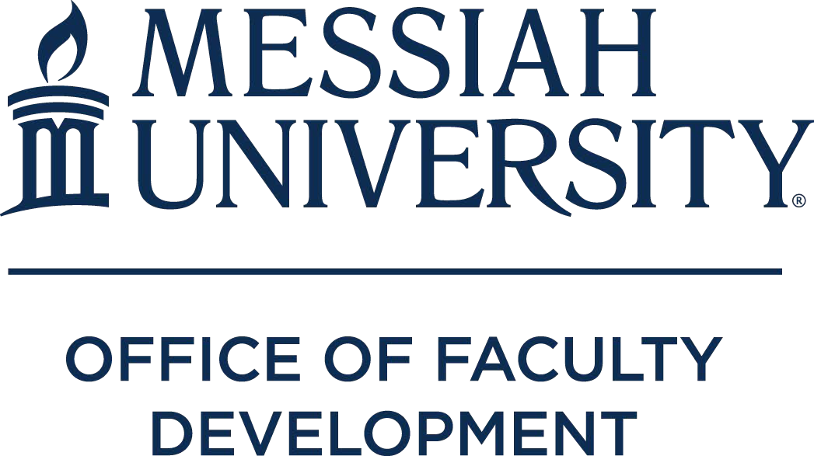

INTERNAL GRANTS

2021-2022 Academic Year

Grants funded by Office of Faculty Development

Course Development
Melinda Burchard (Associate Professor of Special Education) – To revise EDSP 303, Disability in Society, to more fully align with Quest objectives and the Beyond Suffering curriculum of Joni and FriendsInternational, a ministry promoting community belongingness of individuals with disabilities and their families.
Leah Clarke (Associate Professor of Counseling) – To learn more about ungrading and its relation to creating a course environment that is centered on student learning and incorporate ungrading/ community of learning philosophy into COUN 550; to assess student reactions to these changes via the IDEA form and informal assessment tools and share outcome of process with other faculty.
Jan Dormer (Associate Professor of TESOL) – To redesign a foundational course, EDME 525:
Curriculum and Learning, to include assessment and better align with program objectives.
Jennifer Dose (Professor of Management) – To design, revise, develop HRM 356: Compensation and Benefits, and specifically study of group health plans, retirement plans, job evaluations, and market comparisons in determining base pay.
John Harms (Professor of Biological Sciences) – To prepare for the newly-assigned delivery of BIOL/CHEM 495 Natural Sciences Capstone, authoring of a new laboratory manual teaching comparative animal physiology for the new BIOL 170 Cell and Animal Physiology course, and redesign of lecture scope for the newly- approved fusion course, BIOL 416 Cancer and Cell Biology.
Paul Johns (Assistant Professor of Human Development and Family Science) – To support the revision of IDST 300: Relationships and the Brain to be a semester-based course starting fall 2021.
Janet Matanguihan (Assistant Professor of Biological Sciences) – To revise the course content of BIOL 162: Plant Biology and change its title to BIOL 172: Systematics and Plant Biology, as part of the Department’s response to the mandates of the Educational Prioritization Task Force (EPTF).
Lawrence Mylin (Professor of Biology) – To devote time to developing one new STW course, and significantly revising and reorganizing components of four courses (including lab components of two) that will be offered for the first time or as significantly revised versions in the 2021‐2022 academic year. Jason Renn (Assistant Professor of Politics) – To incorporate revisions to POLI 366: Conflict Management and Peace Science, involving updates to readings, design of simulation exercises, and promoting undergraduate social science research in the area of peace studies.
Rick Shaeffer (Professor of Chemistry) – To develop and revise materials and methods – including revising and testing new laboratory projects, to teach the Inorganic Chemistry (lecture and laboratory) course.
Michael Shin (Professor of Biology) – To purchase resources to support the development of a new course, BIOL 380: Genomics and Disease, a 4-credit lab course that will be first offered in Spring 2022. Philip Tan (Assistant Professor of Engineering) – To develop the new ENGR 332: BME Lab Techniques course, launched this fall.

Teaching Enhancement
Michelle Lockwood (Senior Lecturer Engineering) – To enhance teaching with increased technology engagement for students, by investing in learning SolidWorks and SolidWorks Flow Simulation software. Jennifer Thomson (Associate Professor of Biopsychology) – To seek certification in online teaching from Quality Matters through the completion of their seven-course series.
Matt Lewis (Associate Professor of Health and Human Performance) and Brenda White (Senior Lecturer of Athletic Training) – To promote development of standardized patient protocols in support of high-fidelity simulation within the accelerated Master of Science in Athletic Training (MSAT) curriculum and collaborate with peer health professionals within the program.
Kristin Mouttet (Assistant Professor of Counseling) – To obtain specific training about Emotionally Focused Therapy that would enhance knowledge of approach and improve the teaching and curriculum for students in the University Graduate Counseling Program.

Scholarship
Erik Forst (Associate Professor of Music) – To support a video/audio recording project for solo percussion in collaboration with University students and Philadelphia-based Four/Ten Media Productions for promotion to potential students and the larger percussion and music community.
Brenton Good (Associate Professor of Art) – To fund, frame, and ship new works of art for dissemination via a Fall 2021 art exhibition.
Niklas Hellgren (Associate Professor of Physics) – To pay for costs associated with synthesis and characterization of TiBx, AlBx, and TiyAl1-yBx thin films, including trips to Materials Research Institute at Penn State University to utilize their instrumentation.
Abaz Kryemadhi (Associate Professor of Physics) – To fund completion and dissemination of cosmological stream rate in dark matter detectors.
Erik Lindquist (Professor of Biology) – To support research expeditions and manuscript writing related to the determination of the conservation status of several highly endangered Harlequin Frogs (Atelopus) in Panama and Costa Rica.
Obed Mfum-Mensah (Professor of Education) – To support field data collection for book project, Organized Infantilism, Trusteeship, and Education Reforms in Sub-Saharan Africa.
Bernardo Michael (Professor of History) – To hire a research assistant for 45 days to identify documents in Nepali Foreign Ministry materials (19th and 20th centuries) and various libraries in Kathmandu.
David Pettegrew (Professor of History and Archaeology) – To support the costs of professional copy- editing and indexing of a publication of an archaeological survey in Corinth, Greece.
Eric Seibert (Professor of Old Testament) – To support work related to a book provisionally titled, Do No Harm: How to Use Violent Biblical Texts Creatively and Responsibly in Church.
William Stowman (Professor of Music) – To support a recording project for solo trumpet and other instruments featuring myself in collaboration with other Messiah University Musicians (Faculty, Students, and Alumni) in order to promote our department to prospective students, and the greater community.
Cynthia Wells (Associate Professor of Higher Ed) – To conduct research and compose two chapters associated with a book-in-progress, Flourishing at the Core.

Service Learning
Mindy Smith (Assistant Professor of Exercise Science) – To provide budgetary funds for student groups to use within Health Promotion Management (APHS 210) to authentically and effectively support health outcomes with community partner, Brethren Housing Association.

Grants Funded by the Ernest L. Boyer Center

Scholarship of Teaching & Learning (SoTL)
Joanna Behm (Senior Lecturer of Occupational Therapy) – To explore the efficacy of using flipped learning as a pedagogy to improve students’ application of the occupational therapy process.
Sarah Brant-Rajahn (Assistant Professor of Counseling) – To examine the impact of experiential and non-experimental course assignments in the career counseling course on student’s self-efficacy to perform career counseling with culturally diverse clients.
Devin Manzullo-Thomas (Senior Lecturer of the Humanities) – To examine the impact of Conversation Papers, an assignment in First-Year Seminar and Created & Called for Community courses, on first-year students’ ability to read and write effectively at the university level.

Grants Funded by Endowment

Smith Scholar Interns (professor/student)
Carol Buckley / Maria Cushing Daniels
John Fea / Dylan Goss
Raeann Hamon / Anna Weikel
William Stowman / Caeley Hovanec

