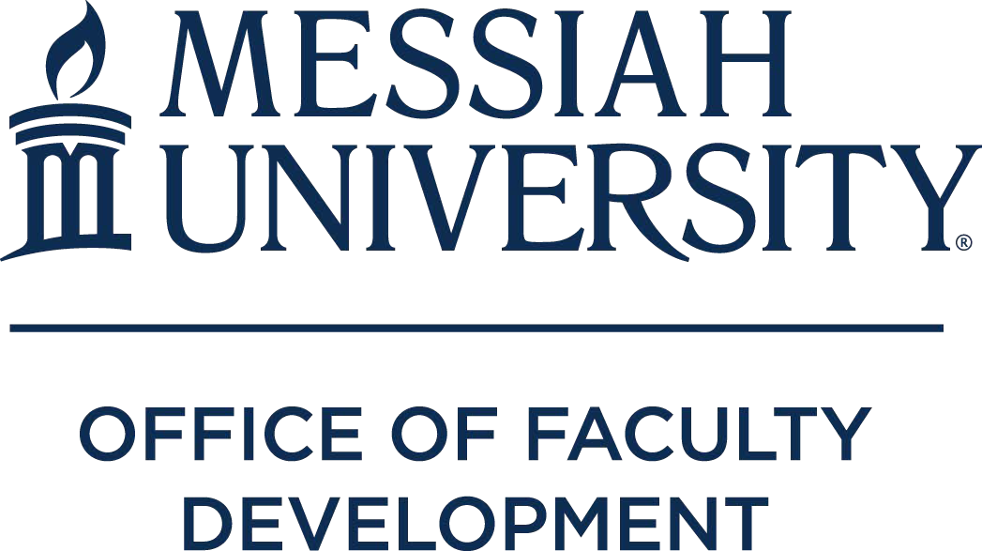

Course Development

INTERNAL GRANTS

2020-2021 Academic Year

Grants funded by Office of Faculty Development

Sheri Boyce (Professor of Biology) - to support the development of BIOL 317 Bioethics.
Emily Farrar (Assistant Professor of Engineering) - to develop a new course in fluid dynamics for the recently approved BS in Mechanical Engineering (BSME) and BS in Biomedical engineering (BSBME) degrees.
Matthew Farrar (Assistant Professor of Physics) - additional funding to support the procurement of materials essential to optics projects for PHYS 317 Optics.
Malcolm Gold (Professor of Sociology) - to develop a First Year Seminar course entitled Bob Dylan, Religion, and Society.
Janet Matanguihan (Assistant Professor of Biology) -to support the deepening of my content knowledge (Teaching Rubric) in human genetics as applied to the health profession by dedicating a specific time for course preparation for BIO 189 Genetics for the Health Profession and to support the revision of the course with the addition of three new lecture topics.
Jason Renn (Assistant Professor of Politics) – to develop Faith and Learning outcomes by expanding course content connecting international peacekeeping and conflict management to religious peace traditions.
Phillip Tan (Assistant Professor of Engineering) - to install and test a Flex 3 OptiTrack motion capture system for the new ENGR 331 Biomechanics course we are launching this fall.
Ye, Stella (Associate Professor of Mandarin Chinese) - support to significantly redesign CHIN301 and CHIN302.

Teaching Enhancement
Michelle Lockwood (Senior Lecturer Engineering) - To enhance my teaching with increased technology engagement for students, I would like to invest in learning MATLAB, which is a language-based computer software that allows for higher level of computation and visualization.

Scholarship
Anthony Eseke (Assistant Professor of Communications and Public Relations) – to fund a sample of case studies of crisis management in faith-based organizations. Three faith-based organizations who have experienced three crisis types will be selected. The crisis types include (a) Paracrisis, (b) Operational crisis, and (c) Organizational misdeeds.
Milton Gaither (Professor of Education) - to contribute a chapter to a book in the prestigious Oxford Handbook series on the history and current state of fundamentalist education, including fundamentalism’s evolving relationship with the public schools, the growth and recent decline of fundamentalist day schools, and of course homeschooling past and present.
Niklas Hellgren (Associate Professor of Physics) - to pay for costs associated with synthesis and characterization of TiBx, AlBx, and TiyAl1-yBx thin films, including trips to Materials Research Institute at Penn State University to utilize their instrumentation, as part of a NSF/MRSEC Materials Research Facilities Network (MRFN) Faculty Fellowship Program grant.

Sang Uk Joo (Assistant Professor of Sports Management) - to examine the impact of physical and relational factors at college sporting events on spectators’ game experience.
David Kasparek (Professor of Graphic Design) - for funding for materials for completion and transport of a body of artwork for a solo exhibition and artist talk at Gordon College’s Barrington Center for the Arts gallery space (October 24 — December 18, 2020).
Tina Keller (Assistant Professor of TESOL Education) – to fund a research study in the United States and Zambia seeking to understand how teachers foster a sense of belonging in linguistically diverse classrooms.
Scott Kieffer (Professor of Health and Exercise Physiology) - to evaluate the effects of a single bout of high intensity exercise on serum BDNF concentrations prior to and following an exercise intervention. Bernardo Michael (Professor of History) – to hire a research assistant for 35 days to continue to identify documents in newly released Nepali Foreign Ministry materials (19th and 20th centuries) and another research assistant to undertake a search in New Zealand for materials relating to C.F. Andrews’ visit to that country (in 1915 & 1936).
David Pettegrew (Professor of History and Archaeology) - to support the cost of a comprehensive publication of the Eastern Korinthia Archaeological Survey Project, which will be published as an open- access linked digital edition.
Robert Reyes (Professor of Human Development and Family Science) - to gather information via the use of a survey to study the adjustment experiences of Puerto Rican families relocating to Central Pennsylvania in the aftermath of Hurricane Maria.
Eric Seibert (Professor of Old Testament) – to support work on a paper Eric has been invited to present at this year’s Society of Biblical Literature (SBL) Annual Meeting in Boston, MA, in a joint session of the “Intertextuality and Hebrew Bible” and “Intertextuality in the New Testament” sections related to theme of “Human Violence in the Hebrew Bible, Early Jewish Writings, and the New Testament.”
William Stowman (Professor of Music) - to create a podcast to share pedagogical ideas, musical advice, and illuminate some of the greatest minds in brass playing is also a viable means through which to impact future students and their teachers.
Cynthia Wells (Associate Professor of Higher Ed) - To conduct and analyze research associated with a book-in-progress, Flourishing at the Core.

Service Learning
Leanne Rutt (Assistant Professor of Occupational Therapy) - for students to learn about community- based practice settings for occupational therapy while addressing school readiness needs for children of low socioeconomic status by attending Capital Area Head Start classrooms.

Grants Funded by the Ernest L. Boyer Center

Scholarship of Teaching & Learning (SoTL)
Jan Dormer – (Associate Professor of TESOL) - like to examine the efficacy of our online graduate education courses for African students who reside and work in their home countries.

Grants Funded by the Teaching and Learning Initiative
Teaching Internship (professor/student)
Stella Ye / Katie Soto

Teaching Conference Attendance
Cynthia Lehman (Senior Lecturer of Mathematics) - To attend a conference focused on distance education and online learning.

Grants Funded by Endowment
Smith Scholar Interns (professor/student)
Carol Buckley / Maria Cushings-Daniels
John Fea / Chloe Kauffman
Raeann Hamon / Victoria Anders
William Stowman / Madison Sinan

Harry & Nancy Preis Graduate Nursing Teaching Enhancement
Amy Humphrey (Assistant Professor of Physical Therapy) - to learn more about the development, implementation, and assessment of clinical case studies via the OSCE, as used by health professions students to promote clinical reasoning and psychomotor skills.

Ortenzio Endowed Research
Karl Bergmann (Associate Professor of Physical Therapy) / Amy Humphrey (Assistant Professor of Physical Therapy) - to investigate the effects of lumbar thrust-mobilization versus sham-mobilization on hip strength and anterior knee pain during three functional activities.
Heather Noll (Assistant Professor of Physical Therapy) - to implement a 6-week exercise protocol for community residents with Parkinson’s Disease to foster balance and efficient, safe walking, using computerized research equipment (Biodex Balance and GaitRite).

