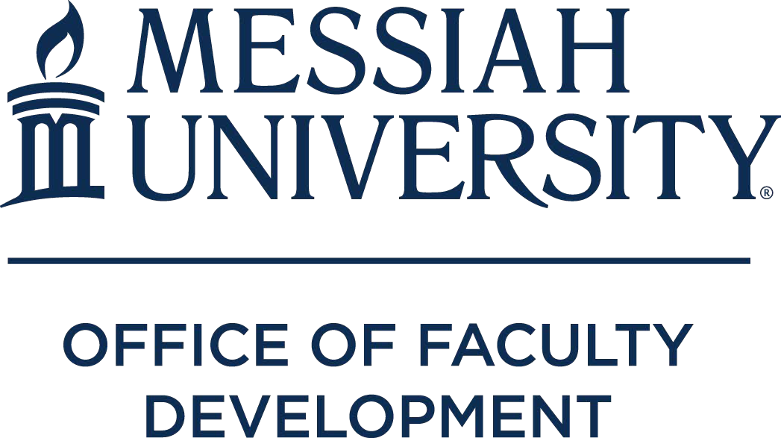

INTERNAL GRANTS

2019-2020 Academic Year

Grants funded by Office of Faculty Development

Course Development
Jan Dormer (Associate Professor of TESOL) – to redesign a course in the Graduate Program of Education: EDME 520 Applied Linquistics: Grammar and Phonology in TESOL.
Milton Gaither (Professor of Education) - for the development of a new Worldviews QuEST course reflecting a more multicultural and gender inclusive range of voices than previous versions possessed. Janet Matanguihan (Assistant Professor of Biology) & David Foster (Professor of Biology & Environmental Science) - to revise Biology 162, Plant Form and Function, to include topics in plant genetics and genomics, plant breeding, and plant diseases.
Dwayne Safer (Assistant Professor of Finance) - to develop the curriculum for a new upper-level finance course (FINA 465 – Advanced Corporate Finance) that will be offered in spring 2020 in conjunction with the finance major that began being offered last year.
Rick Schaeffer (Professor of Chemistry) - to significantly revise the laboratory portion of the Chemical Analysis I (CHEM221) and Chemical Analysis II (CHEM321) Courses.

Teaching Enhancement
Megan Gross (Assistant Professor of Nursing) & Wanda Thuma-McDermond (Professor of Nursing) - Development of a windshield survey video for a Community Health Nursing Course.
Cynthia Lehman (Senior Lecturer of Mathematics) - to enhance the Discrete Mathematics (MATH180) course by integrating quick formative assessments, inquiry based exercises, revisions to team presentations on algorithms, and
Jenell Paris (Professor of Sociology and Anthropology) - to support the deepening of my content knowledge (teaching rubric) in anthropology by funding a site visit to the Sealaska Corporation in Juneau, AK, and the acquisition of Tlingit artifacts.

Scholarship
John Bechtold (Professor of Psychology) - creating a measure of calling and testing it on two test groups (US and the Netherlands) with a presentation at an international conference next spring.
Melinda Burchard (Associate Professor of Special Education) - supports summer 2019 expenses for an investigation of the quality and utility of the IEP Quality Inventory, a tool with which special educators may rate and improve quality of Individualized Education Programs for children in special education Anthony Eseke (Assistant Professor of Communication and Public Relations) - to research intercultural crisis management strategies: interfaith, interethnic, interracial.
Emily Farrar (Assistant Professor of Engineering) - to create a 3D printed soft and hard tissue (skin, muscle, and bone) model of an infant lower limb in order to investigate the forces exerted on the limb by a novel brace for treatment of clubfoot deformity.
Matthew Farrar (Assistant Professor of Physics) - research using the biophysical technique, photon correlation spectroscopy (PCS). The primary apparatus–which was successfully constructed, in part, using a previous Scholarship grant–allows for resolution of molecular dynamics at the single-molecule scale using high-end detectors with single-photon sensitivity.

John Fea (Professor of American History) - development of a database of damage claims from New Jersey during the era of the American Revolution.
Niklas Hellgren (Associate Professor of Physics) - to pay for costs associated with synthesis and characterization of smooth ZnSe thin films, as well as characterization of self-assembled monolayers on ZnSe surfaces.
Sang Uk Joo (Assistant Professor of Sports Management) - to examine the impact of physical and relational factors at college sporting events on spectators' game experience.
H. Scott Kieffer (Professor of Health and Exercise Physiology) - to research the impact of the dopamine (DRD2) and adenosine (ADORA2) polymorphism on fine motor task analysis following caffeine consumption.
David Pettegrew (Professor of History & Archaeology) & James LaGrand (Director of College Honors Program & Professor of American History) - to support the direct costs related to publishing a special issue for the journal Pennsylvania History on the theme of Harrisburg’s City Beautiful Movement.
Obed Mfum-Mensah (Professor of Education) – to fund data collection for a book project, “Global Forces, Education, and Development in Sub-Saharan Africa: A Postcolonial Analysis of Stratification.”
Bernardo Michael (Professor of History) - hiring research assistant for 45 days to continue to identify documents pertaining to the Far Western Region of Nepal (19th and 20th centuries) lying in archival holdings such as the Law Archives, and the National Archives of Nepal.
Deedre Mitchell (Associate Professor of Counseling) - to pursue Beck Cognitive Behavioral Therapy (CBT) Certification.
Donald Pratt (Professor of Engineering) - to support advanced testing in Afghanistan of a new method for destroying landmines and other explosive devices without the use of secondary explosives and without causing detonation of the target.
Anne Reeve (Professor of Chemistry) - to attend a training session for the JEOL NMR spectrometer in August, 2019 in the greater Boston area.
Duu (Jason) Renn (Assistant Professor of Politics) - developing a global database of post-civil conflict electoral competition and international peacekeeping/peacebuilding operations in the post-WWII period as well as expenses related to presenting an article on the pacific effect of international treaties on militarized conflict.
Robert Reyes (Professor of Human Development and Family Sciences) - to study the adjustment experiences of Puerto Rican families relocating to Central Pennsylvania in the aftermath of Hurricane Maria.
Eric Seibert (Professor of Old Testament) - for work related to a book provisionally titled, "Do No Harm: How to Use Violent Biblical Texts Creatively and Responsibly in Church."
Nathan Skulstad (Assistant Professor of Film and Digital Media) - to produce the documentary film, "Ordinary Resurrections," which explores how individuals find a new sense of hope and identity after life-altering loss events.
Cynthia Wells (Associate Professor of Higher Education) - conduct and analyze research associated with a book in progress, "Flourishing at the Core."
Dongjiao Zhao (Associate Professor of Physical Therapy) - to conduct a retrospective study to investigate the substance abuse related traumatic brain injury (TBI) with focus on demographic, situational, and health factors.

Grants Funded by the Teaching and Learning Initiative

Teaching Intern Grants (professor /student) Erin Boyd-Soisson / Kaitlyn Ponchione Carol Buckley / Bryce Eckenrode

Grants Funded by Endowment
Smith Scholar Interns (professor /student)
Melinda Burchard / Katie Hipple
John Fea / Mary Culler
Raeann Hamon / Victoria Anders David Pettegrew / Molly Elspas Stella Ye / Katie Soto

Riegsecker Gender Studies
Bernardo Michael (Professor of History) - research, writing, and its dissemination on the life of Anglican educator and activist Charles F. Andrews (1871-1949) within a framework of global colonial masculinities.
Sharon Putt (Professor of Theology & Religion) - to write a systematic theology text based upon the thought of the medieval/Renaissance Christian female mystics/theologians, whose voices have been largely ignored throughout Christian history.

