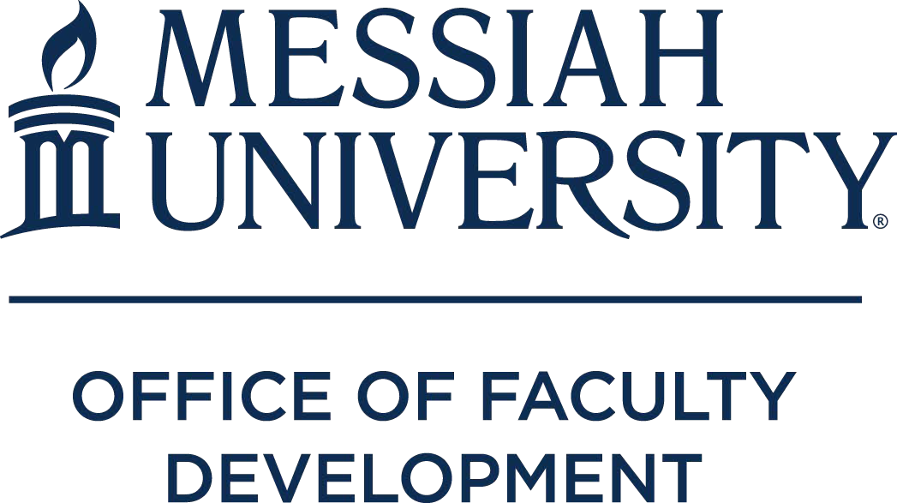

INTERNAL GRANTS

2018-2019 Academic Year

Grants funded by Office of Faculty Development

Course Development
Melinda Burchard (Associate Professor of Special Education) – to develop a new course: Anatomy of Speech and Hearing, BIOL 225.
Michael Dolislager (Assistant Professor of Economics & Economic Development) & Theresa Mannah- Blankson (Assistant Professor of Economics) – to redesign two courses: Economic Development, ECON 312, and Topics in Economic Development, ECON 309 to better fit the objectives of the Economic Development major.
Matthew Farrar (Assistant Professor of Physics) – to develop a new course: Speech and Hearing Science, PHYS 218, to support the new Speech and Language Pathology minor.
Kathleen Johnston (Associate Professor of Accounting) – to implement the current tax law changes into ACCT 247, ACCT 347, and ACCT 348 classes.
Charles Jantzi (Professor of Psychology) & Valerie Lemmon (Associate Professor of Psychology) – to review and revise course assignments for Counseling Theories, PSYC 323, and Counseling Skills, PSYC 423.
Roseann Sachs (Professor of Chemistry) – to develop Physical Chemistry I and II laboratory to include new variable temperature experiments with the nuclear magnetic resonance spectrometer; and a nanoparticle/ macromolecular lab as required by the American Chemical Society.
Dwayne Safer (Assistant Professor of Finance) – to develop curriculum for a Financial Institution Management, FINA 415, course in conjunction with the new finance major.

Teaching Enhancement
John Bechtold (Professor of Psychology) – to help supply the necessary equipment and materials to create and promote a clear line of research on a consumer product that lends itself to investigation through an Experimental Psychology class.
Emily Farrar (Assistant Professor of Engineering) – to develop skills and pedagogical techniques involving two biomedical software packages: Labster.com and Primal Pictures, that will be used to enhance Principles of Biomedical Engineering, ENGR 310, and Bioinstrumentation & Measurement, ENGR 375.
Amy Ginck (Senior lecturer in Modern Languages) – to travel to Spain to re-experience culture and to gather realia, take digital images, and record video to enhance Spanish 101 and 102.

Scholarship
John Fea (Professor of American History) – development of a database of damage claims from New Jersey during the era of the American Revolution.
Milton Gaither (Professor of Education) – to make revisions to a new sixth edition of the book American Education: A History.
Brenton Good (Associate Professor of Art) – funding to frame and ship new works of art for dissemination via forthcoming solo art exhibitions.
Niklas Hellgren (Associate Professor of Physics) – to pay for costs associated with synthesis and characterization of TiB2 and related thin films, as well as characterization of self-assembled monolayers on ZnSe surfaces.

Douglas Jacobsen (Professor of Church History and Theology) – to better understand two of the most important (and least Protestant) aspects of Catholic spirituality, devotion to the Virgin Mary and the practice of pilgrimage, as part of ongoing research related to a book on the Catholic Charismatic Renewal.
H. Scott Kieffer (Professor of Health and Exercise Physiology) – to study the influence of the adenosine receptor expression of ADORA1 and ADORA2 on mechanical power during all-out cycling.
Sean Matthews (Associate Professor of Art) – for project expenses to install a site-specific exhibition, Playground(ed) at the Susquehanna Art Museum in August 2018.
Bernardo Michael (Professor of History) – to hire a research assistant for 50 days to continue to examine archival holdings in Nepal to gather primary source materials on the history of Far Western Nepal (18th-19th centuries).
David Pettegrew (Associate Professor of History) – to conduct a drone photographic survey in Corinthia, Greece, as part of a research project on a vanished 19th century colony called Washingtonia on the Isthmus of Corinth.
Eric Seibert (Professor of Old Testament) – for work related to a book provisionally titled, Do No Harm: How to Use Violent Biblical Texts Creatively and Responsibly in Church.
William Stowman (Professor of Music) – to support a recording project for solo trumpet and other instruments featuring Dr. Stowman in collaboration with other Messiah musicians (Faculty, Students, and Alumni) to promote the music department to prospective students and the greater community.

Grants Funded by the Ernest L. Boyer Center

Scholarship of Teaching & Learning (SoTL)
Thomas Soerens (Professor of Engineering) – to research whether online quizzes with immediate feedback promote better student learning than homework assignments in courses ENGR 321 and ENGR 322.

Grants Funded by the Teaching and Learning Initiative

Teaching Internship (professor/student) Carol Buckley / Samantha Wilson Kerry Hasler-Brooks / Kaitlyn Russell Christine Perrin / Grant Gombert Milton Gaither / TBD

Teaching Conference Grant
Sarah Jones (Assistant Professor of Nursing) – for attendance at a conference designed for nurse educators in preparation for the Certified Nurse Educator exam, to learn methods to incorporate diversity in instruction, and identify evidence-based strategies for improving academic success for English as a second language nursing students.

Grants Funded by Endowment

Smith Scholar Interns (professor/student)
Jan Dormer / Emily Stark
John Fea / Robin Schwarzmann Raeann Hamon / Rachel Jones Abaz Kryemadhi / Trieu Han Luu Bernardo Michael / Ben Baddorf David Pettegrew / Devon Hearn William Stowman / David Wertz

