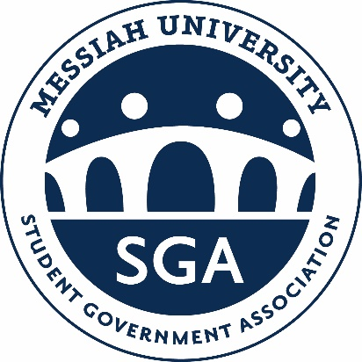
Fall 2023 Student Senate Schedule
Meetings will never run late unless a motion is introduced by members in attendance and approved by majority vote.
Date Time Session Required Attendees Location
Aug. 21st No Meeting Student Engagement Fair
Aug. 28th No Meeting First Full Week of Classes
Sept. 4th 6:00-8:00pm Senate Orientation Extended Forum AWC 310
Sep. 11th 6:00-8:00pm Budget Approval Extended Forum AWC 310
Sep. 18th 6:00-8:00pm Professional Development Primary Forum AWC 310
Sep. 25th 6:00-7:30pm Primary Forum Intro Primary Forum AWC 310
Oct. 2nd 6:00-7:30pm Committee Meetings Committee Members AWC 310
Oct. 9th 6:00-8:00pm GRC TBD Extended Forum AWC 310
Oct. 16th No Meeting Mid-Fall Recess
Oct. 23rd 6:00-8:00pm Town Hall with Operations Extended Form AWC 310
Oct. 30th 6:00-8:00pm Professional Development Primary Forum AWC 310
Nov. 6th 6:00-8:00pm GRC Extended Forum AWC 310
Nov. 13th 6:00-8:00 pm GRC TBD Extended Forum AWC 310
Nov. 20th No Meeting Week of Thanksgiving
Nov. 27th 6:00-8:00pm Student Diplomat Reports Primary Forum AWC 310
Dec. 4th 6:00-8:00pm Town Hall with SGA Cabinet Extended Forum AWC 310
Dec. 11th No Meeting Finals Week
Dec. 18th No Meeting Winter Break

