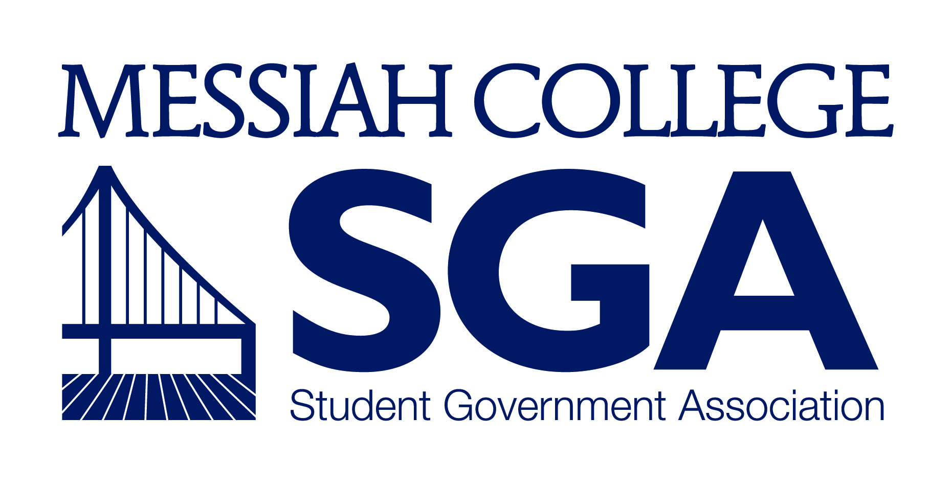

Professional Development
Grant Program

- Objective
- The purpose of the SGA Professional Development Grant is to support students in furthering their professional outlook and success for a post-graduation transition. SGA will help students through partially funding the expenses of conferences, so that students can put to practice the information they have learned and to also have the opportunity to network with other students and professionals. Because conferences may be expensive for students, SGA seeks to help relieve students of some of their financial burdens in order to allow students to gain understanding and experience of the professional world, thus preventing financial issues for attending the conference. The conference being attended by the student must relate to his/her major and/or future professional goals. Please note that this grant is not intended for experiences which relate to faith development or discerning career choices.

- Requirements of Applicant
- Minimum of sophomore status and with good academic standing.
- Conference must relate to identified major or future career plans.
- Submission of a statement of purpose explaining the purpose of the attendance.
- Letter of recommendation from a supporting mentor.
- All applications materials should be submitted no later than three weeks before the scheduled conference.
- Completion of a brief online training session, created by the Career and Professional Development Center.
- Submission of some form of proof (i.e. conference receipt) that the student was at attendance of the conference and of their presentation if presenting.
- Amount of grants
- All grants will be awarded in an amount up to or equal to fifty percent of the anticipated cost of the conference as detailed in the completed cost worksheet, with a maximum grant of three hundred dollars.
- The total dollar amount of grants given in a single school year shall not exceed five thousand dollars.
- Typical distribution will be in the form of a reimbursement for expenses. After the conference has been attended, the grant recipient will submit receipts to the SGA VP of Finance for reimbursement. Requests for funds prior to attending the conference should be directed to the SGA VP of Finance. Failure to attend the conference or show proof of attendance will result in the return of the granted amount back to SGA.

- Procedure for awarding a grant
- The applicant shall complete the application form detailed on the last pages after this manual, along with letters as stated in II.D and II.E.
- The applicant shall then email the signed application in PDF format to the Vice President of Communication (SGA@messiah.edu), who shall then verify with the Application Committee that the application has been properly filled out, approve the application, and submit it to the Vice President of Finance.
- The Application Committee will consist of the Vice President of Diversity Affairs, the Vice President of Finance, a staff member from the Career and Professional Development Center, and an academic faculty member.
- Preference will be given to applicants who a) present at a conference; b) are actively involved in the conference such as being a part of the conference committee; c) attend a conference clearly connected to professional discipline or future career goal.
- The Vice President of Finance shall approve the proposed cost for the conference based on the completed cost worksheet in the application. When the recipient returns from the conference and submits receipts, the VP of Finance shall make a transfer for the amount of the grant, as determined from the parameters outlined in III.A, from the Development Fund program account to the appropriate department account.
- A copy of the transfer form shall be given to the student so that they may present it to the department chair as verification that they have received the grant.
- The applicant will undergo a brief online orientation and training prior to attending the conference.
- Applications that are received over the summer months will be considered by a committee consisting of the President of SGA, a Career and Professional Development Center staff member, the Director of SILP and the SILP Administrative Assistant

- “Give Back” Component
A. Recipient agrees to be featured in the online version of the Pulse where they will talk about their experience at the conference.
- Changes to the programs
- The Academic Affairs Committee, in conjunction with the Finance and Organizations Committee, will be responsible for reviewing the program and recommending any changes to the Student Senate.
- Any changes to the guidelines for the program outlined in this document must be approved by a majority vote of the Student Senate.
- Changes in the monetary amount per grant or the total amount to be given out during the year must also be reconciled with any language in the SGA Financial Policy which references them.
Application of SGA Professional Development Grant
1. Please fill out the following:
Applicant Name: Year:
Major: Contact Number:
Applicant Email: Supporting Mentor:
Name of Conference:
Location of Conference:
Date of Attendance: Conference Website:
Presentation Topic (if presenting):
Other Purpose (if not presenting): (examples: part of conference committees, volunteering at conference, presenting work other than poster such as a paper or artwork)
How did you hear about the SGA Professional Development Grant?
2. Create a one page Statement of Purpose, which should contain the following:
1. What is your purpose in attending the conference?
2. What are your career goals, and how does this conference support those goals?

3. Obtain a Letter of Recommendation from the Supporting Mentor, which should address the following:
1. How do you know this student? What are his/her strengths and skills?
2. Why will this conference in particular be beneficial to this student?
2. How do you expect the student to grow professionally as a result of this conference?

4. Complete the Estimated Expenses Worksheet (on page 2 of the application).

5. Obtain signatures from the Supporting Mentor* (students are also strongly encouraged to speak with department chairs to determine if additional conference funding is available) (on page 2 of the application).
6. Save all documents as a PDF and email them to the Vice President of Communication, at SGA@messiah.edu. Applications will only be considered complete once all documents are received.

ESTIMATED EXPENSE WORKSHEET

Housing $ (no. of nights = x $ per night, max $75/night)

Transportation $ (no. of miles = x $.35/# people going) – Do not calculate if flying to your conference. List the price of airline ticket.

Registration Fee $

Miscellaneous* $ (Please describe in space below)

Total $

Will the reimbursement be made out to you personally or should it be made out to another department on campus? _____________________________________________________

*List any miscellaneous items below. As a note, food for academic conferences cannot be funded by SGA as per Section 10, Article III, Clause iii, Sub-clause 2 of the SGA Governance Manual.

Signatures*:
Student: Date:
Supporting Mentor: Date:

*Student: By electronically signing this, I agree that this signature is coherent to physically signing. With this signature, I confirm that the information above and from the statement are accurate and true.
*Mentor: By electronically signing this, I agree that this signature is coherent to physically signing. With this signature, I confirm that I have looked over the student’s application and approve his/her attendance to the conference.

(For Office Use Below)
SGA Approval:
Vice President of Diversity Affairs: ______________________________________

Vice President of Finance: ______________________________________

