Log-In and System Navigation

The Messiah College Online Recruitment System (Jobs.messiah.edu) may be accessed either directly via <http://jobs.messiah.edu/hr> or via theEmployee Quicklinks channelonMC Square**.** Mozilla Firefox is the preferred browser for better screen clarity.

**How to** Log In

When selecting Jobs.messiah.edu from MC Square, the system will prompt the user for network login information and then will automatically log the user in to the system. Based on your credentials, the system determines your level of access to data and your permission to perform work in the application.

If you are working outside of the Messiah network, the system is accessible via <https://jobs.messiah.edu/hr/>. You will be presented with a login page and must select the link for SSO Authentication and enter your Username and Password from the Central Login Page.

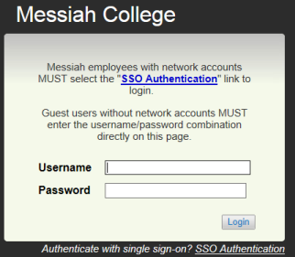

If you find that you require additional roles or specific accesses to data, please contact the appropriate office listed below (contact information located in the footer of this document) who will review and may revise your user role and permissions in the system:

* Office of Human Resources 🡪 administrative, faculty, staff and temporary positions
* Office of Student Employment 🡪 student positions

Once authenticated, the system home page will be displayed.

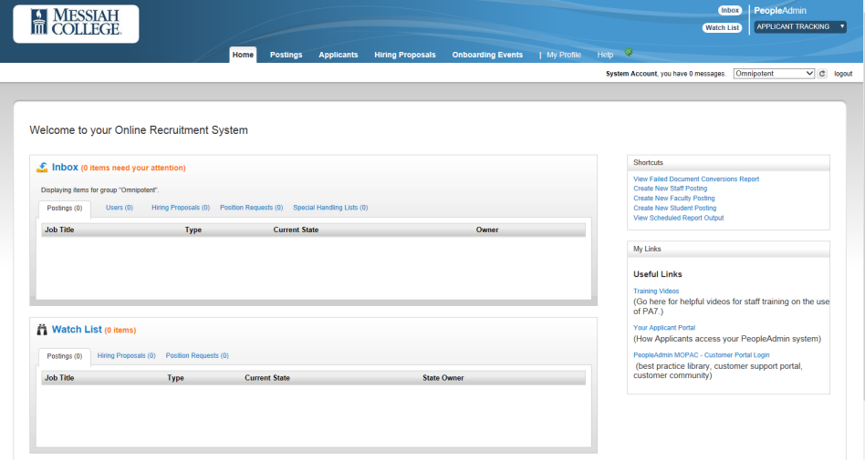

**How to** Select Your Role(s)

Based on your level of access, the home page will display what you are permitted to see and actions you are able to perform in the application. You may have multiple roles in the system (e.g., Employee and Hiring Manager). To select a desired role, navigate to the top right of the screen and open the role selector drop-down box.

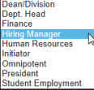

After you have selected your role, click on the refresh button to the right . The home page display will automatically update based on your chosen role. The application will notify you that your role has been changed. This will appear in a green notification bar at the top of your screen.

**Navigation in the System**

**MAIN MENU**



**ALERTS**

**WATCH LIST**

**INBOX**

**SHORTCUTS**

**LINKS**

The Messiah College Online Recruitment System is a roles-based application. Your role in the system determines what you are able to view and process as a contributor to the recruitment process.

Clicking on any link in the Main Menu, the system will direct you to any assigned function: Postings, Applicants, Hiring Notifications, etc.

**There are 8 main driving sections of the home page:  
  
*Main Menu*** - located at the top center of the screen. Select any link from the Main Menu to direct you to permitted areas of the system (e.g., Postings and Applicants).

***Module Selector*** *–* located at the top right of the screen. Based on your role, you may select which module you would like to work in – Applicant Tracking, Position Management, and Admin. The default home page will always be Applicant Tracking

***Role Selector*** – located at the top right of the screen below the Module Selector. Choosing your role permits you to perform certain duties and view specific information in the system

***Alerts Box*** – located mid screen. Displays notifications to you from administrators

***Inbox*** – located below the Alerts Box. Displays items that require your attention, for example, an action on a posting, or approval of a user

***Watch List*** - located below the Inbox. Displays those postings for which you have marked as “Add to Watch List” for special interest

***Shortcuts*** - located at the right of the screen. In one step, shortcuts navigate you to a specific function (e.g., Create Staff Posting)

***My Links*** – located below the Shortcuts Box. Displays specific links to training and other hiring process documentation

**Accessing the** Applicant Portal

Users who wish to view information within the applicant portal can access this information by:

1. Selecting Your Applicant Portal from My Links within the Online Recruitment System
2. Entering the following URL directly into the web browser: <https://jobs.messiah.edu>

**Searches, Search Results & Saved Searches**

The ability to conduct searches exists across all major areas of the site. For example, a user can search the following: (1) Position Descriptions; (2) Position Requests; (3) Postings; (4) Applicants; and (5) Hiring Proposals.

Each section of the site has a default search that appears based either on the institutional setting on a specific user role. To view and select an alternate available saved search, click on the “Open Saved Search” drop-down selector and select an alternate saved search.

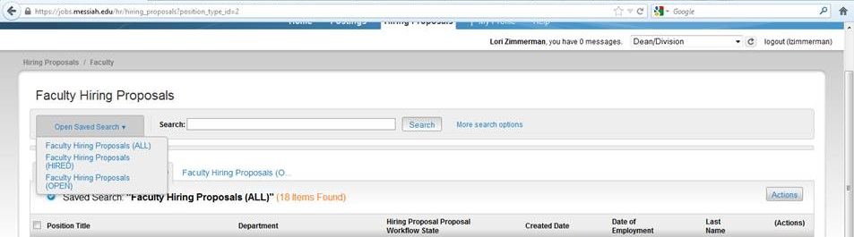

Additionally, users can create and/or their own custom searches using the “More search options” link. Here users can add/remove columns, add/remove workflow states and save a custom search that is available only to the user.

