Position Descriptions & Requests
Student Hiring Manager

Below is a visual diagram for the creation and approval workflow of Student Position Descriptions in the Messiah College Online Recruitment System (https://jobs.messiah.edu/hr).

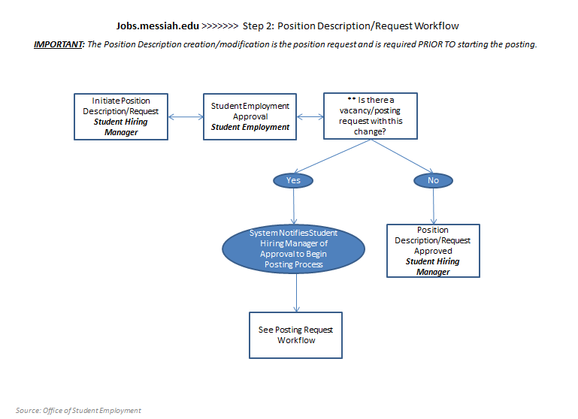

In a stepped process, the flow is as follows:
- A Student Hiring Manager or Student Employment may create or modify a Position Description by creating/viewing a new position description or cloning an existing position. Once complete, the Position Description will be forwarded to Student Employment for approval.
- Student Employment will review the new or cloned position for content, classification and compensation.
- Once approved, the new/modified position is then made available to the Student Hiring Manager and may be used for creating a new Job Posting.

Creating a New Student Position Request
Choose and refresh your role (Student Hiring Manager) from the role drop down box at the top right of the home page. Note that the Employee role will not permit you to access the Position Management module.

Navigate to the Position Management module by clicking on Position Management from the module drop down box. When loaded, the Position Management home page color scheme will turn to “orange”.

To create a new Position Description Request:
- Click on the Position Description link from the main menu at the top of the home page
- Then, click on “Student” from the Position Description Menu

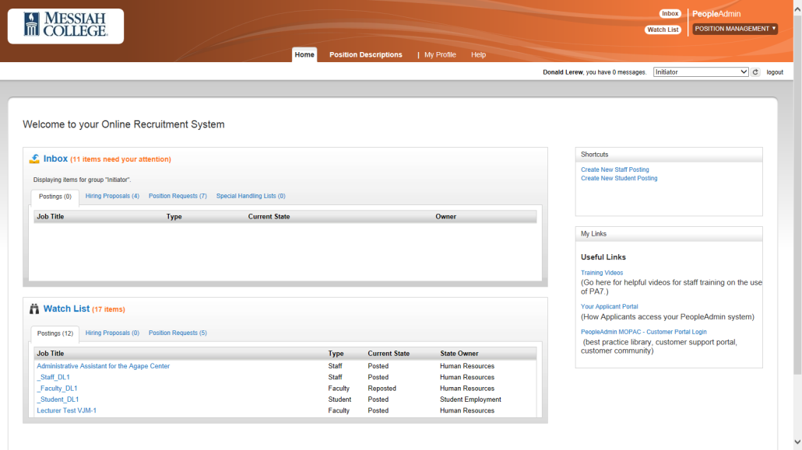
! The Student Position Requests selection from the Position Description menu does not allow you to create positions. Student Position Requests displays your open positions and their request status.

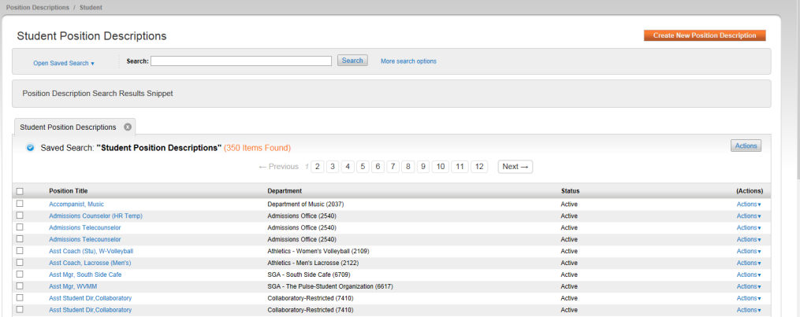
To view a Position Description, you may either click on the Position Title name or select View from the Actions link to the right of the position. Prior to creating a Position Description, search the current Position Description list by viewing or by title or keyword to ensure it does not already exist.
To create a Position Description Request:
- Click on the Create New Position Description button at the top right of the screen
- Click on the New Position Description link from the Create New pop up box
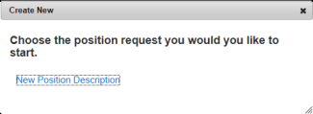
- You will have the option of creating a New Position Request (from scratch) or clone an existing position, with the ability to change specific information. To create a brand new position, first fill in the basic new position information, then select the Start Position Request button at the top right of the page

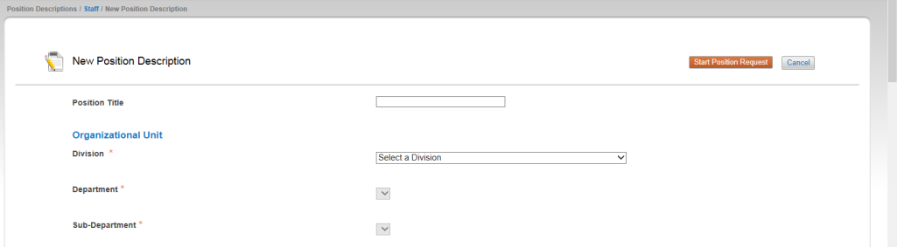

To clone a position, still fill in the basic information about the position (as shown in the above screen), then select a similar/same position title by clicking on the radio button to the left of the Position Title. Once done, select the Start Position Request button at the top right of the screen. Much of the information will be pre-populated and you will be required to modify the pre-populated information and complete the remaining information.

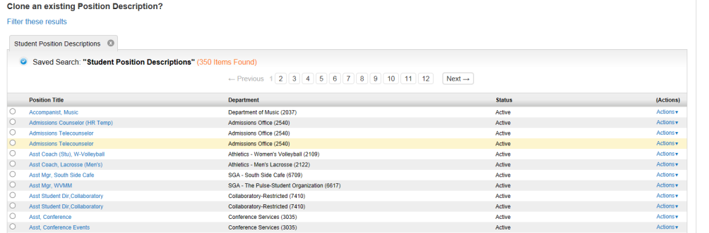

! When a Position Description is created via cloning, the history of the new Position Description will NOT retain any information that is deleted before routing. This helps to ensure that “other position description” data that should not be part of the new position description is purged completely.

- The New Position Request Template will display with a stepped menu, Editing Position Request, appearing to the left of the screen. Note that required information appears in a red box:

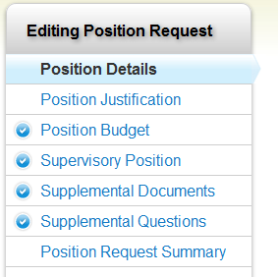
Position Details – Requires information about the position class, position description, working conditions and supervisory responsibilities
Position Justification – requires information about position justification, funding and salary
Position Budget – Budget information requires funding sources and funding percentages
Supervisory Position – select to whom the position reports (edits restricted to Student Employment)
Supplemental Documents – upload documents to support the position request
Supplemental Questions – any questions that should be included in any posting for this position
Position Request Summary – summarizes all entries

! Requests for NEW Supplemental questions for use on the application must be submitted during the Position Request phase and must be approved by Student Employment before use.

- It is recommended that you navigate the steps prior to entering new position information, so that you will understand what is required to complete the New Position Request form.
! At all steps, you will be able to save the new position information and return at a later point to complete your request. When leaving the request form, it is recommended to select “Keep Working on this Position Request” as shown below:

- Once all required information and other data is completed on the New Position Request form, you will Take Action on the Position Request. The Student Hiring Manager will submit directly to Student Employment for job and compensation/classification review and approval.

WORKFLOW ACTIONS
Keep working on this Position Request – Assumes that you are not finished with the Position Request and will continue to work on it
Canceled (move to Canceled) – means that this position is request is no longer needed
Student Employment Approval (move to Student Employment Approval) – The position request is ready for approval by Student Employment
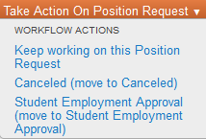

- What’s next?
Once submitted to Student Employment for review, your Position Request will be available for viewing by navigating to Position Descriptions from the Position Management home page, and then choosing Student Position Requests from the Position Descriptions menu

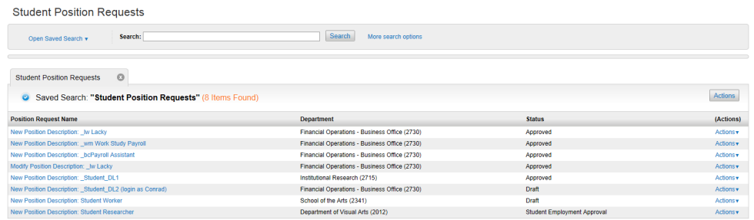

You will be able to view the New Position Request and its status as it moves through the workflow and approval processes.

Cancelling a New Student Position Request
Cancelling a New Position Request will cancel the request, but will keep the request in the system. No Position Description will be created.

Modify a Student Position Description/Request

Instructions for modifying Position Descriptions is the same as listed above for a New Position Request. Once you have identified the Position Description to be modified, either click on the Position Description or select “View” from the Actions drop-down link:

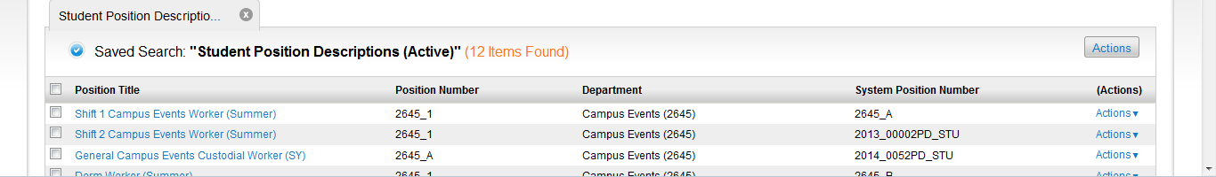

With the Position Description now displayed, select Modify Position Description to initiate changes:
! NOTE: When a Position Description is being modified, it is locked for use in postings.

- Once all required information and other data is completed on the New Position Request form, you will Take Action on the Position Request. The Student Hiring Manager will submit directly to Student Employment for job and compensation/classification review and approval.

WORKFLOW ACTIONS
Keep working on this Position Request – Assumes that you are not finished with the Position Request and will continue to work on it
Canceled (move to Canceled) – means that this position is request is no longer needed
Student Employment Approval (move to Student Employment Approval) – The position request is ready for approval by Student Employment

Cancelling a Modify Student Position Request
Cancelling a Modify Position Request will cancel the request, but will keep a historical record of the request. The previously-approved version of the Position Description is unaffected and remains active and ready for use.

Deactivating a Student Position Description

Position Descriptions can only be deactivated or removed by the Student Employment role. If a Position Description is no longer needed, please contact Student Employment Office.

