Student Applicant Workflow and Statuses
Student Hiring Manager
Below is a visual diagram for the student applicant flows and statuses in the Messiah College Online Recruitment System (https://jobs.messiah.edu/hr).

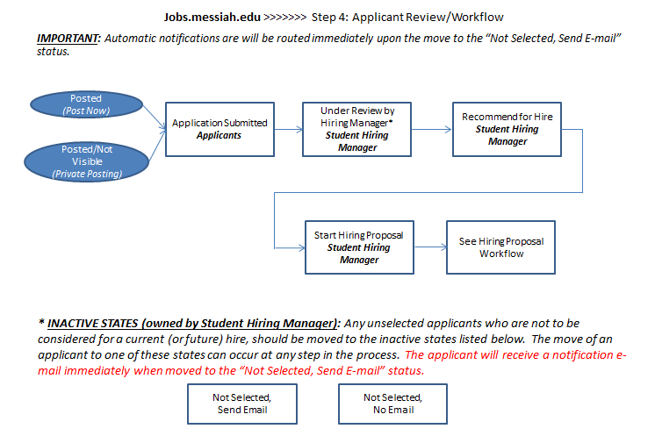
The applicant workflow in an active recruitment process:
- The Applicant receives a confirmation notification via the Applicant Portal that his or her application has been accepted. The corresponding default internal status is “Under Review by Student Hiring Manager”
- The Student Hiring Manager will access the Posting and review Applicants
- The Student Hiring Manager will conduct an interview with the student applicant
  - If interested in an applicant:
    - The Student Hiring Manager will move the applicant to Recommend for Hire which will trigger the link to Start Hiring Proposal
  - If NOT interested in an applicant, the Student Hiring Manager will take action on the application to move the applicant to “Not Selected – Send E-mail” or “Not Selected – No E-mail”.
- The final step will be to take action to “Start Hiring Proposal” on the applicant. A Hiring Proposal may be created for one (or multiple) applicants, as is needed by the department.
Working with Applicants and Applications – Workflow Process
You will work with Job Postings and Applicants in the Applicant Tracking module of the system. This is the main page of the system, however, should you need to navigate to the Applicant Tracking module, you will select Applicant Tracking from the module drop down box at the top right of the screen.

Choose and refresh your role to Student Hiring Manager from the role drop down box at the top right of the home page below the module drop down box. Note that the Employee role will not permit you to access the Applicant Tracking module.

You may access postings in a number of ways:
- Navigate to the Postings Menu and select “Student”. A list of your postings will display. Select a posting by clicking on the Job Title or select the Actions link to the right of the Job Title to view the Posting or View Applicants
- Navigate to the Inbox where you will find postings that require your action. Select a posting by clicking on the Job Title
- Navigate to the Watch List for any postings that you have marked as “Add to Watch List” when you created your posting. Select a posting by clicking on the Job Title

(Selecting a Student Posting from the Postings Page):
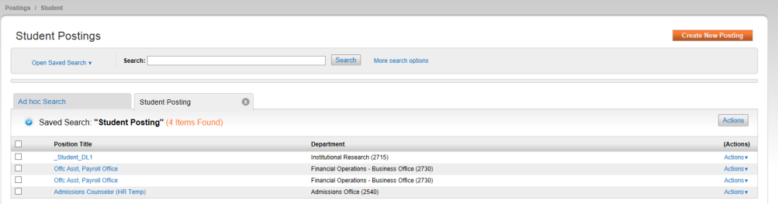

In addition to viewing Postings and Applicants and Stop Watching, Student Hiring Managers may export all job posting results by selecting the Actions button appearing above the Actions link.
Student Hiring Managers may also select Create New Posting from this page.

Viewing Applicants/Applications:

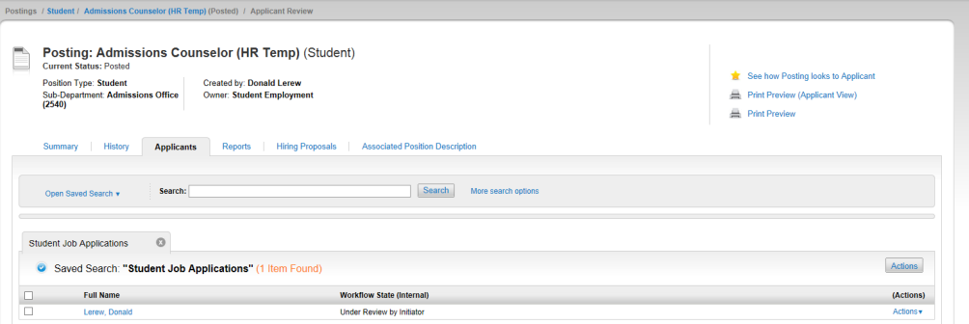
Once you have accessed the Posting, you may view Applicants by clicking on the Applicant tab at the main Posting navigation menu (or View Applicants from the Actions link on the Student Postings page.

Working with Applicants and Workflow Process:
Having selected the Applicants tab on the Posting navigation menu, the system will display completed applicants who have applied to your posting. You may click on the Full Name to open the application or may select View Application from the Actions link to the right of the applicant’s Full Name.

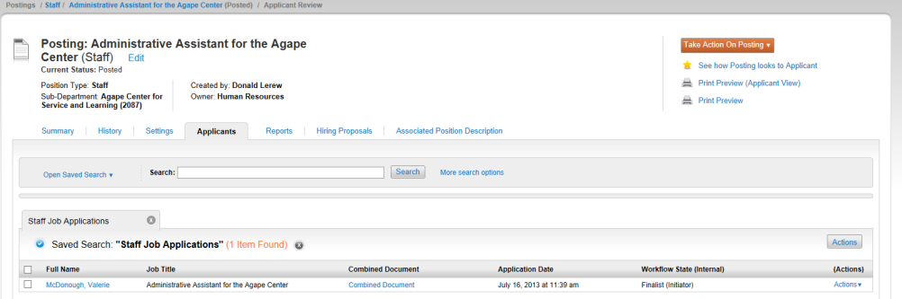

In addition to opening the Applicant information, the Student Hiring Manager may print the applicant information and even see how the posting looked to the applicant, from this page.

Additionally, the Combined Document field allows the user to view the full PDF of the application and any required documents on each applicant. To add a Combined Document to one or more applicants’ records, select the desired applicant(s) and select the bulk action to “Create Document PDF Per Applicant.” The system will generate a link when the combined document is available.

If there is a need for an application to be reactivated to correct/update submitted information (application, questions, or documents), Student Employment will need to be contacted to reactivate.

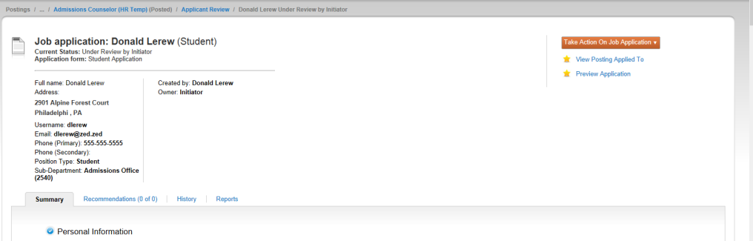

The Applicant’s Job Application is visible and displays current status, as well as the details of the full application, including additional tabs for History and Reports. The Student Hiring Manager will begin the workflow process of moving the applicant through the recruitment cycle:
- Status changes are conducted by selecting the Take Action on the Job Application button at the top right of the Applicant page
- The Student Hiring Manager will conduct an interview with the student applicant
  - If interested in an applicant:
    - The Student Hiring Manager will move the applicant to Recommend for Hire which will trigger the link to Start Hiring Proposal.
  - If NOT interested in an applicant, the Student Hiring Manager will take action on the application to move the applicant to “Not Selected – Send E-mail” or “Not Selected – No E-mail”. If moved to one of these statuses in error, contact Student Employment.
! It is important that all un-hired applicants be moved to the appropriate Not-Selected status (Not Selected – Send E-mail or Not Selected – No E-mail) to ensure applicants receive notification of their application status.

- Once the applicant is moved to Recommend for Hire, the system will generate a link for “Start Hiring Proposal”
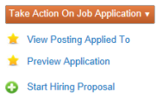

- The final step will be to take action to “Start Hiring Proposal” on the selected applicant. A Hiring Proposal may be created for one (or multiple applicants), as is needed by the department.
! Starting and submitting a Hiring Proposal to Student Employment is required for every hire. Student Employment must approve the Hiring Proposal before a student may begin working.

Bulk Transactions
The Messiah College Online Recruitment System allows Student Hiring Managers to conduct applicant “bulk transactions”, or those transactions that may apply to more than one applicant. Such cases may be for moving a set of applicants from one workflow state to another or for notifications that a position is filled. This functionality offers an efficient method for working with multiple applicants at one time.

To Perform Bulk Transactions on Applicants:
Navigate to the Applicants tab on the Job Posting. You may also navigate to all applicants from the Applicants tab from the main menu.
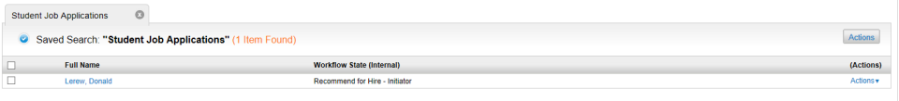

In order to perform a bulk transaction, select applicants by clicking on the select box to the left of the applicant’s Full Name. To select all applicants, click in the select box at the top left, next to the title, Full Name. When done, click on the Actions button above the applicant listing, at the right of the screen.

General Transactions

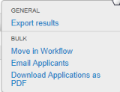

Export Results
The Export Results function allows Student Hiring Managers to export applicant information to Excel for further reporting. When selecting “Export Results”, Excel will prompt you to Open the data in a new window, Save your data to a file or Cancel to terminate the transaction.

Export results will appear in an Excel file as seen below:

Note that the exported information is based on your new or saved search results.

Bulk Transactions

Move in Workflow
The Move in Workflow function takes your selected applicants, displays their current workflow state and allows the user to move the applicants (either individually or all at once) to a specific workflow state.
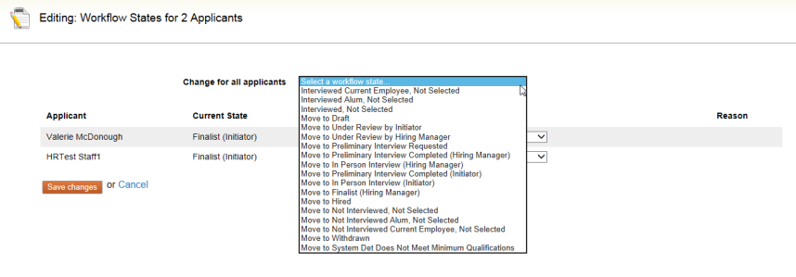
You will select the Status Change by applicant. You may also change the Current State of selected applicants. Once complete select Save Changes or Cancel to terminate the transaction.

Download Applications as PDF and Create PDF Per Applicant
The Download Applications as pdf functionality bundles and send the applicants’ applications to a pdf file. You will have the choice of downloading the Application and All Documents or Only These Document Types, in this case Application Data.
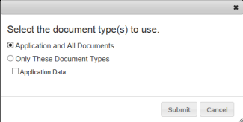

Once selected, choose Submit to download documents or Cancel to terminate the transaction.

