Student Hiring Proposal and Job Offer
Student Hiring Manager
Below is a visual diagram for Student Hiring Proposal workflow and statuses in the Messiah College Online Recruitment System (https://jobs.messiah.edu/hr).

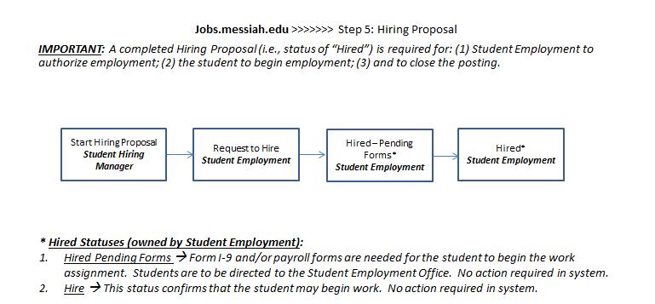

The Hiring Proposal in an active recruitment process:
- The Student Hiring Manager will move the applicant status to “Recommend for HIre”. Upon completion, the system will open a link for Start Hiring Proposal on the Applicant’s Job Application
- The Student Hiring Manager will select the “Start Hiring Proposal” link on the Applicant’s Job Application. The Student Hiring Manager will fill in the required information for the Hiring Proposal and will review the Hiring Proposal Summary
- When complete, the Student Hiring Manager will take action on the Hiring Proposal and will change the status of the Hiring Proposal to “Request to Hire”.
- Student Employment will then review the Hiring Proposal and confirm employment eligibility and confirm completion of required forms (e.g., Form I-9, etc.).
- Student Employment will move an eligible applicant to the status of “Hired – Pending Forms” if forms (e.g., I-9) are needed prior to beginning work assignment. Student Employment will move the Hiring Proposal to a status of “Hired” and will communicate to the Student Hiring Manager when the student may begin employment (i.e., forms have been completed). Once the status is at “Hired”, Student Employment will begin the Onboarding Process.
- The Student Hiring Manager will communicate to Student Employment if the Posting should be marked as “Filled” or remain open for additional hires.

Completing a Hiring Proposal
Choose and refresh your role to Student Hiring Manager from the role drop down box at the top right of the home page below the module drop down box. Note that the Employee role will not permit you to access the Applicant Tracking module.
- To initiate the Hiring Proposal for an Applicant, choose “Start Hiring Proposal” from the Applicant’s Job Application (activated by the Applicant status of “Recommend for Hire”). This is accessible by selecting Postings from the main menu at the top of the screen, then selecting a posting from the posting list and finally “view applicants” by selecting the Actions link. You may also navigate to the job posting via your Inbox or Watch List. The applicant’s status will be set to “Recommend for Hire – Student Hiring Manager”
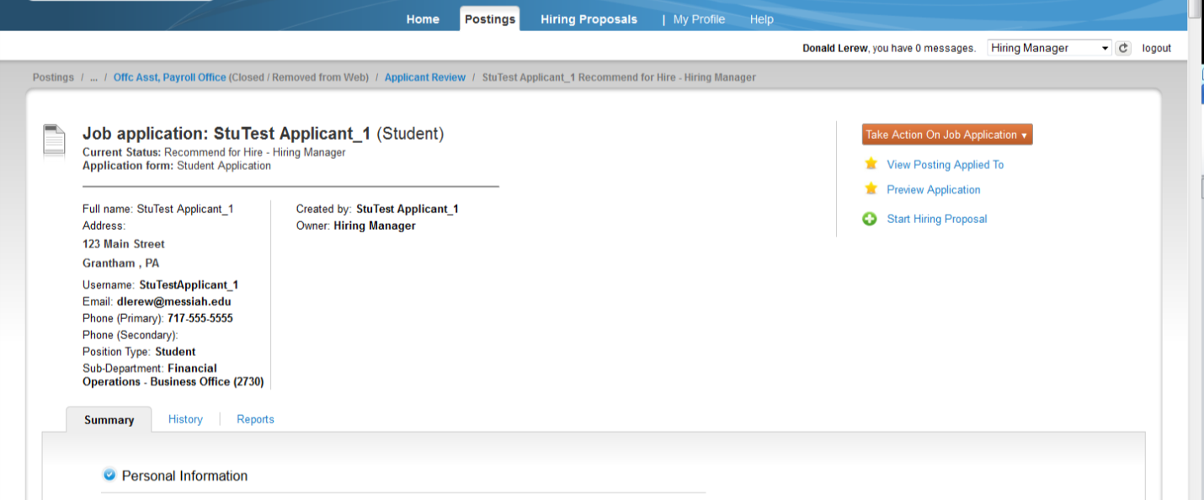

- The Hiring Proposal consists of the actual proposal information for the Hiring Proposal
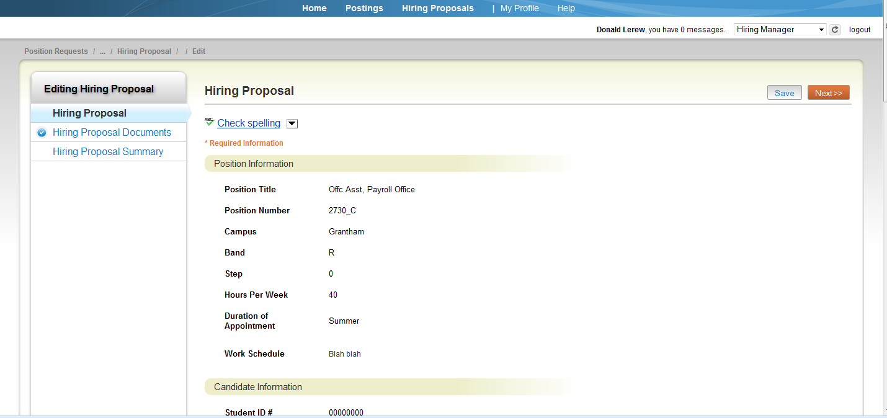
- Review the Hiring Proposal. Complete all required information. No Hiring Proposal Documents are to be uploaded. Choose Save and Next for the Hiring Proposal Summary
- The Student Hiring Manager will Take Action on Hiring Proposal by clicking on the “Take Action on Hiring Proposal” button at the top right of the Hiring Proposal Summary page
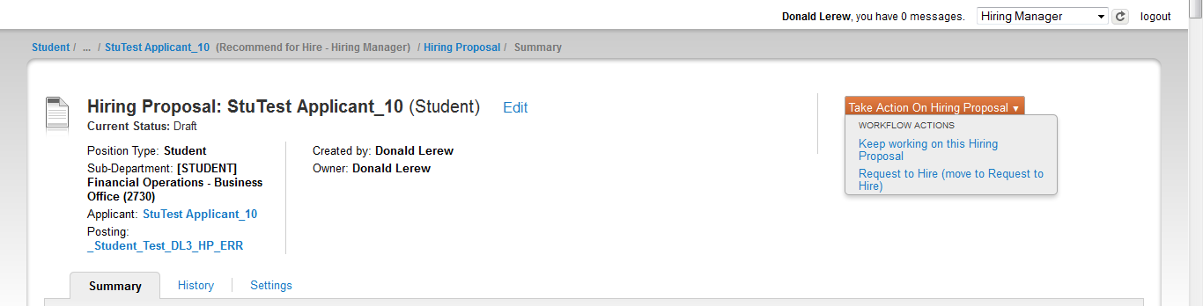

- Choose to “Keep Working on the Hiring Proposal” or if complete, Take Action on the Hiring Proposal and move the status to “Request to Hire”. The Hiring Proposal will now be in a view only mode for the Student Hiring Manager and Student Employment will be required to move the applicant to a status of “Hire” when the student is confirmed to be eligible for employment and all required forms/paperwork have been received.
! The Hiring Proposal MUST be moved by the Student Hiring Manager to “Request to Hire” for Student Employment to receive, evaluate and approve an applicant for hire.

Note that the Hiring Proposal may be printed by selecting “Print Preview” and then use your browser’s print preview function.

Notification of Hire
Upon receipt of the Hiring Proposal from the Student Hiring Manager, Student Employment will review the Hiring Proposal to determine if the applicant is eligible for a work assignment AND when the student may begin the work assignment. Applicants may not begin the work assignment until appropriate forms have been completed. Student Employment will notify the Student Hiring Manager with one of these two statuses:

- Hired Pending Forms Form I-9 and/or payroll forms are needed for the student to begin the work assignment. Students are to be directed to the Student Employment Office. No action is required in the system.
- Hired This status confirms that the student may begin work. No action is required in the system.

