1. My Family and Me

- I can fill out a form, giving personal data.
- Use the form here and other available forms to give students practice.
- Have students create forms for classmates to fill out.
- Exchange forms, reading about each other. This is a good way for students to get to know one another.

- I can understand personal questions and respond with information.
- I can ask questions about someone else, and understand the answers.
- Have students collect information about their classmates (possibly using the form provided), asking them questions:
What’s your first name?
What’s your last name?
How do you spell it?
When were you born?, etc.
- Encourage students to do this exercise with a conversation partner who is not in their class.
OR
- Have students interview each other in pairs, using the worksheet “write about your friend”.

- I can ask about someone else’s family, and understand answers.
- Create a family tree (the teacher’s is good). Give students the names that go on the family tree. Students must ask questions to place names on the tree. Ex:
S: “Who is Kirsten?”
T: “Kirsten is my sister-in-law.”
Provide explanations as necessary, in order for students to learn vocabulary concerning family relationships. Show pictures of the family.
- Have students bring in pictures of their families. Have students provide the names of family members. Working in pairs, students ask and answer questions until they have re-created each other’s family trees.

- I can tell about my family (physical description, age, personality, hobbies).
- Do the worksheet “Describing People”, including “Practice A” on the second page.
- Optional: Play the game “Who’s Who?” (A game describing facial features)
- Have students do “Practice B”, writing characteristics of a family member. Students read their descriptions. Classmates must guess, making statements like “I think it’s your mother” or “I think it’s your daughter. If possible, the student shows a picture of the family member afterwards.

- I can write a paragraph about a family activity.
- I can read a classmate’s paragraph about a family activity.
- Show pictures about typical family activities. Use the accompanying pictures, or your own.
- Give students the worksheet “A family meal”. Guide them in completing the worksheet.
- Correct students’ sentences. Have them write their family activity in corrected form on a 4x6 lined card.
- Have students exchange paragraphs, reading each other’s paragraphs.

Project: Collect paragraphs on cards and accompanying pictures from each student. Put them together in a class booklet.

Fill out a Form

Sample Form:
Personal Information

Name: _____________________________________________________________
Last name First name Nickname

Date of birth: ________________________________________________________

Marital status (circle one): married single engaged divorced/separated

Names and ages of children: ____________________________________________
____________________________________________________________________

Address: ____________________________________________________________

Phone number: _____________ Hand phone: _______________________________

Email address: _______________________________________________________

How many years have you studied English? ________________________________

Why do you want to study English? ______________________________________

Your turn! Make a Form!

- You are a school director. You need to hire a teacher.

- You are beginning a support group for parents of children with learning problems. You want some information about everyone in the group.

- You are planning an English Speech competition for English students. You need an enrollment form.

Get to know your classmates!

Ask questions to collect this information about your classmates:

1. Full name: ______________________________________________
Date of birth: ____________________________________________
Place of birth: ___________________________________________
Father’s name: ___________________________________________
Mother’s name: __________________________________________
Current residence: ________________________________________
Phone number: ___________________________________________

2. Full name: ______________________________________________
Date of birth: ____________________________________________
Place of birth: ___________________________________________
Father’s name: ___________________________________________
Mother’s name: __________________________________________
Current residence: ________________________________________
Phone number: ___________________________________________

3. Full name: ______________________________________________
Date of birth: ____________________________________________
Place of birth: ___________________________________________
Father’s name: ___________________________________________
Mother’s name: __________________________________________
Current residence: ________________________________________
Phone number: ___________________________________________

4. Full name: ______________________________________________
Date of birth: ____________________________________________
Place of birth: ___________________________________________
Father’s name: ___________________________________________
Mother’s name: __________________________________________
Current residence: ________________________________________
Phone number: ___________________________________________

Write about Your Friend!
- Write questions.
- Interview a friend.
- Write answers.
- Fill in the blanks to write a paragraph about your friend.
- Read your paragraph to the class.
 | Question | Answer
Name
Country
Age
Family

Job

My friend is ______________. ______ comes from ___________________. _____ is ________________ years old. ______ has _________________

_____________________________________________________________.

______ job is _________________________________________________.

I like my new _________________!

DESCRIBING PEOPLE

She / he has.... blue / grey / green / brown / black eyes

long / short / curly / wavy / straight hair

black / brown / blond / red / white / grey hair

a mustache / a beard

braces (teeth) / a brace (leg)

She / he is... tall / short

heavy / thin

bald / partially bald

pretty (women) / handsome (men) / attractive

nice / friendly / helpful / funny

She / he wears.... glasses / a gold necklace / a white and navy uniform / a watch

She / he is wearing.... blue pants
a white sweater
gold earrings
black shoes
a red tie
a pink jacket
a watch

PRACTICE A: Fill in the blanks.

My friend John ______________ glasses. He _____________ blue eyes, and short, wavy hair. He ____________ partially bald, and he ________________ a mustache. His hair ________________ white, but his mustache _______________ brown. He_____________ fairly tall, and thin. He _______________ very friendly. He usually _____________ a navy and white uniform, because he works in the military. But today he _______________ a red sweater and black slacks. He _____________________black shoes, and black socks. I think he ________ also _______________ a watch.

PRACTICE B:

Describe a family member. Your classmates will guess who it is!

She / he has _________________________________________________
______________________________________________________________________________________________________________________

She / he is __________________________________________________
______________________________________________________________________________________________________________________

She / he wears _______________________________________________
______________________________________________________________________________________________________________________

Common Family Activities

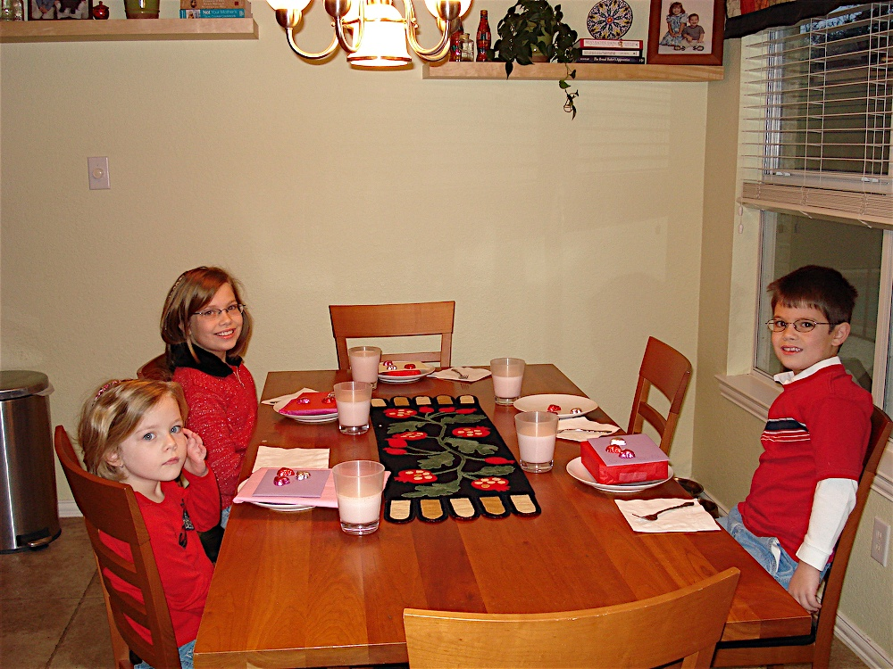
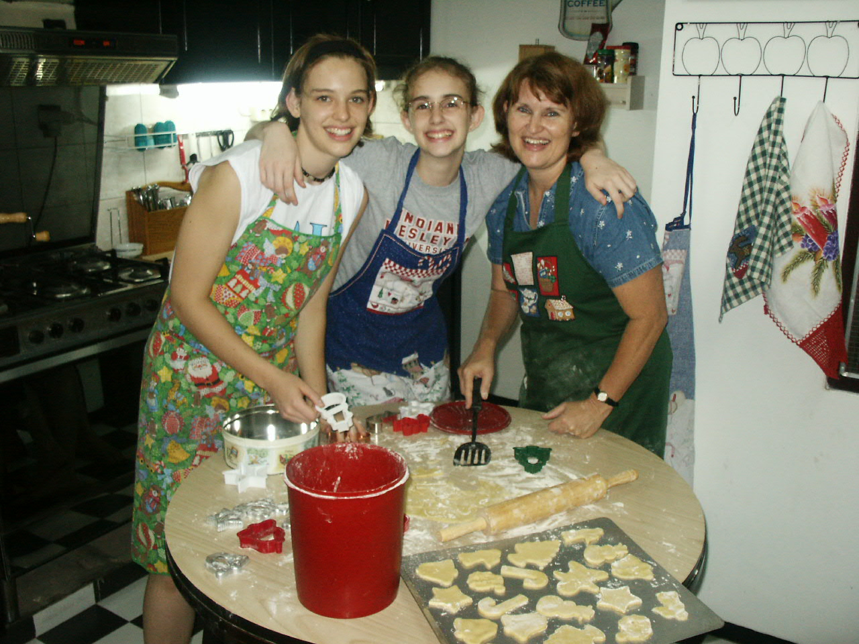

A family meal

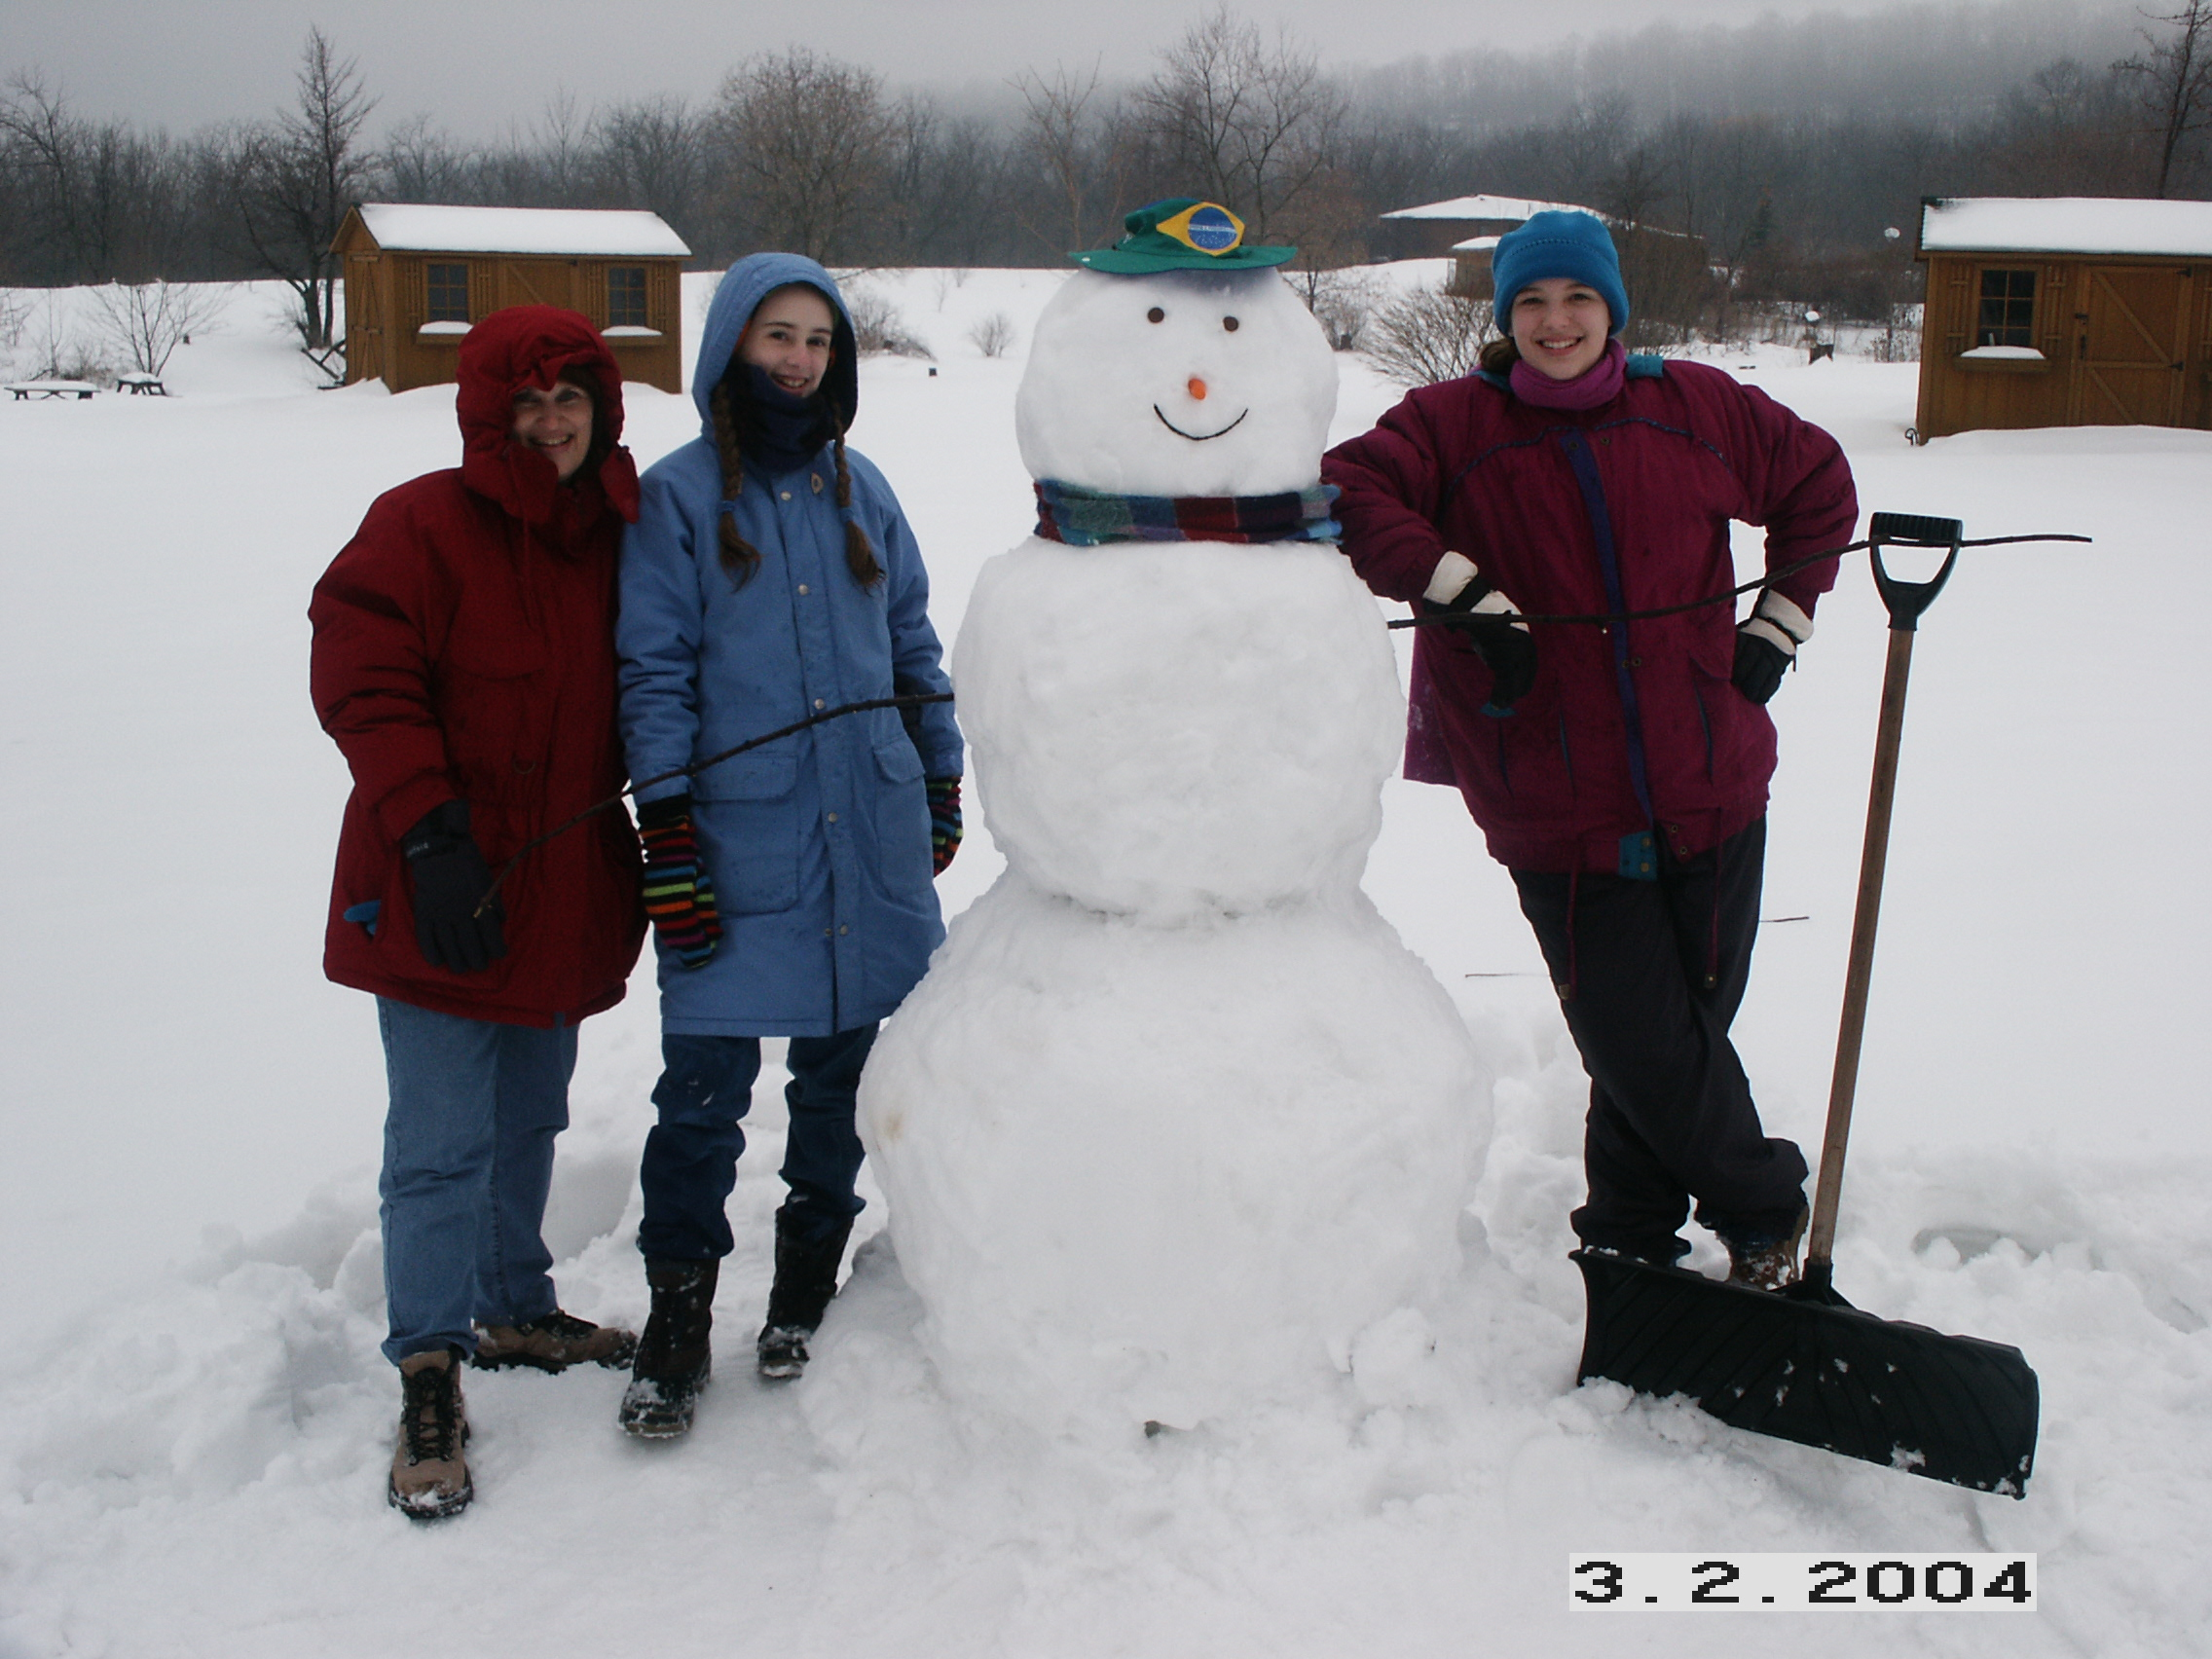
Cooking together

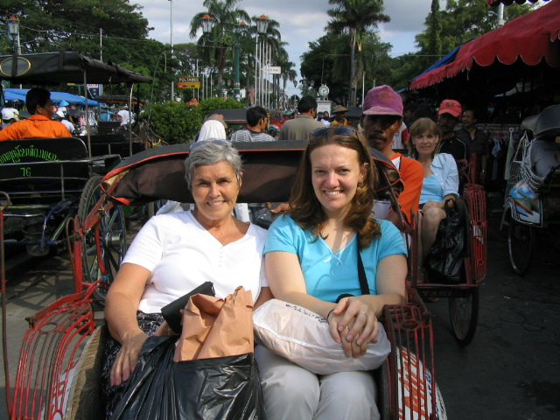
Having fun together

Shopping together!

A Family Meal!

Read about a family meal. Circle the correct verb.
In my family, we enjoy / enjoys getting together for a big dinner! My mom like / likes to cook for everyone. We sit / sits around a big table. Before we eat, everyone sing / sings, and then my Dad pray / prays. We eat / eats all the good food, and then sometimes we play / plays a game together. We all love / loves each other, and everyone have / has a good time at our family meals!

Now it is your turn! Answer the questions with complete sentences.
What do you enjoy doing in your family?
__________________________________________________________________________________________________________________________
What activities do you do?
__________________________________________________________________________________________________________________________
_____________________________________________________________
Who does something special?
__________________________________________________________________________________________________________________________
How do you feel?
__________________________________________________________________________________________________________________________

