2. A Family Event

- I can show pictures of a family event and explain their meaning.
- I can look at a classmate’s pictures and ask questions.
- Show sample pictures of special family events (yours, or the pictures provided). Have students bring in pictures of weddings, new babies, graduations, etc.
- Teach students the relevant words, such as “birthday party”, “wedding” and “graduation”.
- Use the work sheet “A Wedding”, or a similar worksheet about a family activity of yours. In this worksheet, students first create the questions to ask, perhaps working in pairs. Then they ask the questions (about the wedding) and write in the teacher’s responses. Respond in complete but simple sentences, such as “Jenna married Brendan.” And “They got married in Indiana.”
- Have students complete the paragraph at the bottom of the page, using the words in the box.
- Brainstorm together questions that students can ask each other about the pictures of family events that they have brought in. Questions might include:
  - What is this? (What was the event?)
  - When did it happen?
  - Who was there?
  - What did you do?
- Have students work in pairs to ask and answer questions about their family events.
- Have students ask each other questions about their pictures. For example:
Who is this?
When was this?
How old were you?

- I can tell about a family event and answer questions.
- I can understand an event described by someone else, and ask questions.
- Have students go to the front of the class one at a time to tell about their event.
- Require each student to ask at least one question of one of the presenters. Have the speaker answer the questions.
  - Questions might include: Where did you go? Who went? Do you go every year? What did you wear?

- I can write a paragraph about a past event.
- I can read about someone else’s past event, and write follow-up questions.
- Have students choose another event in their lives, preferably involving family. Here are some examples: A mother going back to work after staying home with the kids; an illness in the family; teaching a child to do something; a move
- Students write the paragraph for homework, teacher checks, and students re-write.
- Exchange paragraphs. After reading the paragraph, students write 3 questions for the author of the paragraph, and return it. The author reads the questions, answering orally.
- NOTE: If students are lower in level, you may want to have them write about the same event that they have already now practiced speaking about twice – in pairs, and then in the front of the class.

Project: Collect paragraphs and accompanying pictures from each student, and create a class booklet or poster.

Special Family Events

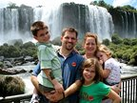

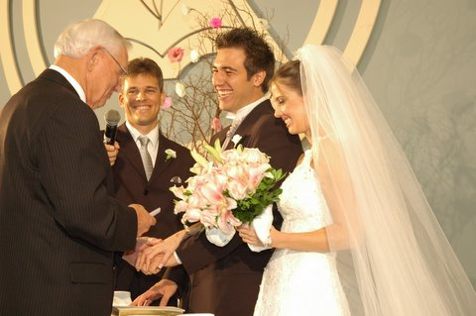
A family vacation

A wedding!
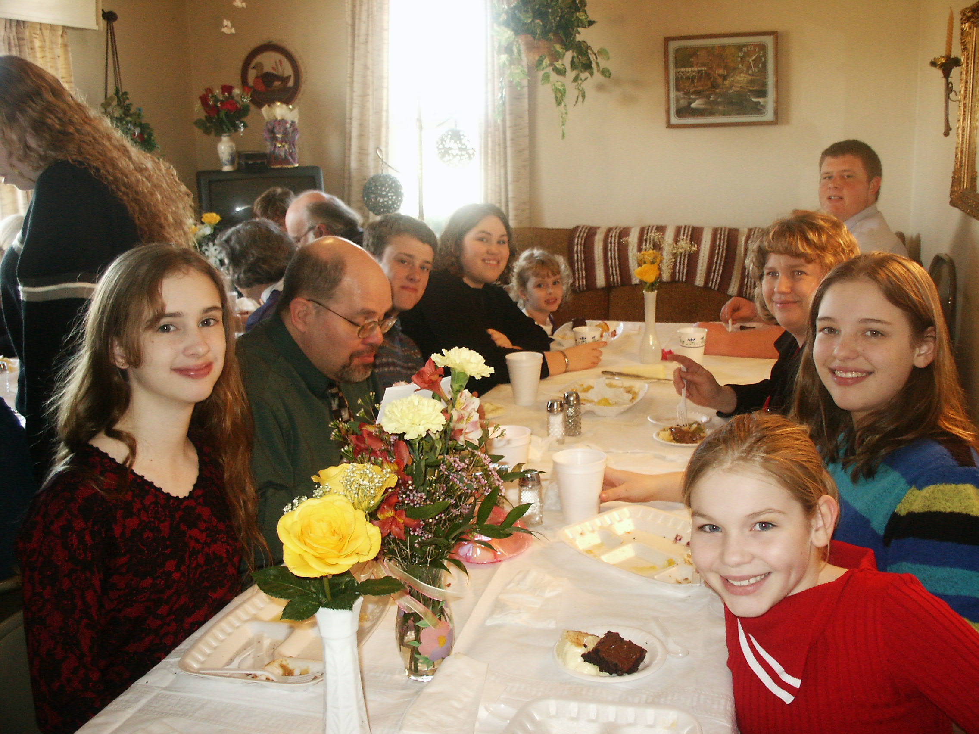
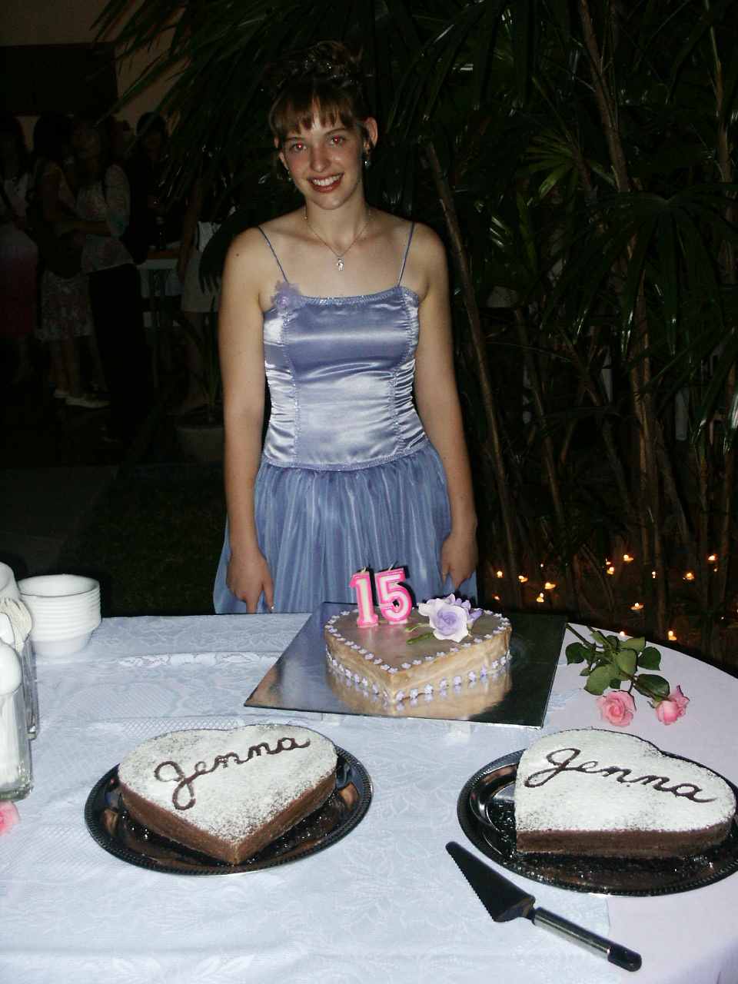

A family reunion

A birthday party

A Wedding!
My daughter Jenna got married!
Who / marry / she / did
Q: _______________________________________________________?
A: ________________________________________________________

Where / get / they / married / did
Q: _______________________________________________________?
A: ________________________________________________________

When / they / married / did / get
Q: _______________________________________________________?
A: ________________________________________________________
Tell / about / me / wedding / the
food
song
reception
God
winter
aisle
danced
presents
ceremony
cake

_____________________________________________________!
It was _____________. The _________________ was beautiful! My husband walked Jenna down the _______________. My nephew and his wife sang a _____________. Jenna and Brendan committed their lives to each other and to ____________.
The __________________ was fun! Jenna and Brendan _____________. We had good ___________ and a beautiful __________. They received many ________________.

