- Days and Months

DAYS OF THE WEEK OR MONTHS

1. What day is it?
Ask one student to write down a day of the week or month. The other students have to write down which day they think it is and ask: Is it Monday? They ask the questions until they get the right answer.

2. When is your birthday?
Write the first letters of the months on the board on a chart like this:

NAME | J | F | M | A | M | J | J | A | S | O | N | D
Carol |  |  | x
Paul | x

Interview a couple of students yourself asking: When is your birthday? Fill in the chart as you go. Students draw their own charts and interview each other around the room.
Notes:
- You can use this activity with other topics such as: favorite food, favorite color, etc.
- You can use this activity many times by asking the birthdates of family members. For example, “When is your mother’s birthday?” “When is your sister’s birthday?”

3. Daily Routine
Get into the habit of beginning each class by asking a student to give the complete date: Ex: “Today is Monday, February fifteenth, two thousand seven.”

4. Grouping
To vary groups or seating, have students first stand according to their birthdates. Then, students sit or work with those they are standing beside.

SONGS
- The Days of the Week
- When Is a Good Day to Praise the Lord
- The Month Song

GAMES / ACTIVITIES
- Sentence Scramble (practices dates and prepositions). Create sentences such as the following:
Sarah was born in October, on the fifth, in 1982.
Jimmy was born on November 3rd, in 1965.
Luke’s birthday party was at 3:00 on Saturday.
Lucy turned fifteen in May, on the twenty-ninth.
- Bingo: provide 25 dates for students to fill in on Bingo forms. Call out the dates, as students check them off.

WORKSHEETS
- Days and months

DAYS AND MONTHS

A. Complete the missing letters for the days of the week:

1. M__N D__Y 2. __U E__D__Y 3. W__D N__S D A__

4. T__U__S__A Y 5. F__I__A Y 6. S__T U__D__Y

7. S__N D A__

B. Unscramble the word to write the months:

1. NRUAYJA = ________________ 7. ERCTOOB = ________________

2. ARMCH = __________________ 8. ECEDMBRE = ______________

3. YAM = _____________________ 9. YLUJ = ____________________

4. BFEUAYRR = _______________ 10. PILRA = ___________________

5. JNUE = ____________________ 11. SUGUAT = _________________

6. ESPEMRBET = ______________ 12. BNVEOERM = ______________

C. Interview your friends:

“When is your birthday?” “It's in July.”
NAME | January | February | March | April | May | June | July | August | September | October | November | December

D: Complete the missing months or days of the week:

Months: January, __________, March, ________, May, June, ________, August, ______________, October, ___________, December.

Days: _____________, Tuesday, _______________,Thursday, _____________, Saturday, ______________.

E.  Find the months and the days of the week in the word search:

J | A | N | U | A | R | Y | C | F | V | A | J | D | A | I | F | R | I | G | O
V | C | E | W | E | D | A | S | D | F | U | U | Y | T | R | B | C | M | U | S
N | H | J | A | N | U | T | D | D | B | A | L | E | I | Z | C | O | P | I | R
B | V | V | F | R | O | F | R | I | D | A | Y | B | E | R | O | C | T | O | B
M | A | S | E | T | U | E | D | A | S | V | B | T | B | Y | U | T | A | M | P
Z | J | U | N | U | A | W | E | D | N | E | S | D | A | Y | A | O | R | U | Q
I | J | U | N | E | P | F | R | I | D | E | S | T | E | E | N | B | M | Y | U
V | B | R | A | S | E | I | O | N | O | V | E | M | B | E | R | E | A | F | E
A | I | D | Y | D | A | Y | N | O | V | E | M | S | U | N | D | R | A | E | M
A | M | I | E | A | N | M | A | R | C | H | S | S | D | S | N | P | I | B | S
S | S | E | K | Y | A | O | A | Y | A | S | E | U | S | A | A | H | T | R | U
X | E | S | B | A | E | N | V | A | Y | S | B | K | K | T | L | Y | G | U | S
C | P | D | R | C | S | D | C | D | S | T | N | O | V | U | H | A | D | A | Y
D | T | C | E | E | A | A | X | F | T | R | V | D | L | R | G | C | V | R | A
E | E | V | B | F | T | Y | J | R | S | H | N | J | E | D | S | M | A | Y | D
I | M | C | M | R | A | P | R | I | L | U | U | G | T | A | U | T | R | A | S
R | B | V | E | I | R | A | O | S | S | S | F | R | S | Y | N | P | T | P | R
F | E | C | C | T | F | S | U | N | D | A | Y | F | A | Y | D | S | F | I | U
T | R | V | E | U | R | S | I | B | S | D | C | D | M | H | I | V | O | P | H
J | B | T | D | E | I | A | Y | Y | A | A | U | G | U | S | T | S | D | K | T

F: Tell about yourself.

I was born on ________________ _____, __________.
(month) (date) (year)

I was born on a ______________________.
(day of the week)
- Food

FOOD

1. Do you have…
Give a food picture to each student. Tell them they cannot show it to anyone. They have to ask each other: Do you have a …………….? If their guess is correct they win that card. At the end the student with most cards is the winner.

2. Food Groups
Divide the food in groups such as: dairy, meat, fruit, vegetable, grains and dessert. Call out a word and students say which group it belongs. Call out a group and students give you examples of that group.
Note: If you have space in your class, ask students to bring magazine pictures of food and make beautiful posters to decorate the classroom.

3. Pictionary
Students sit in groups of four. Within each group they take turns playing the part of the ‘messenger’. Each messenger has to come to you, and you whisper to them the name of a food: T: apple. etc. The messenger runs to his group and draws the food you have named, showing it to the other students as he does so. The members of the group guess what food it is. The messenger is only allowed to communicate by drawing. When they have guessed correctly, the group sends the next messenger. The group which is first to guess all the foods you have named wins the game.
Note: The game only works properly if students draw quickly.

4. What’s missing?
Put food cards up on the board one at a time. As you do so say each word aloud, and tell the students to repeat. Mix the cards and take one out. Ask: What’s missing? The student who knows gets the card. At the end the student with most cards is the winner.
Note: You can practice any vocabulary you want with this activity.

5. Mime
Mime eating a certain food. Students guess what each item is.
T: What am I eating?
S1: apple?
T: No.
S2: orange?
T: Yes.
6. Food Categories
Write the following categories on the board: dairy, meat, fruit, vegetable, grains, and dessert. Write an example under each category, and then ask the students to name other examples. Add these words to the lists on the board. Then throw a soft ball (or another soft object) to a student and name one of the four categories for example:
T: Dairy.
The student says a word from that category, for example milk, and throws the ball as quickly as possible back to you, and the game continues.
Note: This game is more demanding if the list of categories is erased from the board.

SONGS
- We Thank You
- I Like Bananas
- Peanut Butter
- Pop Goes the Popcorn

GAMES / ACTIVITIES
- Bingo: food and pictures (or real food)
- Matching: picture and word
- Letter Scramble making various food words

WORKSHEETS
- A Survey on Food Preferences. This could be changed many times using different foods.

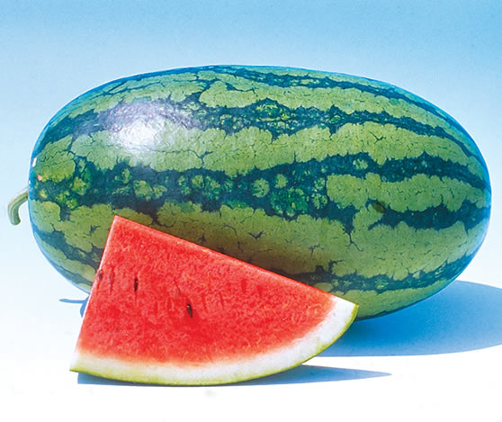
Fruits

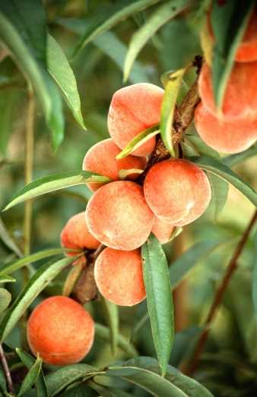
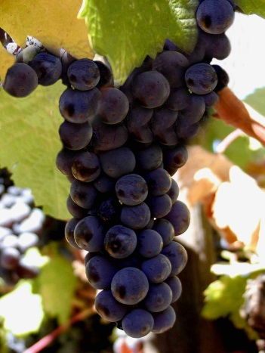
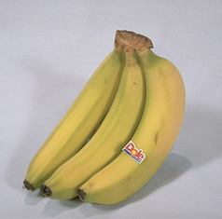

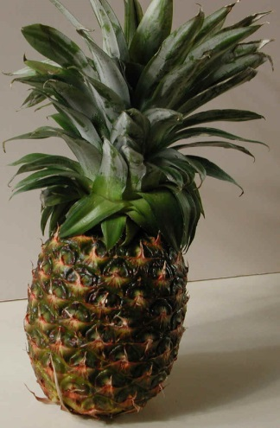
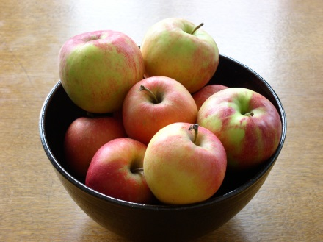
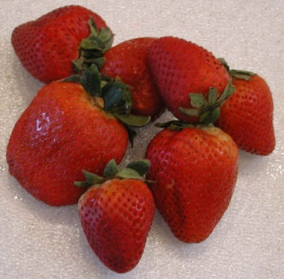

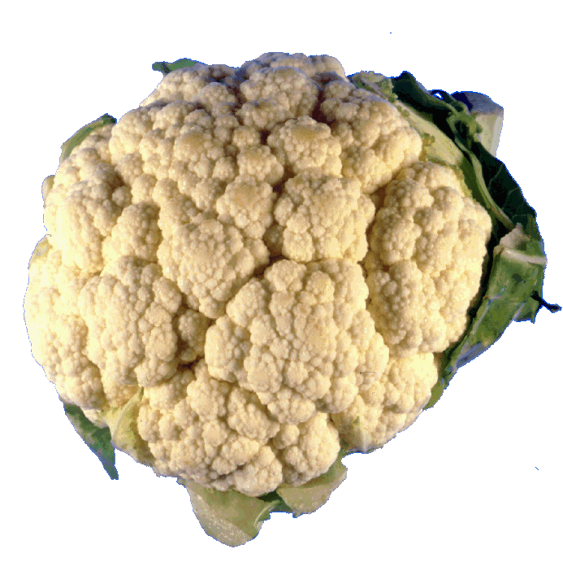
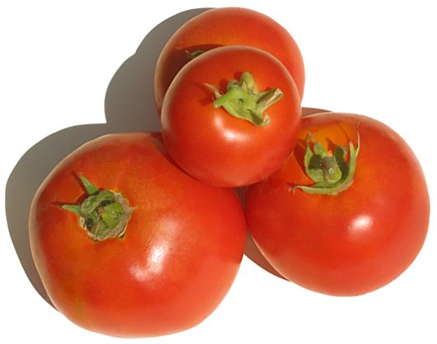
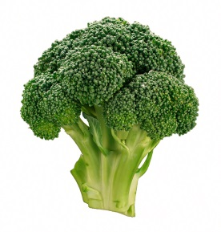
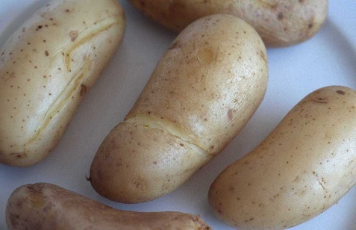
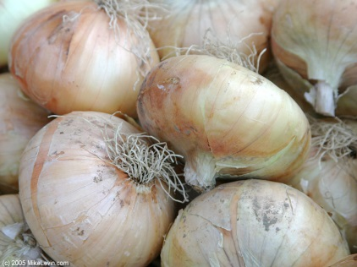
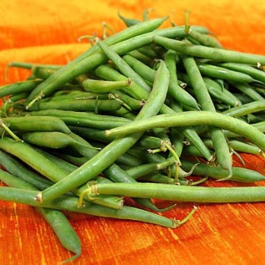
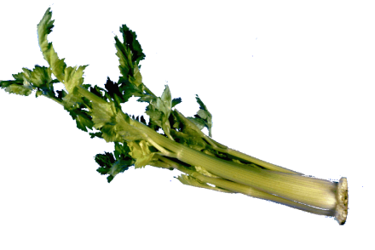
Vegetables
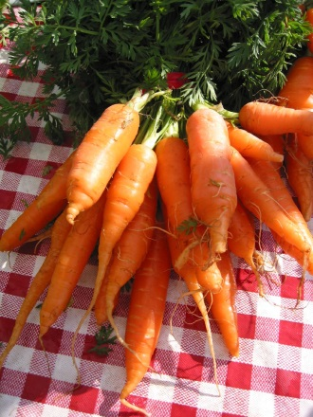

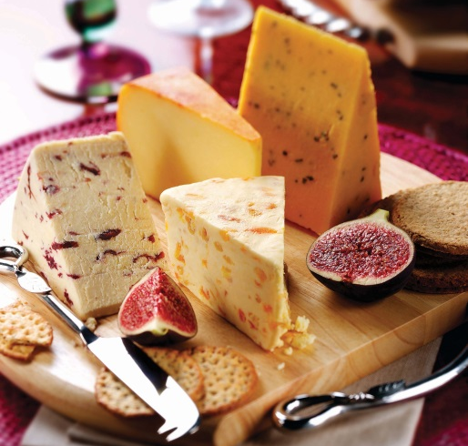
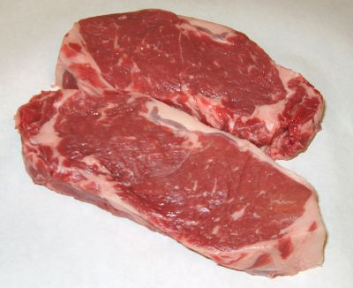
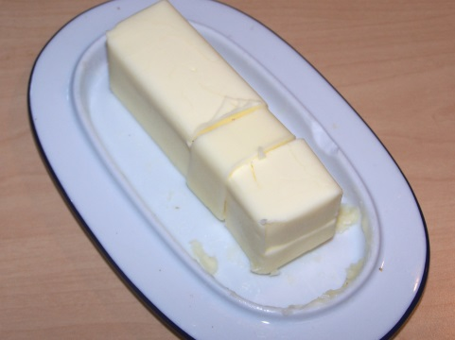
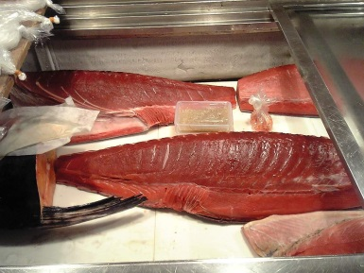
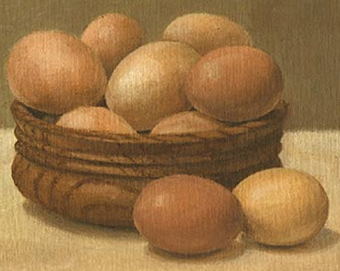
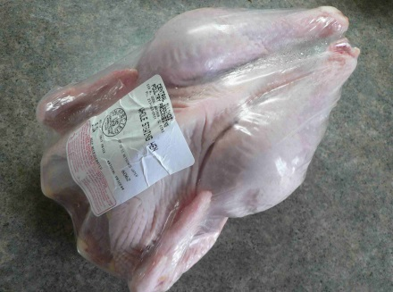
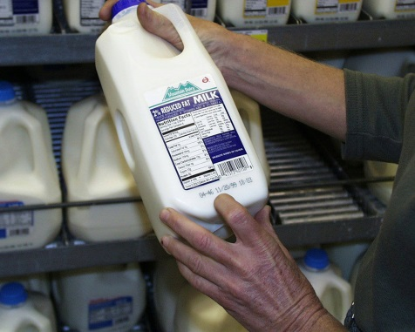
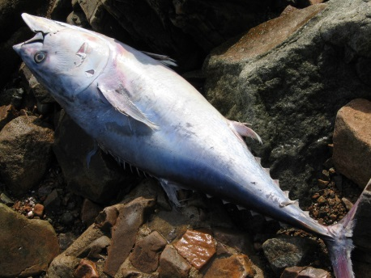
Other Foods

A Survey On Food Preferences

Ask your friends!

Ask: Do you like ____________?
Answer: Yes, I do.
No, I don’t.

Name of Friend | eggs | milk | bread | coffee | rice | potatoes

