Unit 1
Content: face, body, introductions, greetings

My Face

Match:

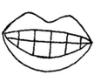
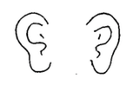
hair

eyes

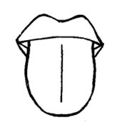
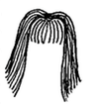
nose

ears

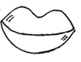
mouth

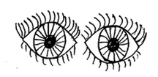
teeth
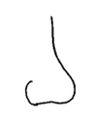

tongue

Write:

1. __ a __ r 5. m __ u __ h

2. e y __ s 6. __ e e __ __

3. n __ __ e 7. t __ n g __ __

4. e __ r s

Color and Write!

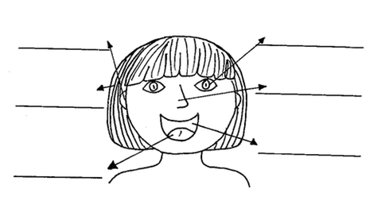

Introductions

Choose a word:

is name meet too

Teacher: What’s your ______________?

Student: My name is _______________.
(your name)

Teacher: Nice to _______________ meet you.

Student: Nice to meet you ______________.

Read:
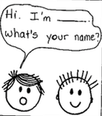 | 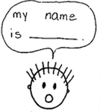 | 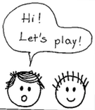

Write:

You: Hi. I’m ____________. What’s ________ name?
(your name)

Friend: My name _______ _____________.
(friend’s name)

You: _____! Let’s play!
My Body

Choose a word:

stomach arms hands

fingers heart shoulders

back head knees

foot toes legs

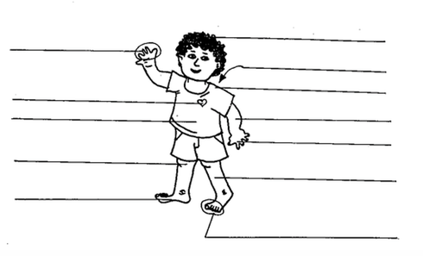

Greetings

Read:
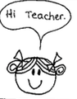 | 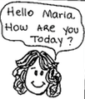 | 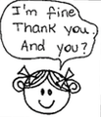 | 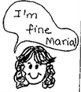

Write:

Maria: Hi ______________.

Teacher: __________ Maria. How _______ you today?

Maria: I’m _________ thank you. And _________?

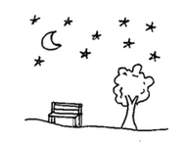
Teacher: _______ fine Maria!

Match!
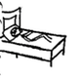
Good morning


Good afternoon

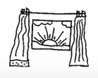
Good evening
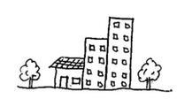

Good night

Sing!

Head and Shoulders

Head and shoulders knees and toes, knees and toes

Head and shoulders knees and toes, knees and toes

Eyes and ears and mouth and nose

Head and shoulders knees and toes, knees and toes

Hokey Pokey

You put your right hand in, you put your right hand out

You put your right hand in and you shake it all about

You do the hokey pokey and you turn yourself around

That’s what it’s all about!

- left hand
- right foot
- left foot
- back side
- head
- whole self

