Unit 2
Content: family, colors, polite phrases

My Family

Copy:

mom __ __ __ sister __ __ __ __ __ __

dad __ __ __ brother __ __ __ __ __ __ __

baby __ __ __ __ parents __ __ __ __ __ __ __

Draw and label YOUR family:

Match:

mom grandmother

dad mother

grandma grandfather

grandpa father
Review Greetings

Choose a word:

your My to Nice

Teacher: What’s ______________ name?

Student: ________ name is _______________.
(your name)

Teacher: Nice ______ meet you.

Student: ___________ to meet you too.

Meet a new friend! Draw a picture. Write what you say:

Colors

Color:

pink

red

orange

grey

green

yellow

purple

brown

blue

black

white

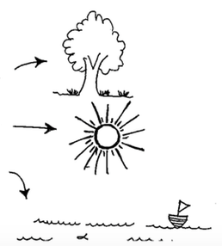

What colors are these things?

___________________________

___________________________

___________________________

Politeness

Read:

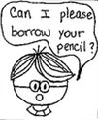 | 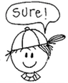 | 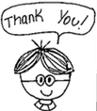 | 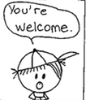

Write:

John: Can I ______________borrow your pencil?

Mark: Sure!

John: Thank ________.

Mark: You’re _______________.

Color these important words:

Please
Thank you!

Read:
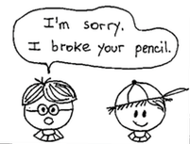 | 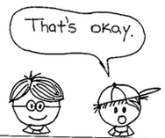

Write:

John: I’m ______________. I broke your pencil.

Mark: That’s ______________.

Remember: Say these polite words:

P __ E __ S E

__ H A __ K __ O __

Y __U’__ __ __ E L __ __ M __

I’__ S __ R R __

T __ __ T’S O __ A __
Sing!

It’s About Love

Love, love, love, that’s what it’s all about

‘Cause God loves us, we love each other

Mother, father, sister, brother, everybody sing and SHOUT!

‘Cause that’s what it’s all about, it’s about love, love, love

Rainbow

First Part:
Yellow and orange and red and green, purple and blue

Rainbow, rainbow

Second Part:
God made a rainbow in the sky

Beautiful, colorful, rainbow, rainbow

We Thank You

We thank you, thank you, thank you for the good, good food (4x)

We thank you… for the good, good food!

Second Part:
We thank you, we thank you, we thank you for the food

With fellowship and harmony we thank you!

