Unit 3
Content: numbers, letters, personal information

Numbers

Match:

0 ten

1 three

2 five

3 zero

4 nine

5 eight

6 one

7 four

8 seven

9 two

10 six

Review
Write the polite words:

1. May I _____________ get a drink of water?

2. ___________ ________ for the present!

3. You’re ___________________.

Letters

Match letters and beginning sounds:
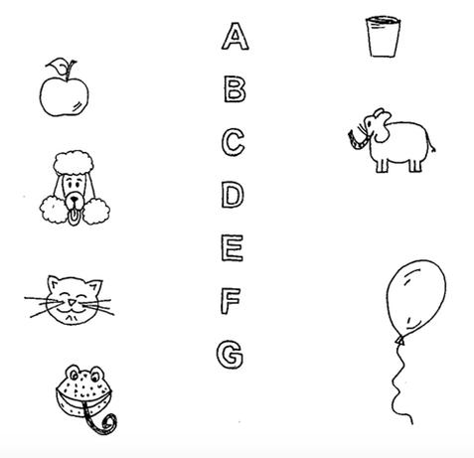
Numbers

Match:

11 thirteen

12 sixteen

13 eleven

14 nineteen

15 fifteen

16 twelve

17 fourteen

18 twenty

19 seventeen

20 eighteen

Match letters and beginning sounds:

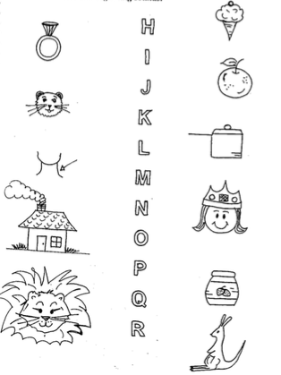
Personal Information

Read:
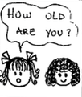 | 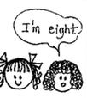 | 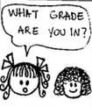 | 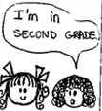

Write:

Lucy: How ___________ are you?

Sarah: ________ eight.

Lucy: What ____________ are you in?

Sarah: I’m _______ second grade.

Write about YOU!

I’m ________________.
(your age)

I’m in _________________ grade.
(your grade)

Match letters and beginning sounds:

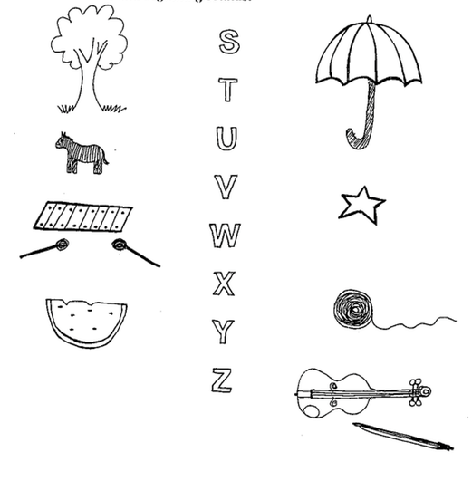

Sing!

The ABC Song

A B C D E F G, H I J K L M N O P, Q R S, T U V, W, X, Y and Z

These are the letters of the alphabet.

Sing it again, so you won’t forget.

1-2-3 Jesus Loves Me

One, two three, Jesus loves me.

One, two, Jesus loves you.

Three and four, He loves me more

More than I’ve ever been loved before

Five, six, seven, I’m going to heaven

Eight, nine, ‘cause Jesus is mine.

Now we’ve sung right up to ten

And we have time to sing it again! So…

Last time: We don’t have time to sing it again! But…

One, two, three, Jesus loves me

One, two, Jesus loves you!

