Unit 4
Content: weather, clothing, partings

Weather

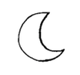
Match:

sun

moon

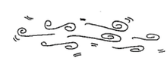
wind
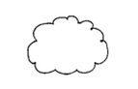

rain

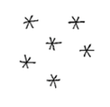
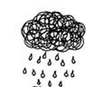
snow

cloud

Choose a word:

hot wet cold
1. The sun is _______________.

2. Snow is ________________.

3. Rain is ________________.
Review Personal Information

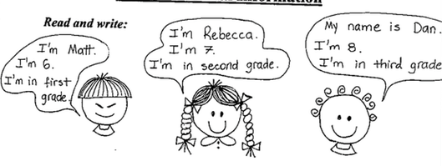
Read and write:

1. Matt is ___________. He’s in ____________ ___________.

2. Dan is ___________. He’s _______ third _____________.

3. Rebecca is __________. She’s in ___________ _________.

Clothing

Label:

hat shirt pants shoes
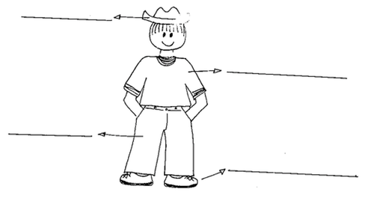

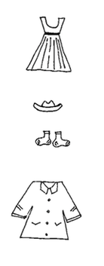
Match:
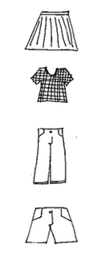

skirt

dress

hat

jeans

shorts

socks

coat

shirt

Complete:

1. I am wearing ______________________________________

_________________________________________________.

2. _________ is wearing _______________________________
(friend’s name)

_________________________________________________.

3. _________ is wearing _______________________________
(friend’s name)

_________________________________________________.
Partings

Read:
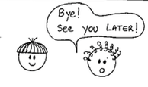 | 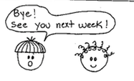

Write:

Luke: Bye! ________ you later!

Tom: ________! See you ________ week!

Color as your teacher says:
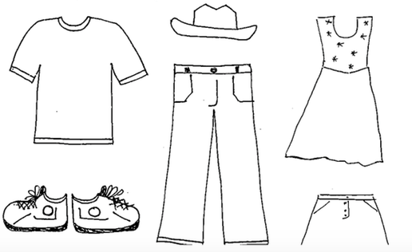

Sing!

Crazy Clothes

Crazy clothes, I love wearing crazy clothes

From my head, to my toes, I love crazy clothes!

Pink and purple polka dots on my hat

Brown and orange stripes on my pants

My shirt is blue with red and yellow flowers

And my socks are one red, one green, one blue

Got a silk blouse that’s lacy and sweet

Goes with the flip-flops on my feet

Socks with the flip-flops, sweat pants too

What a great outfit, Whoop-de-doo!

All Weather Friend

Why should I care if the sun doesn’t shine

Jesus is mine, all of the time

Why should I care if it’s cloudy and grey

Jesus is with me always

If it’s rainy, snowy, cold and dark

I still have God’s love in my heart…

