Unit 6
Content: animals, days of the week, questions, requests

Animals

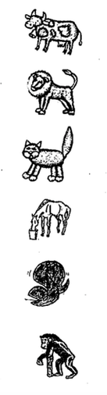
Match:
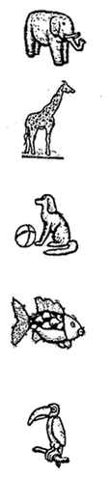
dog

cat

cow

horse

bird

fish

lion

monkey

elephant

giraffe

snake
Match:

1. A snake likes bananas

2. An elephant can fly

3. A monkey is very big

4. A bird says “meow”

5. A cat doesn’t have legs

Write!

My favorite animals are _________________________________.

My friend’s favorite animals are ___________________________.

Days of the Week

Put in order:

Tuesday, Sunday, Monday, Wednesday, Friday, Saturday, Thursday

1. _____________________
2. _____________________
3. _____________________
4. _____________________
5. _____________________
6. _____________________
7. _____________________
Questions

Unscramble the words. Write questions:

1. you – Are – happy ? ________________________________

2. Are – thirsty – you ? ________________________________

3. hungry – you – Are ? _______________________________

4. ready to go – you – Are ? ____________________________

Ask your friend!

Copy the question | Circle your friend’s answer
1. | Yes, I am.  No, I’m not.
2. | Yes, I am.  No, I’m not.
3. | Yes, I am.  No, I’m not.
4. | Yes, I am.  No, I’m not.

Answer:

Are you a girl? ____________________________.

Are you a boy? ____________________________.

Are you a teacher? __________________________.

Are you a student? __________________________.
Guessing Game!

In groups: One person thinks of a color. The others guess.
Write your guesses. Fill in the missing words. Circle the answer.

1. Is it _______________? Yes, it is. / No, it’s not.
(color)
2. ______ it _______________? Yes, it is. / No, it’s not.
(color)
3. Is _____ _______________? Yes, it is. / No, it’s not.
(color)
4. _____ ____ ____________? Yes, it is. / No, it’s not.
(color)

Requests

Unscramble these requests:

1. please / May / I / in / come / ?

_____________________________________________________________

2. don’t / Please / that / do

_____________________________________________________________

3. Could you please / the light / turn on / ?

_____________________________________________________________

4. May / drink water / I / ?

_____________________________________________________________

5. May I / borrow / eraser / your ?

_____________________________________________________________
Sing!

Noah’s Animals

The animals went into the ark (3X)
And then God closed the door

The dog (bow wow) and the monkey, the cat (meow) and the bear
The cow (moo) and the elephant, and then the lion (ROAR!)
The horse (neigh) and the rabbit

The bird (tweet tweet) and the snake
The pig (oink) and the kangaroo, and then the lion (ROAR!)
When Is a Good Day?

When is a good day to praise the Lord? (2x)

Oh…. Monday is a good day

Tuesday is a good day

Wednesday is a good day too

Oh…. Thursday is a good day

Friday is a good day

Saturday and Sunday too!

