Unit 8
Content: food, preferences, agreement

Food

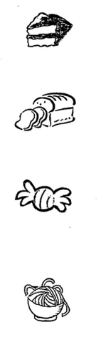
Match:
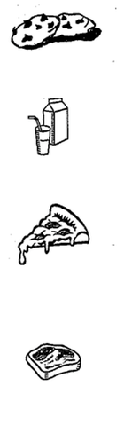
pizza

candy

cake

meat

bread

milk

spaghetti

cookies

Fruits and Vegetables

Label the pictures using these words:

apple banana orange pineapple

strawberry watermelon tomato green beans

corn potatoes peas lettuce carrots

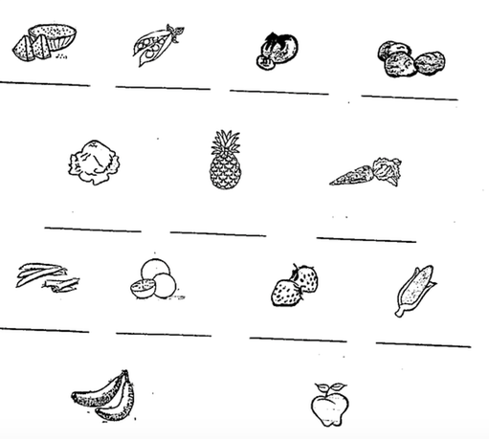

Preferences

Write complete sentences. Give your preferences:

I like… | I don’t like…

Share:
1. ____________________ likes ________________________.
(friend’s name) (food)

2. ____________________ likes ________________________.
(friend’s name) (food)

3. ____________________ doesn’t like __________________.
(friend’s name) (food)

4. ____________________ doesn’t like __________________.
(friend’s name) (food)

Read:
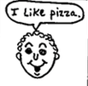 | 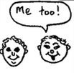 | 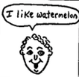 | 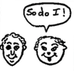
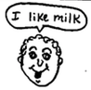 | 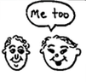 | 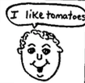 | 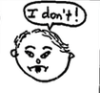

Write:

Matt: I ___________ pizza.

Robert: ________ too!

Matt: ______ like watermelon.

Robert: So __________ I!

Matt: ______ ___________ milk.

Robert: Me __________!

Matt: I __________ tomatoes.

Robert: I ____________!

Write:

1. Yesterday I ate: ____________________________________

______________________________________________________

______________________________________________________

______________________________________________________

2. Yesterday my friend ate: _____________________________

______________________________________________________

______________________________________________________

______________________________________________________

Circle the things used to make COOKIES:

SUGAR PIZZA

RICE EGGS FLOUR

BUTTER MEAT

SPAGHETTI CHOCOLATE

Sing!

I Like Bananas

I like bananas, and mangoes are sweet
I like papaya, but nothing can beat
The sweet love of God (sweet, sweet, sweet, sweet love of God)

Peanut Butter (“em” = “them”)

Peanut, peanut butter (JELLY!) Peanut, peanut butter (JELLY!)

First you take the peanuts and you dig em, you dig em,
You dig em, dig em dig em
Then you crush em, you crush em, you crush em, crush em, crush em,
Then you spread em, you spread em, you spread em, spread em, spread em

Peanut, peanut butter (JELLY!) Peanut, peanut butter (JELLY!)

Next you take the berries and you pick em, you pick em,
Then you crush em, you crush em, you crush em, crush em, crush em,
Then you spread em, you spread em, you spread em, spread em, spread em

Peanut, peanut butter (JELLY!) Peanut, peanut butter (JELLY!)

Next you take the sandwich and you bite it, you bite it, you bite it bite it bite it
Then you chew it, you chew it, You chew it, chew it, chew it,
Then you swallow, you swallow, You swallow, swallow, swallow

Peanut, peanut butter (JELLY!) Peanut, peanut butter (JELLY!)
Mmmmm good!

