Unit 10
Content: kitchen, prepositions, review

Kitchen

Match:

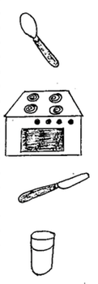
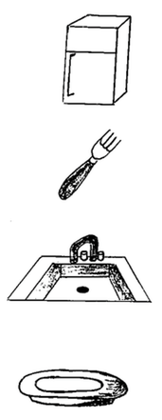
stove

sink

refrigerator

plate

knife

fork

spoon

glass

Circle what you eat with:

fork stove pencil
plate spoon

refrigerator book knife

Connect the nouns with the adjectives:

1. Stove wet

2. Refrigerator hot

3. Knife sharp

4. Sink cold

Set the table! Cut out the table things on the next page.
Glue them here correctly:

Table Things
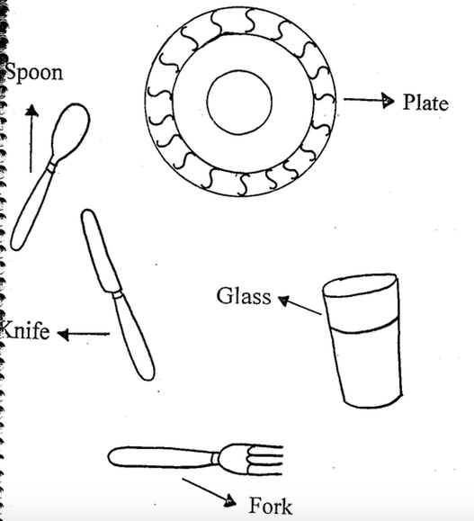

Read:

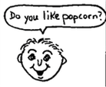 | 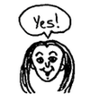 | 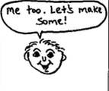
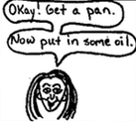 | 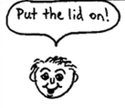 | 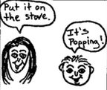

Write:

Jeremy: Do you __________ popcorn?

Emily: Yes!

Jeremy: Me ________. Let’s make some!

Emily: Okay! Get a ____________.

Now _________ in some oil.

Jeremy: Put the __________ on!

Emily: Put it on the _______________.

Jeremy: It’s popping!

Prepositions

Where are the mice?
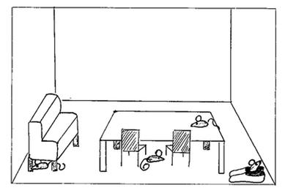

Fill in the sentences with these words:

under on in between

1. _____________ the sofa

2. _____________ the two chairs

3. _____________ the shoe

4. _____________ the table

Fill in the sentences with these words:

on with at above

1. Clouds are ____________ the earth.

2. I like to be ____________ my friends.

3. I am ___________ school.

4. My birthday is _________ ______________________.
(month and day)

Review

Fill in the blanks:

1. Today is ___________________.
(day of the week)

2. This month is _______________________.

3. Today’s date is __________________________.
(write the number in words)

4. Today is _____________________________.
(describe the weather)

5. In my classroom I see: ______________________________

_________________________________________________

_________________________________________________
Sing!

Pop Goes the Popcorn!

Put the popcorn in the pot

Put the lid on tight

Put it on the stove and wait…

POP goes the popcorn!

Pop, pop, pop, pop, POP goes the popcorn! (2 x)

God is Watching Over Me

Watching, watching, watching, watching…

God is watching over me, God is watching over me

Wherever I go, whatever I do

God is watching over me

- When I’m in school
- When I’m at church
- When I’m on a bus
- When I’m in a car
- When I’m in a space ship headed for Mars!

