Unit 1: God Made the World
Lesson 3: The Story of a Tree
Teacher’s Guide

Introductory Activities

1. Show a large picture of a tree. Point out the words: trunk, branch, leaf. Have students point to the parts of the tree as you say them. Use the plural forms orally, making sentences:
- This is a branch. These are branches.
- This is a leaf. These are leaves.

2. Write the word “maple” on the board. Explain that this is a kind of tree that grows in North American. Explain that it is the national tree of Canada. Find Canada on a map or globe. Ask questions:
- Have you ever met anyone from Canada?
- What language do they speak there?
- Have you ever seen the Canadian flag? What colors is it?
- What’s the weather like in Canada?

Worksheets Follow general guidelines

Expansion Activities

1. Take children outside to look at a real tree. Have them name the parts of the tree. Ask questions:
- Does this tree have sap? (Yes)
- Can we make syrup from the sap? (No, because it’s not a maple tree)

2. Have children collect leaves to make leaf rubbings:
- Place a leaf upside down under a piece of white paper.
- Rub a crayon on the paper, over the leaf, so that the outline of the leaf appears.
- Do the activity in red, yellow and orange, and make a collage of FALL LEAVES!

3. Have children work in groups to create “SEASON COLLAGES”. Divide a piece of poster board into four sections. Students label each section with a season. Let students look through magazines for pictures illustrating each season. As children glue on seasonal pictures, talk with them in English about the weather and their pictures.

4. Do drama presentations of the maple tree. Children can work in groups, with one child acting the part of the tree, another collecting the sap, another boiling the sap for syrup, and another eating the pancakes!

5. Using the recipe provided, make Canadian pancakes and syrup! Say the prayer in section “H” together before you eat!

6. Have children make CANADA POSTERS. Some ideas for the poster are: Canadian flag, maple tree, snow, pancakes.
Unit 1: God Made the World
Lesson 3: The Story of a Tree

LESSON WORDS: maple, trunk, branch, leaf, spring, sap, bucket, syrup,
pancakes

A. ☺ Read!

Hi! My name is Susan! | 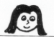
I live in Canada. | 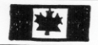
Our national tree is the maple tree. | 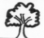
It has a trunk, branches and leaves. | 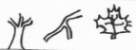
In the spring, we collect the sap in a bucket. | 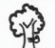
We boil the sap. It becomes a syrup. | 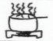
We eat maple syrup on our pancakes. | 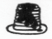
It’s delicious! | 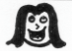

B. ☺☺☺ Find a word that is…

hot: _____________ tall: _____________ liquid: ______________
green: ___________ good: ____________ brown: _____________
C. ☺☺☺ I can tell the story with the pictures!

D. ☺ Where do the seasons belong?

spring fall winter summer

___________  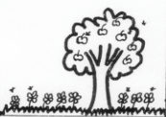 | ___________  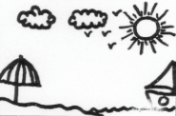
___________  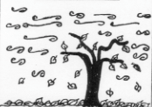 | ____________  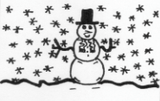

E. ☺☺ Write a season:

1. In _____________, trees are very green.

2. Leaves fall in the _____________.

3. In ______________, leaves are small and new.

4. Branches have NO leaves in _____________.

F. ☺ One or more than one?

ONE | Draw ONE | Write more than one | Draw more than one
tree |  | tree_
branch |  | branch_ _
leaf |  | lea_ _ _
pancake |  | pancake_

G. ☺ COLOR!
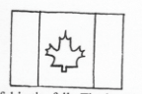

The Canadian flag has a red maple leaf. It also has

red on the outside.
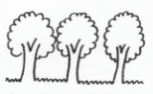

Maple trees are beautiful in the fall. The leaves

are red, orange, and yellow.

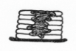
Pancakes are light brown, and syrup is dark brown.

H. Let’s thank God!

“Dear God, thank you for making the maple tree. Thank you for pancakes and syrup. In Jesus’ name, Amen.”
COOKING FUN!

CANADIAN PANCAKES

Ingredients

1 egg
1 cup flour
¾ cup milk
1 tablespoon sugar
2 tablespoons oil
3 teaspoons baking powder
½ teaspoon salt

Method

Beat egg with whisk. Add remaining ingredients. Heat skillet over medium flame. Melt 1 tablespoon butter in skillet. For each pancake, pour about ¼ cup batter onto skillet. Cook until bubbles on top begin to break. Turn over. Cook until brown. Top with butter and syrup.

PANCAKE SYRUP

Ingredients

½ cup white sugar
½ cup brown sugar
½ cup water
1 tablespoon corn starch mixed with 1 tablespoon water
½ teaspoon maple flavoring*

Method

Cook water and sugars until boiling. Add corn starch mixture. Stir until thick. Add maple flavoring.

*Maple flavoring makes this recipe taste like real maple syrup! Maple flavoring is available in the United States or Canada.

