Unit 1: God Made the World
Lesson 4: Review

A. Match the words and the pictures:
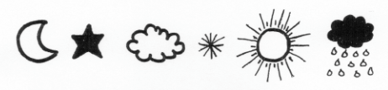
cloud sun moon snow rain star

B. Write something that is hot: _____________________

Write something that is cold: ____________________

C. Write an adjective. (HINT: Use “y”)

1. I feel the sun. It’s ___________________.

2. I feel rain. It’s ____________________.

3. I see snow. It’s ___________________.

4. I see clouds. It’s ____________________.

D. Write “There is” or “There are”. Draw a picture!

My sentence! | My picture!
1. ___________ _______ some

flowers.

2. ___________ _______ a rock.

3. ___________ _______ a river.

4. ___________ _______ some

mountains.

5. ___________ _______ some

grass.

E. Where do the words belong? (You can put words more than one place!)

grass rain ocean earth sea mountain

river sun leaf sap 2 flower lake

WET | BIG | GREEN

F. True or False

1. ______ Canada’s flag has blue.

2. ______ Maple syrup is good to eat.

3. ______ Maple syrup is made from grass.

4. ______ Summer is cold.

5. ______ Trees have branches.

