Unit 2: God made me!
Lesson 4: Review

A. Match the words and the pictures:
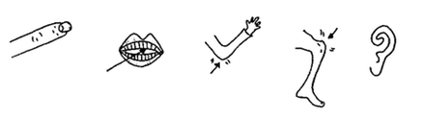

teeth ear knee elbow finger

B. Write five parts of the head:

________________________________________________________________

Write five parts of the body:

_________________________________________________________________

C. Fill in the blank. (Hint: lesson words from lesson 1 and 2)

God made my _____________. I can walk!

God made my______________. I can see!

God made my______________. I can write!

God made my ______________. I can hear!

God made my ______________. I can eat!

D. Write about yourself.

I was ____________ on _______________(your birthday.) I have ___________

hair and _____________ eyes. I can _______________________ and

_____________________, but I can’t ___________________________. God

loves me just the ___________ I __________!

E. Label these parts of the body:

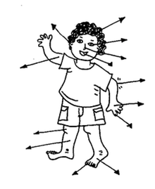

F. What can you do? Draw a picture:

