Unit 5: God Gave Us Language
Lesson 2: How do we talk about words?
Teacher’s Guide

Introductory Activities

1. Use some ideas from “Activities for Oral Instruction” (in the Teacher’s Book) to introduce the alphabet. They probably know it. Sing The ABC Song (in the Teacher’s Book).

2. Spell some easy words for them to write and check their spelling on the board.

3. In small groups, ask them to spell words for their classmates to write.

4. Play Hangman on the board to practice the letters.

5. Teach the phrase, “How do you spell…?” Have students work in pairs, asking each other how to spell words.

Worksheets Follow general guidelines

Expansion Activities

1. Play Junior Scrabble, or Boggle.

2. Have students bring pictures of nouns. In groups, have students display their pictures on a poster, separated into the five categories of nouns.

3. Play Simon says with action verbs.

4. Have students make an alphabet book by cutting pictures out of magazines, or drawing pictures and words.

5. Prepare in advance many words divided into colors. For example: nouns in red, verbs in green and adjectives in yellow. Ask them to make sentences. NOTE: This can be done using large words, as a class or in small groups. Or, students can work individually or in pairs to make sentences out of smaller cards.

6. Make a memory game with adjective opposites such as new-old, pretty-ugly, tall-short, light-dark, black-white, old-young.

7. Have students make personalized word lists (separate word lists for nouns, verbs, and adjectives) of all the words they know in English. It will encourage them to see how many words they know!

8. During recess, have students go on a “Word Search.” Have them take a pencil and paper, and write down all the words they “see” in the proper category (noun, verb, adjective). For example, students might write the following:
NOUNS: boy, girl, teacher, ball, students, pop…
VERBS: run, talk, laugh, smile, eat, drink…
ADJECTIVES: pretty, nice, cold (pop), hot (snack), loud (voices), tired (teachers!)…

Unit 5: God gave us Language
Lesson 2: How do we talk about words?

LESSON WORDS: letters of the alphabet, nouns, verbs and adjectives

A. ☺ NOUNS: Look at this hand and say the 5 kinds of nouns:
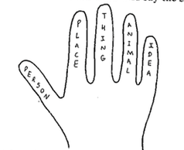

B. ☺ Match each noun to its category:

1. teacher animal

2. Canada idea

3. apple person

4. cat thing

5. love place

C. ☺☺ Think of words to complete the table:

Person  ____________  ____________  ____________  ____________  ____________ | Place  ____________  ____________  ____________  ____________  ____________ | Thing  ____________  ____________  ____________  ____________  ____________ | Animal  ____________  ____________  ____________  ____________  ____________ | Idea  ____________  ____________  ____________  ____________  ____________

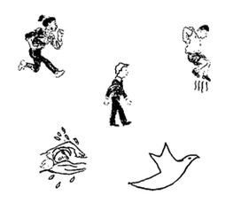
D. ☺ VERBS = ACTION Match the pictures and the words:

fly

swim

run

walk

hop

E. ☺ Circle the VERBS (action words):

1. I swim very well. 3. We walk to school.

2. Let's run fast! 4. Birds can fly.

F. ☺ ADJECTIVE = a word that describes something.

a pretty flower a nice car a tall tree
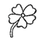
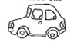
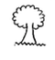

G. ☺☺ Circle the ADJECTIVE:

1. He is a tall man. 4. I have a small dog.

2. This is a big house. 5. I like good books.

3. John is a nice boy. 6. My dad is a strong man.

H. ☺ Where is the adjective? (before / after) the noun.

