Unit 5: God Gave Us Language
Lesson 3: Why are there different languages?
Teacher’s Guide

Introductory Activities

1. Ask children to think about different languages they know about. Have them say any words they know in another language. If possible, learn a song in a different language (other than English or the native language). Emphasize the fun and enjoyment of language, and knowing another language.

2. Have students brainstorm all the different ways they use language. Some possibilities are:
- To talk with friends
- To show love and affection
- To play and have fun
- To learn
- To communicate with people far away

3. Have students think about the different parts of language. Help them brainstorm, and make a list on the board of the following:
- Letters
- Words
- Sounds
- Sentences
- Books and stories
- Music

Worksheets Follow general guidelines

Expansion Activities

1. Invite a special speaker to come in and speak about a foreign country and language. Encourage the speaker to wear native dress, and to teach a little about the language. Look up the country on a map, and make sure students learn some phrases or a song in the foreign language. Encourage discussion about how that language is similar to or different from their native language and English.

2. Look at some words written in languages that don’t use the Roman alphabet. Have someone explain these characters or symbols. If possible, help students learn to write their names in a language that doesn’t use the Roman alphabet. A follow-up group activity could be to create a poster showing the same word in various languages, some using our alphabet, and some using other characters.

3. Create a display of Bibles in various languages. Find the same verse in all the Bibles, and discuss how they vary. Which is the longest? The shortest? Do some of the languages read right to left instead of left to right? Back to front? Invite other classes to come look at the display.
Unit 5: God Gave Us Language
Lesson 3: Why are there different languages?

LESSON WORDS: language, speak, different, same, proud, tower, stay together, scatter, earth, understand, culture, country,
right, wrong, hard-harder, fast-faster
“a long time ago”

A. ☺ Read!
THE TOWER OF BABEL
How many languages can you name? There are many! | 
Why do people speak different languages? | 
A long time ago, everyone spoke the same language. | 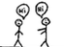
The people got proud, and started to build a tower. | 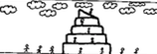
They wanted to stay together. | 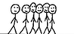
But God wanted them to scatter over the earth. | 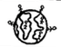
God gave them many languages. They couldn’t understand each other! | 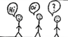
So, they stopped building the tower, and scattered. That’s why there are many languages, cultures, and countries today. | 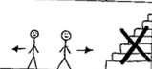

B. ☺☺☺ I can tell the story with the pictures!

C. ☺ Write TRUE or FALSE:

1. _______ In the beginning, people spoke the same language.

2. _______ They started to build a palace.

3. _______ People wanted to speak different languages.

4. _______ God made people speak different languages.

5. _______ People stayed together.

D. ☺ Match the opposites:

same scatter

stay together false

a long time ago different

true now

E. ☺ ☺☺ How many languages can you list? Make a chart of languages
and the countries where they are spoken. Share your list with
your class!

LANGUAGE | COUNTRY / COUNTRIES

F. ☺ Learn a new word: “Bilingual” means two languages. Write this
word in the blanks below:

1. Sarah speaks Portuguese and Japanese. She is __________________.

2. I need a _________________ dictionary.

3. John has a ________________ Bible. It’s in English and Portuguese.

Do you know anyone who is bilingual? Write their name: _________________

G. ☺ Languages are different, but sometimes they are the same. Circle
the English words that are similar in your language.

dog computer love hamburger

ping pong bank table chocolate work red

house music write banana class

H. ☺☺☺ Some people have wrong ideas about language. Are these
sentences TRUE or FALSE?

1. ______ All languages use the same alphabet.

2. ______ English is harder than my language.

3. ______ Other languages are faster than my language.

4. ______ Everyone can learn a language.

5. ______ Some languages are better than others.

I. Let’s thank God!

“Dear God, thank you for making languages! Thank you that we can speak and share your love, in many different languages. In Jesus’ name, Amen.”

FUN WITH LANGUAGE!

LEARN AMERICAN SIGN LANGUAGE

Look at the alphabet signs below. Then, practice spelling your name for someone!
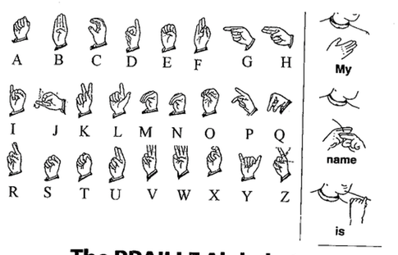

LEARN BRAILLE

Braille is a reading system for the blind. Look at the alphabet below. Press your pencil into each dot from the back to make an impression. Then, try to “read” the letters with your fingers! Can you write your name in Braille?
