Unit 1: God Gives Us Families
Lesson 1: Who lives in my house?
Teacher’s Guide

Introductory Activities

1. Show a picture of a family and explain the different people.

2. Ask questions:
- How many brothers do you have? And sisters?
- How many grandparents?
- Who are your parents?

Worksheets Follow general guidelines

Expansion Activities

1. In groups of 5 or 6, have students form families. Let them decide who is who in
the family. If possible, provide props such as the following:
- baby powder to make hair look white
- a tie for the father
- a purse and hat for the mother
- toys for children; a bottle for a baby
Have each group introduce their family to the rest of the class. Pre-teach the phrase, “This is the __________ (grandpa, baby, sister, etc.).”

2. Game: Have one child stand up front and describe a person in a family (mother,
father, etc.) and have other students guess who he/she is talking about. The explanations
can be given in the first language.

3. Have students bring in pictures of their families. In small groups or in the whole
class, have students introduce their families. (This should be done after students have
completed exercise D in which introductions are practiced.)

4. Talk about special family days and dates in different countries. For example:

 | North America | Brazil
Mother’s Day | 2nd Sunday in May | 2nd Sunday in May
Father’s Day | 3rd Sunday in June | 2nd Sunday in August
Children’s Day | doesn’t exist | October 12

Children could be shown a similar chart, and asked to answer questions such as:
- What holidays are the same in North America and Brazil?
- What holidays are different? How are they different?
Unit 1: God Gives Us Families
Lesson 1: Who lives in my house?

LESSON WORDS: mother (mom), father (dad), parents, sister, brother, grandmother (grandma), grandfather (grandpa)

A. ☺ Match the picture with the lesson word.


Sister

Father

Brother

Mother

Grandfather

Grandmother

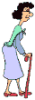

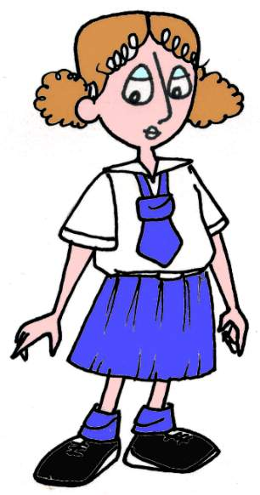


B. ☺ Draw your family. Write beside each person what they are to you (brother, sister, mother, father, grandmother, or grandfather).

D. ☺ Write a lesson word:

What makes the weather?

C. ☺ Write more words.
_______ Another word for grandmother is __ __ __ __ __ __ __.
_______ Your __ __ __ is your father.
_______ Mother is the same as __ __ __.
_______ Your grandfather is also your __ __ __ __ __ __ __.

D. ☺☺ Pretend! Introduce your friend and her/his parents to your teacher. Words to use: his or her, my and names.

Hello! This is my friend. ______ name is ________________. This is _____ mother, ________________; and _____ father ________________. And _____ teacher is _________________.

E. ☺☺☺ Look at Mary’s family. Answer the questions.
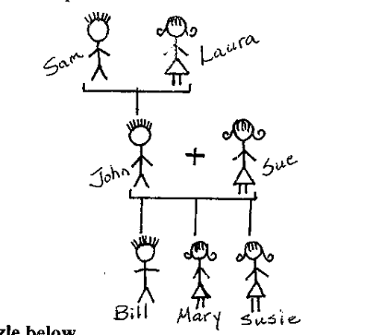
1. Laura is Mary’s ________________.

2. Susie is Mary’s ________________.

3. John is Mary’s _________________.

4. Sam is Mary’s _________________.

5. Bill is Mary’s __________________.

6. Sue is Mary’s __________________.

F. ☺ Find your lesson words in the puzzle below.

G R A N D F A T H E R R R O C
R E H T O M D N A R G E E P J
B E B D O X K E S J Q H T U O
U R H Y J J G H C N C T S I N
U P O T D H Y E G B N O I J T
V M J T A A Z B Z S I M S L W
Y B I V H F J R V F J Q X U Z
B J E J E E H N K M B F P C Q
D S N C V O R M O W L F V X Z

