Unit 2: God Gives Us Homes
Lesson 1: What are you doing in the kitchen?
Teacher’s Guide

Introductory Activities

1. Show pictures: Appliances: refrigerator, stove, microwave, sink, table, chair
Dishes: plate, cup, knife, fork, spoon

2. Ask questions: 1. What do you put in the refrigerator?
2. What do you cook on the stove?
3. Where you eat?
4. Where you wash the dishes?
5. What do you bake in the oven?

Worksheets Follow the general guidelines

Extension Activities

1. Set a table. Bring plastic plates, cups and utensils. In groups, have students take turns setting the table correctly. You can also divide the class into two teams, and have a relay race in table setting! Have the items a fair running distance from the teams. Make sure items are mixed up. Each runner must run up, set the table correctly, then go back and tag the next runner. Before the next runner arrives, you must mix up the items again.

2. Make something good to eat in a kitchen to practice the vocabulary. Quiz students repeatedly on the names of appliances and dishes. Have students write sentences about what they did in the kitchen. Encourage them to use all their lesson words in their sentences. For example: 1. We made cookies.
2. We baked them in the oven.
3. We washed the dishes in the sink.

3. Have students talk about their family’s kitchen customs. Help them make sentences like:
1. My mom bakes cakes in the oven.
2. My father doesn’t cook.

4. Divide students into groups of 4 or 5. Give each group a space in the room to create an imaginary kitchen. Have them decide places for all their appliances. Then, give them imaginary commands, while they act them out, such as:
- Mix up some cookies (put in flour, sugar, eggs, etc.)
- Put them on a baking sheet
- Put it in the oven. (Wait a few seconds…) Take them out of the oven.
- Get the milk out of the fridge. Pour a glass.
- Enjoy your cookies and milk!
Unit 2: God Gives Us Homes
Lesson 1: What are you doing in the kitchen?

LESSON WORDS: Action words: cook, make, wash, bake, eat, dry
Things in the kitchen: refrigerator (fridge), stove/oven, microwave, sink, table, chair
Dishes: plate, cup, knife, fork, spoon

A. ☺ Write a LESSON WORD for each picture:
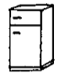
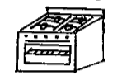
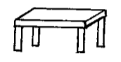

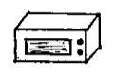
______________ ________________ _______________
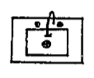
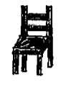

______________ ________________ _______________

B. ☺ Write action words for these places:

1. At the sink you can __________ and __________.

2. On the stove you can ____________. In the oven you can ___________.

3. At the table we _________!

C. ☺☺ True or False:

1. ________You cook in the fridge. 4. ________You sit in a chair.

2. ________You eat at the microwave. 5. ________You dry dishes at the table.

3. ________You wash in the sink. 6. ________You bake in the oven.
D. ☺☺☺ What does everyone do in the kitchen? Take a survey!

Names of Friends | Do you wash dishes? | Do you dry dishes? | Do you set the table? | Do you cook or bake?

E. ☺ Draw and label your kitchen. (View from the top, like a floor plan, is best)

F. ☺☺ Label the place setting:
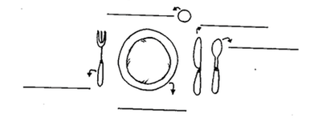

G. ☺☺ Choose the best word:

1. I use a ( spoon / fork ) to eat soup.
2. I drink from a ( plate / cup ).
3. I put food on a ( plate / knife ).
4. I cut meat with a ( spoon / knife ).
5. I put milk in a ( fork / cup ).

