Unit 2: God Gives Us Homes
Lesson 2: What are you doing in the living room?
Teacher’s guide

Introductory Activities

1. Introduce the unit by showing pictures of the following, and saying their names: couch, chair, rug, table, TV, CD player, computer, desk, lamp, phone. Also, show a picture of a living room with most of these items in it.

2. Ask, “What do you do in the living room?” Elicit answers, such as:
- I watch TV.
- I listen to music.
- I talk with my family.
Help students learn to ask and answer the question. Have them work in pairs or small groups, asking and answering the question.

Worksheets Follow the general guidelines

Expansion Activities

1. Bring to the class a set of doll living room furniture, inside a box that can function as a living room. In small groups, allow students to rearrange the future. However, they must say the English word for each piece as they move it. If desired, the whole class could take on the project of cutting windows and doors in the box, designing wallpaper on the walls, putting in doll people, and making an attractive living room scene. Label all the items in the scene in English, and the display can be a daily source of learning throughout the unit.

2. Provide students with a living room “base”, and small colorful squares of paper cut to scale to represent pieces of furniture. Then, have them place the furniture in their living room as they wish. Have students share their living room floor plans in small groups. They should make short statements about activities in various parts of the room, such as: 1. I talk on the phone here.
2. I watch T.V here.
3. I work on the computer here.

3. Have students keep a chart for a week, showing all the activities that take place in their living room. If students aren’t familiar with past tense, show them how to write a few key sentences in past tense. Make sure they write the activities in English!
Unit 2: God Gives Us Homes
Monday | Tuesday | Wednesday | Thursday | Friday | Saturday
We played games.  I did homework.  Mom sewed. | Mary listened to music.  Dad watched TV. | I did homework.  Mom and Dad watched TV. | Mary listened  to music.  Dad read.  I studied. | We all played a game.  Mom talked on the phone. | We watched a video.  We played computer games.
Lesson 2: What are you doing in the living room?

LESSON WORDS: Action words: sit, watch, play, study, write,
listen, talk
Things in the living room: couch, chair, rug, table, TV, CD player, computer, desk, lamp, phone

A. ☺ Label the things in this living room:

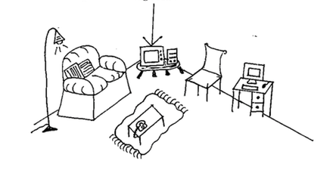

B. ☺☺ Match the activities with the items used.

I watch a movie. computer

I sit down. lamp

I turn on the light. TV

I write email. phone

I do homework. couch

I talk to my friend. desk

C. ☺ Write an action word. Remember… sometimes you need “S”!

1. He _____________ TV every day.

2. I ___________ on the couch after school.

3. My friends and I ____________ together after school.

4. My dad _____________ to music.

5. I don’t _____________ on the phone very much.

D. ☺ Draw and label your living room. (View from the top, like a floor plan, is best)

E. ☺☺ What do your friends do in the living room?

Names of Friends | Do you watch TV? | Do you listen to music? | Do you do your homework? | Do you use the computer?

