Unit 2: God Gives Us Homes
Lesson 4: Review

A. Match the words to the pictures:
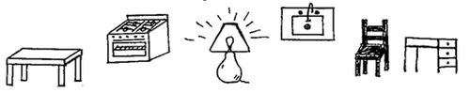

stove chair table sink desk lamp

B. Use an action word. Add “ing”.

1. She is _______________ cookies.

2. He is _________________ science.

3. She is _________________ dishes.

4. He is __________________ a letter.

5. She is _________________ her room.

C. Write the best word:

7:00 p.m. cup clean 7:00 a.m. spoon messy

1. I use a ____________ to eat soup.

2. I put milk in a ____________ to drink it.

3. I eat breakfast in the morning at ____________.

4. I eat supper at night around _____________.

5. It’s good for a room to be _____________.
D. Where do these words belong? (You can put words in more than one place!)

microwave pillow sink couch

desk oven bed picture

chair refrigerator table phone

lamp CD player stove closet

computer T.V. clothes plate

KITCHEN | BEDROOM | LIVING ROOM

