Unit 3: God Gives Us Clothes
Lesson 2: Let’s go to the store!
Teacher’s Guide

Introductory Activities
1. Bring quite a few clothing items to the class, and set up a mock second-hand store. Some items should be words that were learned in the previous lesson, with some new words such as skirt and dress. Attach price tags and post a sign so that it really does look like a store. Explain that a second-hand store sells used clothing, but much of it is still very nice.

Make sure you have an item of clothing that can illustrate each of the adjectives in the lesson: small (little), large (big), short, plain, striped, cheap, expensive, nice, new, old, pretty, ugly. Hold up the items one at a time. Have students tell the color and the name of the garment. Encourage the use of complete sentences. For example:
Teacher: What’s this?
Class: It’s a pink shirt.

After going through the items in this way, teach the adjectives. Again quiz the students until they can respond in this way:
Teacher: What’s this?
Class: It’s an old pink shirt.

2. Show some magazine pictures of clothing. Have students make sentences describing the clothing items using adjectives and colors before the name of the piece of clothing.

Grammar Note: Both of these exercises may lend themselves to a discussion on the difference between “a” and “an.” If students are able to understand, explain that a precedes a consonant sound, and an precedes a vowel sound.

Worksheets Follow general guidelines

Expansion Activities
1. If possible, organize a real used clothing sale! Prepare by collecting used clothing a couple of weeks in advance. (You could state that proceeds from sales will go towards purchasing supplies for the school’s English program.) Have children organize the clothing, make price tags, decide who will be the cashier (taking turns is best), and learn how to help customers. Help children learn phrases in English such as “May I help you?” Even though the customers may not speak English, the children can say the phrases in both language – impressing the parents and helping the children in their English!

At least a week before the sale, involve children in the task of making invitations (in both English and the native language) and distributing them to parents and friends. You may want to have some refreshments for sale as well.

2. Have children select one or more clothing items for which they can develop a commercial. The commercial could be a print ad, prepared on poster board and presented to the class, or it could even be a video. Encourage the use of the adjectives learned, and others, to create a favorable image of the clothing item in the mind of the viewer.
Unit 3: God Gives Us Clothes
Lesson 2: Let’s go to the store!

LESSON WORDS: Adjectives: small (little), large (big), short, plain, striped,
cheap, expensive, nice, new, old, pretty, ugly
Clothing: dress, skirt, pants

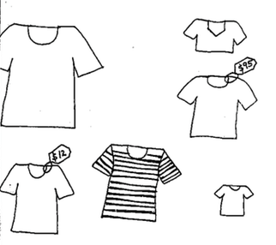
A. ☺☺ Match the words with the pictures:
small

large

short

striped

cheap

expensive

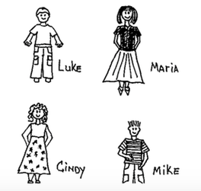
B. ☺ Write LESSON WORDS:

1. Luke is wearing _____________ .

2. Maria is wearing a ____________.

3. Cindy is wearing a ____________.

5. Mike has a _________ shirt.

6. Luke’s shirt is ____________.
C. ☺ Write the word “too” or a lesson word in each space:

Sally went to the store to buy (a)________________. But she couldn’t find

^{clothing}

any she liked! Everything was either _____ ______________, _____

^{adjective}

_______________, or _____ ________________. Then, she finally saw what

^{adjective} ^{adjective}

she wanted: (a) ______________ ______________. But it was ______
^{adjective} ^{clothing}
expensive. So Sally decided to be satisfied with what she had.
D. ☺ Draw:

Little dress: Striped Skirt: Short pants:

E. ☺☺☺ Go shopping! You and your friends are going to the store. You have $20.00 (twenty dollars) to spend! What will you buy?

Example: I will buy the striped shirt and the pants for $16.95.
I won’t buy the plain skirt because it’s too expensive.
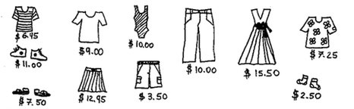
I will buy ___________________________________ for __________________.

I won’t buy ___________________ because ____________________________.

I won’t buy ___________________ because ____________________________.

Now, see what your friends bought. Read each other your sentences!
F. ☺☺ Color each shirt a different way. Make some look old, new, pretty, ugly, cheap, expensive, striped, and plain. Then, trade papers with your partner. Check () each word that you think describes each shirt.

 | old | new | pretty | ugly | cheap | expensive | striped | plain
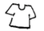
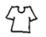
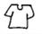
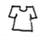
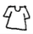

G. ☺ Use the code to find out what this says!

A B C D E F G H I J K L M N O P Q
              □  

R S T U V W X Y Z . ? ’
           

____ ________ ________ __________ __ _____ ________
 

______ _________ ______ ___ _______ ___ __________ __


