Unit 3: God Gives Us Clothes
Lesson 4: Review

A. Write the opposites:

1. The opposite of expensive is ________________.

2. The opposite of ugly is ________________.

3. The opposite of old is ________________.

4. The opposite of large is ________________.

B. Write TRUE or FALSE:

1. _______ Boys wear dresses.

2. _______ Striped shirts are plain.

3. _______ Sandals go on your feet.

4. _______ You tie your socks.

5. _______ You wear a jacket when it’s cold.

D. Put the words in the right order:

1. That too expensive shirt is. ______________________________

2. I like blue the pants. _____________________________________

3. John wearing is a hat brown. ______________________________

4. She has already red dress a. ______________________________

5. I need don’t jeans cool. __________________________________
E. Draw these things on the child:

1. A yellow hat

2. A red and blue striped shirt

3. Green shorts

4. Orange socks

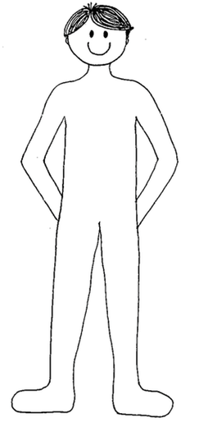
5. Dark blue tennis shoes

