Unit 4: God Gives Us Education
Lesson 1: Be the teacher!
Teacher’s Guide

Introductory Activities

1. Introduce the new unit, focusing on education. In addition to improving language skills, some goals in this unit are:
- To encourage appreciation and gratitude for the privilege of education
- To encourage a love for learning
- To encourage responsibility in learning

To help students begin thinking about these important topics, brainstorm with them, in the first language, about right and wrong attitudes about education. Encourage dialog and discussion, trying to come up with something like this chart on the board:

Right attitudes about education | Wrong attitudes about education
Education is a privilege. | Education is a waste of time.
I am responsible for learning. | The teacher has to make me learn.
It’s interesting to learn new things. | Learning is boring.
Kids can behave well, be obedient, and show respect for others. | It’s okay if I yell and walk around and disrupt the class. I’m only a kid.
If I learn discipline in school, I’ll be well-prepared for life. | Real life is a lot easier and more fun than school. You don’t have to have discipline outside of school.

2. Introduce the First Lesson. Ask students to think of all the things that their teachers say in the classroom. Put a list of these commands on the board in the first language. Then, ask student how many of those things they know how to say in English. Write as many phrases as possible.

Worksheets Follow general guidelines

Expansion Activities

1. Do TPR using the classroom commands learned. Add in other commands as students can understand them, such as: open the door, erase the board, write a sentence on the board, close the curtains, etc. Have students then do TPR in small groups.

2. Give students a taste of what it’s like to be the teacher! Plan with a student in advance for him/her to open the class, using phrases such as: good morning, come in, close the door, sit down, open your books to page __.

3. Have students work together to create posters about “Problems that teachers have in the classroom.” Students can draw pictures and write short sentences, such as “Students don’t listen” and “Students don’t do their homework.” Have groups present their posters, and discuss ways to solve these problems.

Unit 4: God Gives Us Education
Lesson 1: Be the teacher!

LESSON PHRASES: sit down, stand up, turn on the light, turn off the light,
open your book, close your book, go to the board,
do your homework, don’t talk, no talking please, turn
to page _____, do exercise _____.

A. ☺ Write a lesson phrase using these pictures:
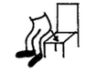

1. __ __ __ __ __ __ __


2. __ __ __ __ __ __ __ __ __ __ __ __ __ __

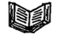
3. __ __ __ __ __ __ __ __ __ __ __ __
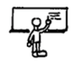

4. __ __ __ __ __ __ __ __ __ __ __ __

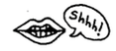
5. __ __ __’__ __ __ __ __!

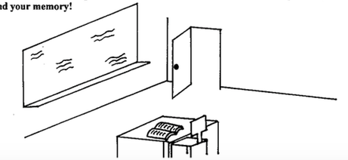
B. ☺ Label the things in this classroom. Use words in the lesson phrases, and your memory!

C. ☺☺ What would a teacher say next? Write lesson phrases:

1. It’s dark. __________________________________________________

2. Good bye. See you tomorrow. Don’t forget:

___________________________________________________________

3. You have been sitting for a long time. Now, ______________________

4. Here is some chalk. __________________________________________

5. We’re leaving the classroom. We don’t waste electricity. So,

____________________________________________________________

6. Please be quiet. _______________________________________________

7. We’re taking a test. You can’t use your book. So,

____________________________________________________________

8. Don’t stand up. _______________________________________________

9. Take out your books. ______________________________ to page 25.

10. We already did exercise “A”. Now, _________________________ “B”.

D. ☺☺☺ Practice giving commands! Say each phrase to your friends.
Put a check () if your friends did the right thing!

Action | __________ could do it!  (friend’s name) | __________ could do it!  (friend’s name)
turn on the light
open your book
stand up
turn off the light
sit down
open your book to page__
go to the board

