Unit 4: God Gives Us Education
Lesson 4: Review

A. Make a polite request:

1. The door is open.
Request: ________________________________________________.

2. You need to go to the bathroom.
Request: ________________________________________________.

3. It’s too dark.
Request: ________________________________________________.

4. You are thirsty.
Request: ________________________________________________.

5. You want to come into the classroom.
Request: ________________________________________________.

B. Match the commands and the pictures:
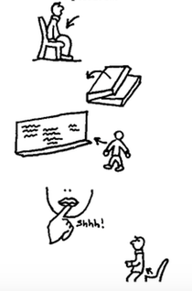
1. Stand up.

2. Sit down.

3. Don’t talk.

4. Go to the board.

5. Open your book.

C. Tell about three people in your family. Tell whether they are older or younger than you.

1. My __________________ is ________________ than me.
(someone in family) (older / younger)

2. My __________________ is ________________ than me.
(someone in family) (older / younger)

3. My __________________ is ________________ than me.
(someone in family) (older / younger)

D. Unscramble the sentences. Read about GOOD ATTITUDES!

1. If I / it’s / don’t learn / MY fault
___________________________________________

2. I / to the teacher / listen / should
___________________________________________

3. Education / a privilege / is
___________________________________________

4. fun / learning / can be
___________________________________________

5. It’s / to learn / responsibility / MY
___________________________________________

E. Write some things that you “take care of”:

1. I take care of ___________________________________________

2. I take care of ___________________________________________

3. I take care of ___________________________________________

