Unit 5: God Gives Us Friends
Lesson 4: Review

A. Look at Paul and Dave. Look at what Paul says. How will Dave answer? Choose the correct phrase:

I don’t Neither do I So do I

I’m not Neither am I So am I
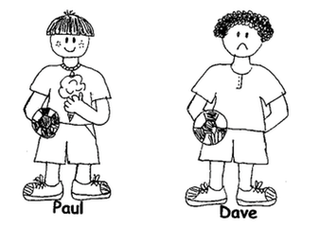

1. Paul: I don’t have a hat. Dave: __________________

2. Paul: I am a boy. Dave: __________________

3. Paul: I have ice cream. Dave: __________________

4. Paul: I’m happy! Dave: __________________

5. Paul: I like soccer. Dave: __________________

B. Circle the correct word: present or past

1. Yesterday we ( rode / ride ) our bikes.

2. I ( do / did ) my best on the test last week.

3. Please don’t ( lost / lose ) your homework!

4. Right now we ( were / are ) learning English.

5. Every day I ( sit / sat ) quietly in class.

C. Use “mine” or “my”:

1. That pencil is ______________.

2. This is ____________ book.

3. Do you have ____________ eraser?

4. I like ____________ teacher!

5. This backpack is _____________.

D. Unscramble the sentences.

1. Anna has / but / a pencil / doesn’t / Jane
___________________________________________

2. Danielle / how to / play piano / knows
___________________________________________

3. play / let’s / soccer
___________________________________________

4. Matt and Joe / beside each other / are sitting
___________________________________________

5. you / like / Do / to play / UNO / ?
___________________________________________

