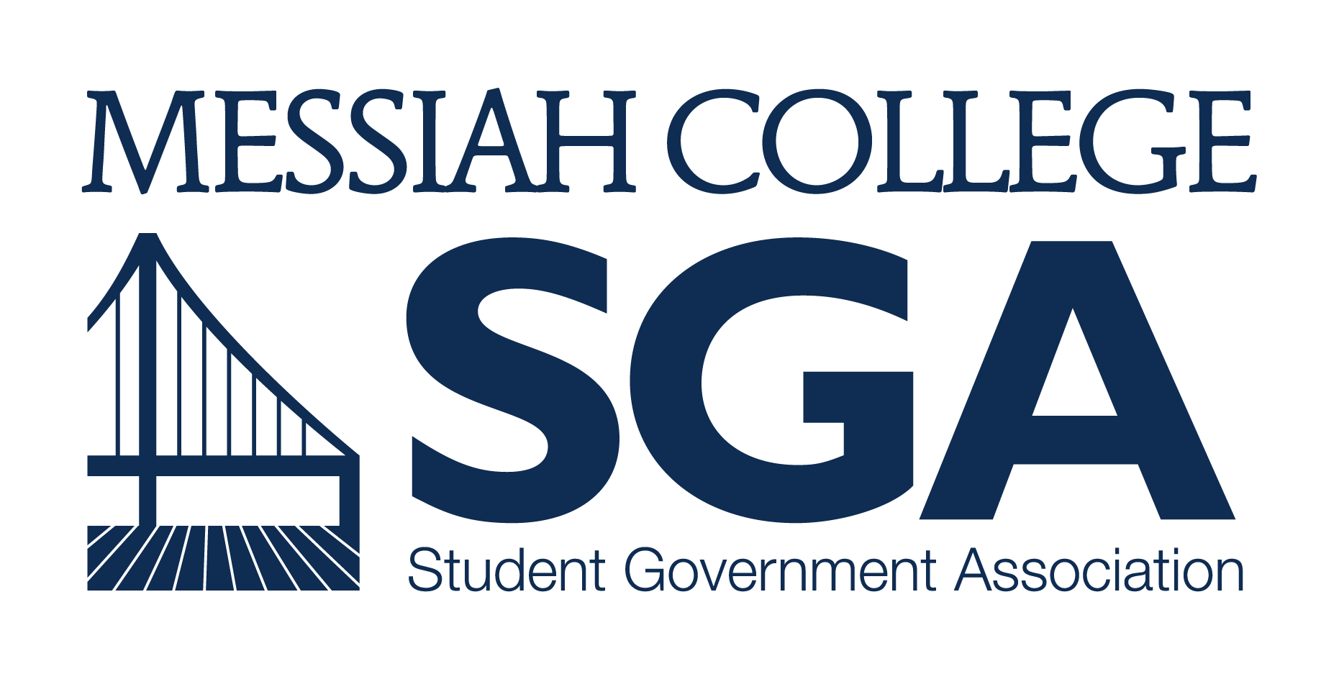

APPLICATION and PETITION
FOR
STUDENT BODY PRESIDENT

JOB DESCRIPTION and QUALIFICATIONS
Wages: 8.15/hour
Hours per week: 18
Key Responsibilities:
  - Provide unity and purpose for the Student Government Association.
  - Act as the principal representative of the student body before the administration, trustees, faculty, and the surrounding community through service on college committees, correspondence, and personal contact.
  - Plan and chair meetings of the Student Body President’s Cabinet, Leadership Council and College Committee Representatives.
  - Plan, coordinate, and facilitate training programs for each of the groups listed in point c.
  - Ensure that the provisions of the SGA Governance Manual are properly implemented.
  - Coordinate the nomination and appointment of Diplomatic Corps of student representatives to College Committees during the semester in which he/she is elected.
  - Serve as a student representative on the College Council.
  - Meet weekly with the SGA Advisor.
  - Meet monthly with each member of the Student Body President’s Cabinet, Leadership Council, and Dean of Students.
  - Compile a written end-of-year report, including individual reports from each member of the Leadership Council that summarizes the year and offers suggestions for the future.
  - Regularly attend meetings of the Student Senate.
  - Sign or veto all Senate legislation within five days of their passage. If vetoed, a written rationale for the veto must be immediately presented to the Senate.
  - Implement all approved Senate legislation or direct them to their intended audience.
  - Collaborate with the Student Body Vice President to approve or deny petitions to amend the Governance Manual.
  - Call and chair Governance Review Council consisting of all SGA Officers to consider changes to the SGA Governance Manual.
  - Serve on a committee of Student Senate per the direction of the Chair of Student Senate.
  - Attend leadership training and development sessions such as the Leadership Retreat.

*see Section 4.1.1 of the SGA Governance Manual[goo.gl/bCi71i] for a complete list of responsibilities for the Student Body President position.
Candidate Qualifications:
- NOT be on academic, chapel, or disciplinary probation the semester before or semesters during term in office.
- Be in at least second semester at Messiah College.
- Intend to hold office for both fall and spring semesters of the 2017-18 academic year.

APPLICATION PROCEDURES for 2017

- Below is the application to run for Student Body President. Please answer all questions in neat, legible handwriting or electronic type.
- In accordance with Section 5 of the SGA Governance Manual, the following timeline and procedures are to be followed for Student Body President’s Cabinet elections and nominations:
  - APPLICATIONS/RESUMES DUE: February 22, 2017; please submit electronic materials to SGA@messiah.edu and print materials to Suite 3050/Larsen 202.
  - CAMPAIGNS for Student Body President/Vice President pairs may begin on February 27. Do not begin unless the Elections Coordinator confirms receipt of the pair’s application. All campaign material must be removed within 24 hours of the end of the voting period and are subject to review by the Elections Coordinator.
  - ALL President/Vice President pairs must be available for an election event on March 7; to be decided after all applications are submitted. Pairs will either be available for a meet-and-greet during the day or prepare a speech and/or talking points for a Speech Night that evening.
  - POLLS WILL OPEN to the Student Body for the Student Body President/Vice President pairs on March 7 at 9PM and close on March 9 at 9PM.
  - Candidates for all other Cabinet positions will be notified of the names for President-elect and Vice President-elect within 24-hours polls closing.
  - The President-elect, Vice President-elect and the Cabinet Nominations Panel will receive all applications for Chair of the Student Review Board, Vice President of Diversity Affairs, Vice President of Finance, Vice President of Organizations, and Vice President of Communication within 48-hours of polls closing.
  - Interviews for the Chair of the Student Review Board, Vice President of Diversity Affairs, Vice President of Finance, Vice President of Organizations, and Vice President of Communication candidates will take place with the Student Body President, President-elect, Vice President-elect, and SGA Advisor and will be held from March 20 to March 24. Candidates will be notified if they did or did not receive the position by March 31, 2017.
  - The Cabinet Nominations Panel will make their recommendations to Student Senate for approval on April 6, 2017.

APPLICATION and PETITION
STUDENT BODY PRESIDENT, 2017-2018

Answers to these questions will be used by SGA for advertising the campaign; however, these questions are meant to help candidates reflect on their character, calling and competencies as they apply to leadership at Messiah. Candidates may choose to submit their answers in a separate document. Please keep answers to 200 words.

NAME: Click to Enter Text
YEAR: Click to Enter Text
MAJOR: Click to Enter Text
NAME OF RUNNING MATE: Click to Enter Text

Why do you want to hold this position AND what purpose does this position serve on campus (in your own words)?
Click to Enter Text

In your opinion, what is currently the most pressing issue facing Messiah College?
Click to Enter Text

What 2-3 things would you like to accomplish as STUDENT BODY PRESIDENT?
Click to Enter Text

What does leadership look like for you and what are the characteristics of a good leader?
Click to Enter Text

Please list any academic or co-curricular experiences and position you’ve held on campus.
Click to Enter Text

Which experience have you most appreciated and why?
*Please explain in 3-5 sentences.
Click to Enter Text

How do character and faith relate to leadership?
Click to Enter Text

Please attach your resume to this application.

Please print the remaining pages of this application.

In accordance with Section 5 of the SGA Governance Manual, you must petition 150 signatures from your peers in order to appear on the ballot with your running mate. All signatures must be current students. The petition is due the same day as the above application.

PRINT NAME | SIGNATURE
Candidate Name: | Candidate Signature:
2
3
4
5
6
7
8
9
10
11
12
13
14
15
16
17
18
19
20
21
22
23
24
25
26
27
28
29
30
31
32
33
34
35
36
37
38
39
40
41
42
43
44
45
46
47
48
49
50
51
52
53
54
55
56
57
58
59
60
61
62
63
64
65
66
67
68
69
70
71
72
73
74
75
76
77
78
79
80
81
82
83
84
85
86
87
88
89
90
91
92
93
94
95
96
97
98
99
100
101
102
103
104
105
106
107
108
109
110
111
112
113
114
115
116
117
118
119
120
121
122
123
124
125
126
127
128
129
130
131
132
133
134
135
136
137
138
139
140
141
142
143
144
145
146
147
148
149
150

Please submit all electronic materials to SGA@messiah.edu by February 22, 2017.
Please submit all print materials to Suite 3050/Larsen 202 by February 22, 2017.

