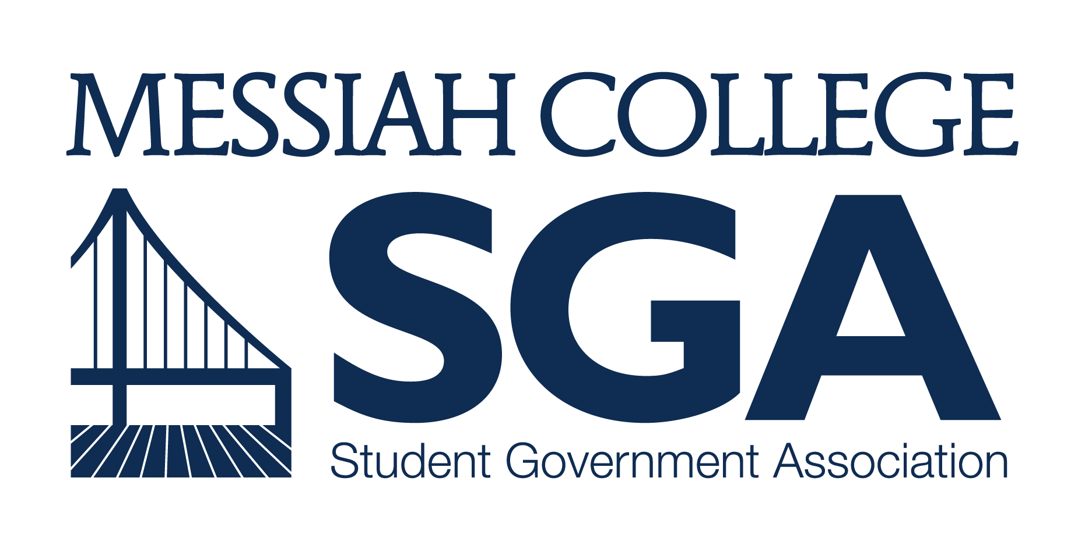

APPLICATION and PETITION
FOR
STUDENT BODY VICE PRESIDENT

JOB DESCRIPTION and QUALIFICATIONS
Wages: 8.15/hour
Hours per week: 18
Key Responsibilities:

Plan and moderate all meetings of the Student Senate, voting only in the case of a tie. Ensure that the Student Body President receives all passed proposals for approval or veto within two days of passage.

Work with the Student Body President in providing leadership, unity, and purpose for the Student Government.
- Serve as the Election Coordinator; perform all duties specified in Section 5, IV of the SGA Governance Manual related to election proceedings.
- Serve as a member of the Student Body President’s Cabinet and Student Senate. Attendance is mandatory.
- Provide orientation and training activities for the Senate members.
- Work with the Student Body President to appoint Representatives to committees and select one from each committee to serve as chair. The recommendations must be approved by a two-thirds majority vote of the Student Senate.
- Ensure that SGA Committees operate efficiently and productively. Meet regularly with the SGA Committee Chairs to offer support and suggestions.
- Work with the Vice President of Diversity Affairs to recruit potential candidates to represent multicultural and international organizations on campus.
- Form special committees as needed to address specific issues.
- Serve as a student representative on the Community of Educators (C.O.E. Senate).
- Prepare an end-of-year report in the spring for the new Student Body Vice President and the outgoing Student Body President. Include each of the proposals passed by the Student Senate and approved by the President.
- Maintain consistent and reliable attendance.
- Fulfill all presidential responsibility and power in the President’s absence or upon the President’s request or resignation.
- Chair the Review Committee when necessary.
- Collaborate with the Student Body President to approve or deny petitions to amend the Governance Manual.
- Attend leadership training and development sessions such as the Leadership Retreat.

Candidate Qualifications:
- NOT be on academic, chapel, or disciplinary probation the semester before or semesters during term in office.
- Be in at least second semester at Messiah College.
- Intend to hold office for both fall and spring semesters of the 2017-18 academic year.

APPLICATION PROCEDURES for 2017
- Below is the application to run for Student Body VICE President. Please answer all questions in neat, legible handwriting or electronic type.
- In accordance with Section 5 of the SGA Governance Manual, the following timeline and procedures are to be followed for Student Body President’s Cabinet elections and nominations:
  - APPLICATIONS/RESUMES DUE: February 22, 2017; please submit electronic materials to SGA@messiah.edu and print materials to Suite 3050/Larsen 202.
  - CAMPAIGNS for Student Body President/Vice President pairs may begin on February 27. Do not begin unless the Elections Coordinator confirms receipt of the pair’s application. All campaign material must be removed within 24 hours of the end of the voting period and are subject to review by the Elections Coordinator.
  - ALL President/Vice President pairs must be available for an election event on March 7; to be decided after all applications are submitted. Pairs will either be available for a meet-and-greet during the day or prepare a speech and/or talking points for a Speech Night that evening.
  - POLLS WILL OPEN to the Student Body for the Student Body President/Vice President pairs on March 7 at 9PM and close on March 9 at 9PM.
  - Candidates for all other Cabinet positions will be notified of the names for President-elect and Vice President-elect within 24-hours polls closing.
  - The President-elect, Vice President-elect and the Cabinet Nominations Panel will receive all applications for Chair of the Student Review Board, Vice President of Diversity Affairs, Vice President of Finance, Vice President of Organizations, and Vice President of Communication within 48-hours of polls closing.
  - Interviews for the Chair of the Student Review Board, Vice President of Diversity Affairs, Vice President of Finance, Vice President of Organizations, and Vice President of Communication candidates will take place with the Student Body President, President-elect, Vice President-elect, current office holder, and SGA Advisor and will be held from March 20 to March 24. Candidates will be notified if they did or did not receive the position by March 31.
  - The Cabinet Nominations Panel will make their recommendations to Student Senate for approval on April 6, 2017.

APPLICATION and PETITION
STUDENT BODY VICE PRESIDENT, 2017-2018

Answers to these questions will be used by SGA for advertising the campaign; however, these questions are meant to help candidates reflect on their character, calling and competencies as they apply to leadership at Messiah. Candidates may choose to submit their answers in a separate document. Please keep answers to 200 words.

NAME: Click to Enter Text
YEAR: Click to Enter Text
MAJOR: Click to Enter Text
NAME OF RUNNING MATE: Click to Enter Text

Why do you want to hold this position AND what purpose does this position serve on campus (in your own words)?
Click to Enter Text

In your opinion, what is currently the most pressing issue facing Messiah College?
Click to Enter Text

What 2-3 things would you like to accomplish as STUDENT BODY VICE PRESIDENT?
Click to Enter Text

What does leadership look like for you and what are the characteristics of a good leader?
Click to Enter Text

Please list any academic or co-curricular experiences and position you’ve held on campus.
Click to Enter Text

Which experience have you most appreciated and why?
*Please explain in 3-5 sentences.
Click to Enter Text

How do character and faith relate to leadership?
Click to Enter Text

Please attach your resume to this application.

Please print the remaining pages of this application.

In accordance with Section 5 of the SGA Governance Manual, you must petition 150 signatures from your peers in order to appear on the ballot with your running mate. All signatures must be current students. The petition is due the same day as the above application.

PRINT NAME | SIGNATURE
Candidate Name: | Candidate Signature:
2
3
4
5
6
7
8
9
10
11
12
13
14
15
16
17
18
19
20
21
22
23
24
25
26
27
28
29
30
31
32
33
34
35
36
37
38
39
40
41
42
43
44
45
46
47
48
49
50
51
52
53
54
55
56
57
58
59
60
61
62
63
64
65
66
67
68
69
70
71
72
73
74
75
76
77
78
79
80
81
82
83
84
85
86
87
88
89
90
91
92
93
94
95
96
97
98
99
100
101
102
103
104
105
106
107
108
109
110
111
112
113
114
115
116
117
118
119
120
121
122
123
124
125
126
127
128
129
130
131
132
133
134
135
136
137
138
139
140
141
142
143
144
145
146
147
148
149
150

Please submit all electronic materials to SGA@messiah.edu by February 22, 2017.
Please submit all print materials to Suite 3050/Larsen 202 by February 22, 2017.

