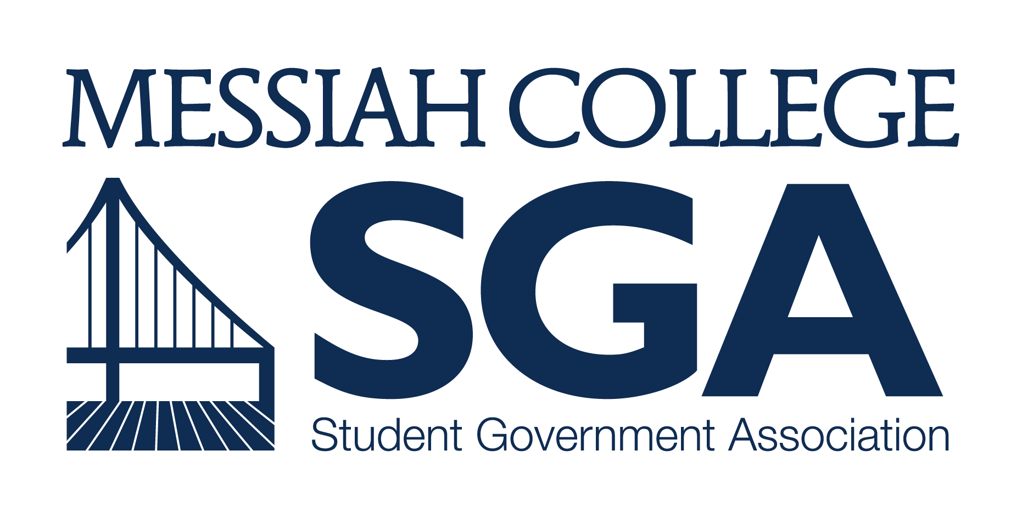

APPLICATION and RESUME
FOR
CHAIR OF STUDENT REVIEW BOARD

JOB DESCRIPTION and QUALIFICATIONS
Wages: $8.15/hour
Hours per week: 10
Responsibilities:
- Provide leadership, unity, and purpose to the Student Review Board.
- Moderate meetings of the Student Review Board, voting only in the case of a tie.
- Receive and schedule parking appeals to be heard by the Student Review Board.
- Understand the rules, regulations, and disciplinary processes of the College.
- Perform necessary follow-up with students who have been sent before the Student Review Board.
- Serve as a member of the Student Body President’s Cabinet.
- Serve as a student representative on Community Standards Committee.
- Meet regularly with the Student Review Board Advisor.
- Appoint a non-voting Executive Secretary to serve on the Student Review Board.
- Call meetings of the Student Review Board Applicant Review Committee.
- Approve all SGA officer candidates with regard to Academic, Disciplinary, and Chapel Probations.
- Prepare a written end-of-year report in the spring for the new Chair and outgoing Student Body President.
- Serve as a member of the Review Committee when necessary.
- Attend leadership training and development sessions such as the Leadership Retreat (see Appendix C).

*see Section 4.1.3 of the SGA Governance Manual [goo.gl/bCi71i] for a complete list of responsibilities for the Chair of the Student Review Board position.

Candidate Qualifications:
- NOT be on academic, chapel, or disciplinary probation the semester before or semesters during term in office.
- Be in at least second semester at Messiah College.
- Intend to hold office for both fall and spring semesters of the 2017-18 academic year.

APPLICATION PROCEDURES for 2017
- Below is the application to run for CHAIR OF STUDENT REVIEW BOARD. Please answer all questions in neat, legible handwriting or electronic type.
- In accordance with Section 5 of the SGA Governance Manual, the following timeline and procedures are to be followed for Student Body President’s Cabinet elections and nominations:
  - APPLICATIONS/RESUMES DUE: February 22, 2017; please submit electronic materials to SGA@messiah.edu and print materials to Suite 3050/Larsen 202.
  - Candidates for all other Cabinet positions will be notified of the names for President-elect and Vice President-elect within 24-hours of polls closing on March 9 at 9PM.
  - The President-elect, Vice President-elect and the Cabinet Nominations Panel will receive all applications for Chair of the Student Review Board, Vice President of Diversity Affairs, Vice President of Finance, Vice President of Organizations, and Vice President of Communication within 48-hours of polls closing.
  - Interviews for the Chair of the Student Review Board, Vice President of Diversity Affairs, Vice President of Finance, Vice President of Organizations, and Vice President of Communication candidates will take place with the Student Body President, President-elect, Vice President-elect, current office holder, and SGA Advisor and will be held from March 20 to March 24.
  - The Cabinet Nominations Panel will make their recommendations to Student Senate for approval on April 6, 2017.

APPLICATION and RESUME
CHAIR OF STUDENT REVIEW BOARD, 2017-2018

Answers to these questions will be used by SGA for advertising the campaign; however, these questions are meant to help candidates reflect on their character, calling and competencies as they apply to leadership at Messiah. Candidates may choose to submit their answers in a separate document. You may write answers up to 200 words.

NAME: Click to Enter Text
YEAR: Click to Enter Text
MAJOR: Click to Enter Text

What experience and qualifications do you have that are relevant to this position?
Click to Enter Text

What is your understanding of SGA’s role within Messiah College and what this specific position entails?
Click to Enter Text

What do you think is the purpose of the Code of Conduct and Community Covenant of Messiah College?
Click to Enter Text

In regard to this position, what is an issue (i.e. alcohol, disciplinary probation, education regarding rules, etc…) of the college that you think is problematic, and how would you choose to address it?
Click to Enter Text

A recommendation from the Associate Dean of Students and current Student Review Board Chair is required to run for this position. Please attach those to this application, along with your resume.

