- Clothes and Weather

WEATHER

1. Weather Pictures
Students draw pictures that express weather. In pairs they ask each other questions to guess the weather, e.g. S1: - Is it raining? S2: No, it isn’t.
Note: You can also ask students to draw someone wearing clothes that they already know in English and they have to guess what their partner’s person is wearing. e.g. S1: - Is he/she wearing a T-shirt? S2: - No, he isn’t.

2. Weather Photos
Have students come up one at a time. Show the student at the front an outdoor picture (pictures should include: snowy, rainy, stormy, sunny, windy). The remaining students ask questions (e.g. “Is it sunny?”) until they guess the right one.

CLOTHING

1. Run and Draw
Colored chalk or board markers are needed for this activity. Divide the class into two groups and ask them to line up. Draw two washing-lines on the board. Give an oral command to each student such as: -Hang a purple sweater. / - Hang a green t-shirt. Students run to the board one by one and draw what they have to. The first team to finish the drawings correctly is the winner.
Note: You can also draw two big school bags and ask students to draw school things inside it.

2. Run and Stand
This works best outside, using colored chalk. Draw circles on the floor in different colors. Give commands like: Stand in the red circle if you are wearing shorts. Stand in the green circle if you are wearing socks.
Note: For this activity you will need an open area and if you have a large class draw 2 or 3 circles with the same color.

3. Weather and Clothing
Have students work in pairs. Provide each pair with a set of weather pictures and three clothing pictures that match. For example:

Rainy Umbrella, rain boots, rain coat
Snowy Mittens, scarf, coat
Sunny T-shirt, flip-flops, sunglasses

First: Have one student keep the weather cards and the other the clothing cards. The person with the weather cards holds up a picture, and says, for example, “It is sunny.” The other student must respond by saying, “I will wear my T-shirt, flip-flops, and sunglasses.” Students then trade roles.

Second: Have students put all pictures face down. They take turns turning over two. If the two go together (for example, “umbrella” and “rainy”, or “mittens” and “scarf”) the student gets to keep those two. The student with the most pairs at the end wins.

SONGS
- Crazy Clothes
- All Weather Friend

CHANTS
- Weather Chant

GAMES / ACTIVITIES
- Bingo: clothing
- Two-Board Game: Months and Clothing
See the complete description of two-board games at the back of the book. For this version, students will land on both a month and a clothing article, and then will make a sentence based on North American seasons (or, the teacher can choose a different geographical location).
For example:
“I can wear snow boots in January.”
“I can’t wear mittens in July.”
- Upset the Fruit Basket; possible versions:
  - Month of birth
  - What students are wearing
  - Assign a day of the week

WORKSHEETS
- Shopping Trip

Clothing
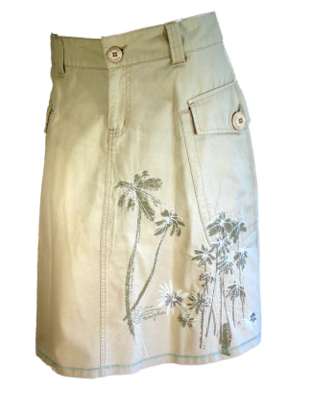
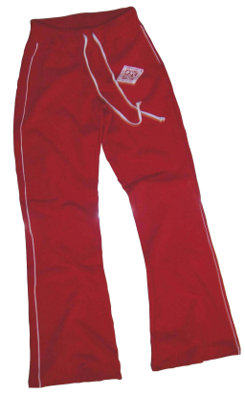

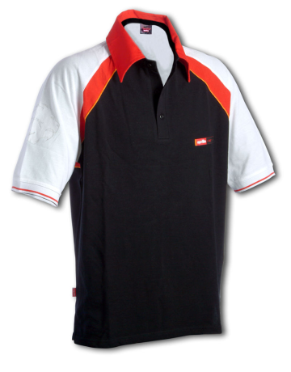
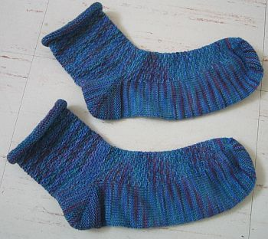

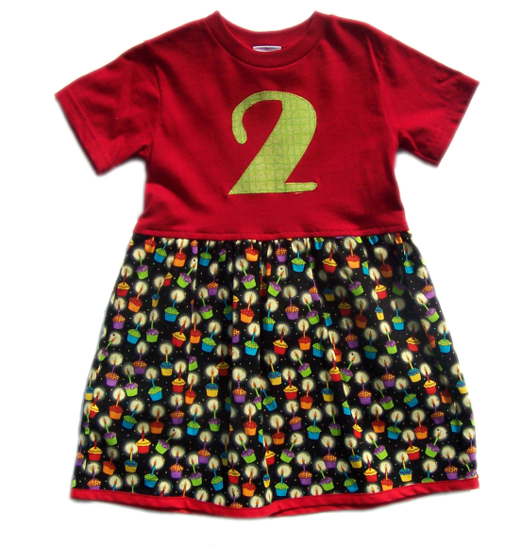

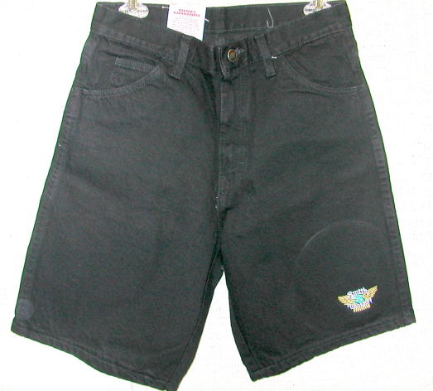

Winter and Rain Clothing
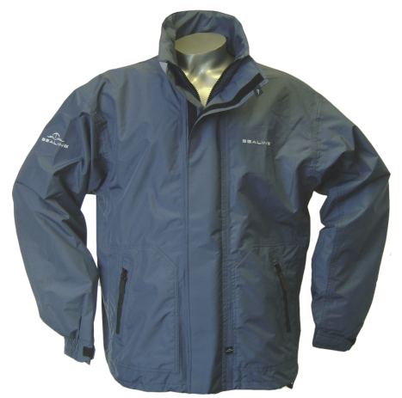
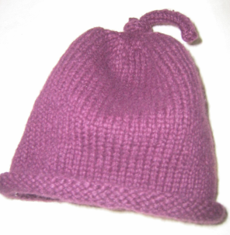
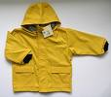

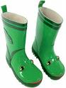

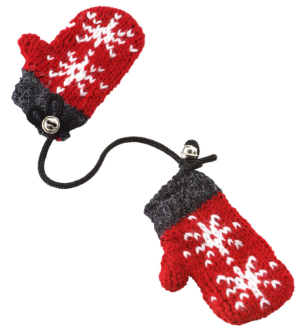
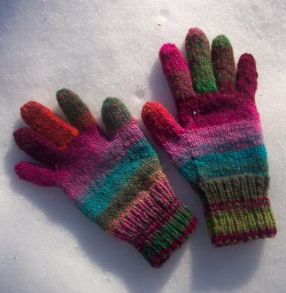

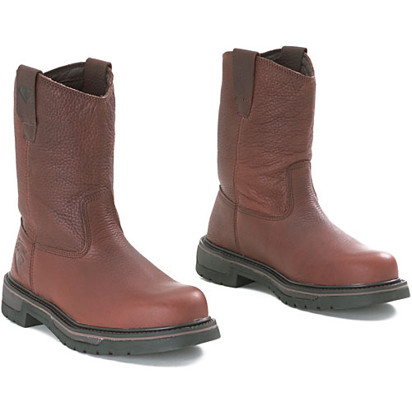
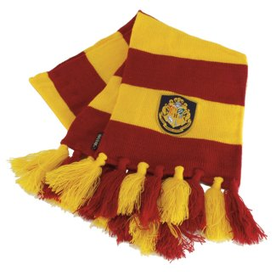

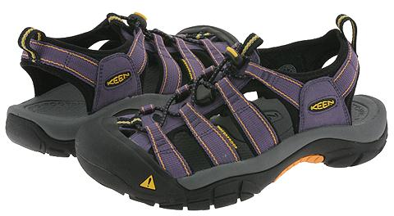
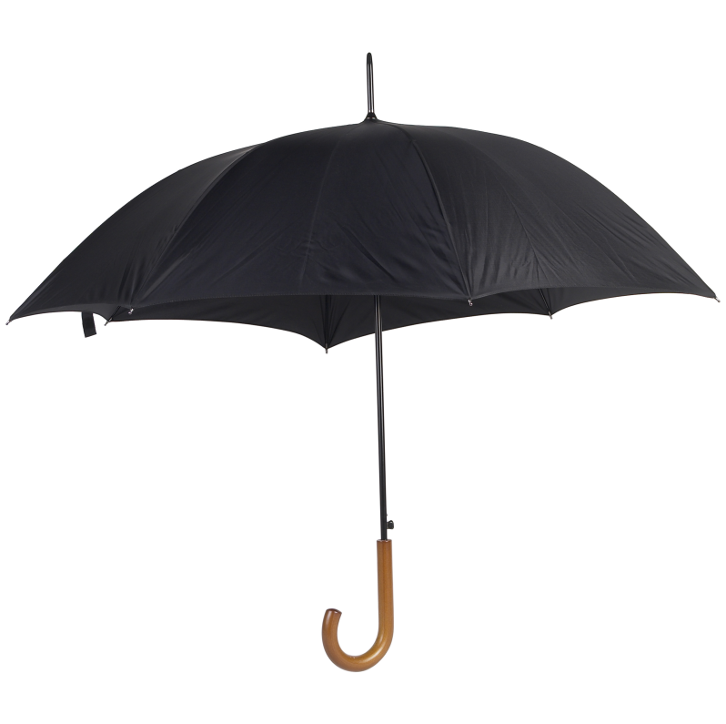
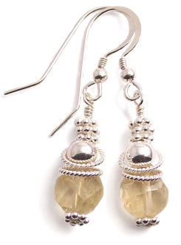
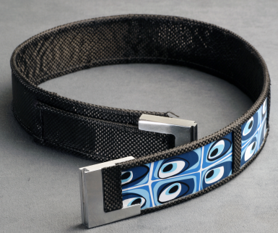
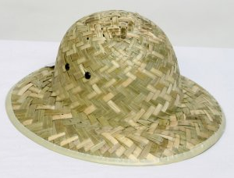
Accessories

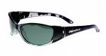

Weather

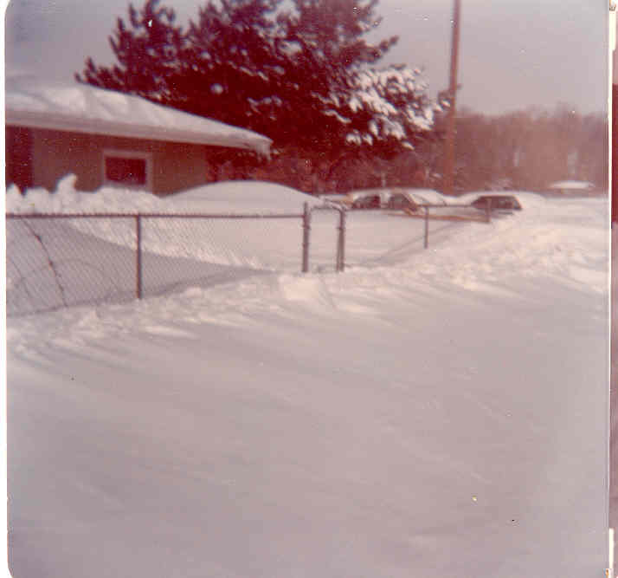

Windy
Snowy

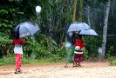

Rainy Sunny
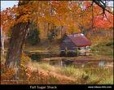
Seasons
Spring Summer Fall Winter

Months and Clothing
(A two-board game)

START
shorts | Pants | winter  Scarf | summer  Hat | flip-flops
Sandals | Sunglasses | Light jacket | Pants | Skirt
heavy socks | rain boots | Sleeveless shirt | mittens | rain jacket
Winter hat | umbrella | Long warm coat | Summer dress | Snow boots
END

January | February | March | April
December |  |  | May
November |  |  | June
October | September | August | July

Shopping Trip!

You can go shopping! What clothes do you want to buy?

Example:
Clothing | Color | Price
1. A skirt | Black | Rp. 50,000
2. A belt | Brown | Rp. 20,000

It’s your turn!

Clothing | Color | Price
1.
2.
3.
4.
5.
6.
7.
8.
9.
10.

Go around the room. Tell your friends what you want to buy. Find someone to go shopping with!

- Activities and Times

TIME

1. Teaching Time
Use a teaching clock to teach times. Teach hour and half hour first. Then teach “after” and “to” by moving the hands five minutes at a time and repeating the time. Teach one version first, then add additional versions (e.g. three-thirty, half past three; quarter after, fifteen after, quarter past, fifteen past). After showing and students repeating, have students make times that you call out on student clocks. Finally, move to showing a time on the teaching clock, and having students tell you what time it is. Repeat all of these activities over the course of several weeks during review sessions.

2. What time is it?
Periodically stop in the middle of your lesson to ask students what time it is. Do this over several weeks’ time as students are learning to say the time.

ACTIVITIES

1. Charades
Have these common daily activities on pieces of paper around the room (choose activities you know your students are involved in):
- Get up
- Take a shower
- Get dressed
- Eat breakfast
- Go to work
- Study
- Eat lunch
- Exercise
- Eat supper
- Go to bed
Act out each one, and ask a student to bring you the card for what you are acting out.

2. Times and Activities
Say a time, and ask students to guess which activity you do at that time. When they get it right, state it in a sentence: “I get up at six o’clock.” Let students take turns saying times, with their classmates guessing what they do at those times.

3. Time Questions
Looking at the activity cards, have students work in pairs to ask and answer the question, “What time do you _______?”

4. Activities
Show pictures of sports activities. Teach the names of the activities. Ask students to make simple statements such as:
- I play soccer.
- I don’t play basketball.
- I don’t go camping.
- I swim.
When students answer affirmatively, ask “When do you play soccer?” Elicit answers such as, “I play soccer on Mondays at 4:00.”

5. Olympic Athletes
Ask students to pretend that they are Olympic athletes, and choose a sport. In front of the class interview students to find out when they practice their sport.

SONGS
- When I Wake Up
- Days of the Week

CHANTS
- Brush Your Teeth

GAMES / ACTIVITIES

Time Game (basic and intermediate)
This is a good follow-up after students have learned how to say the time of day in English. Before the game begins, the teacher puts the following on the board:
Student 1: What time do you _______ on _______?
Student 2: I ________ at __________ on _______.
OR
I don’t __________ on __________.
The teacher explains: When a student (Student 1) lands on a phrase and a day of the week, he will use that information to pose a question to another student in the group (Student 2), such as, “What time do you study on Saturday?” Student 2 will then answer with one of the options above. For example, “I study at 9:00 on Saturday.” OR “I don’t study on Saturday.”

WORKSHEETS
- What time?

Activities
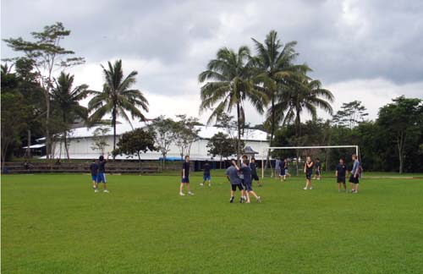
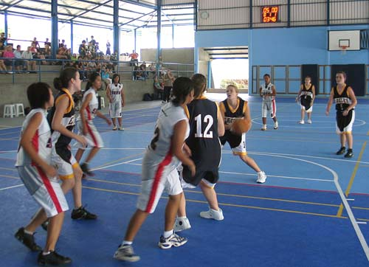

Playing basketball
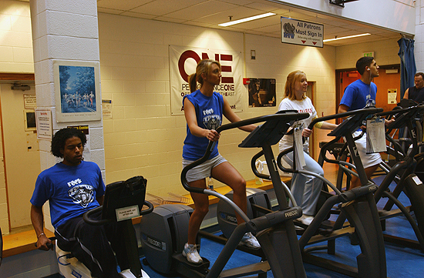
Playing soccer
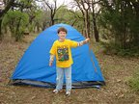

Camping Working out

Running

Playing hockey

Swimming

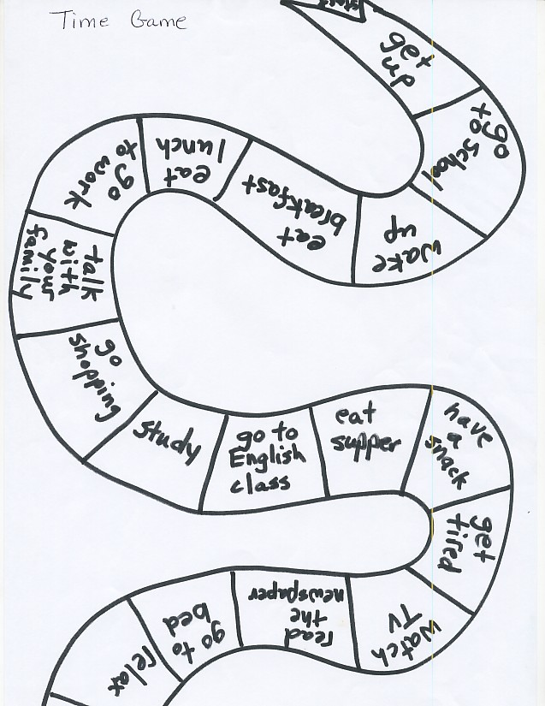
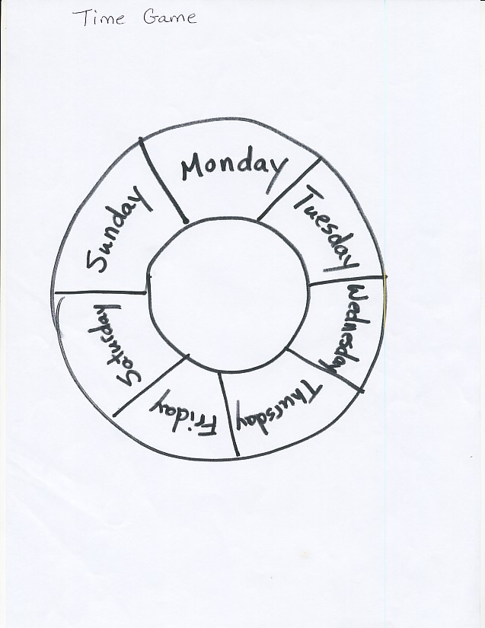
What time?

Ask: What time do you…?
Answer: I _________ at __________.

Friend   | Get up | Take a shower | Eat lunch | Study | Exercise | Go to bed

