Steps to follow for faculty being observed

Observation by peer evaluators

- Watch for an email from each of your two peer evaluators who will be contacting you and your department chair to determine the courses to be observed and dates for the observations.

- Be in conversation with your department chair to identify the two courses that will be observed by the peer evaluators this semester.

- Using the information the peer evaluators sent you regarding their schedules, send each of your peer evaluators Outlook Calendar appointments for the following three events:
  - Pre-observation conference (set for a few days prior to the first observation)
  - First observation date/time/class location
  - Second observation date/time/class location (usually the next class period, but not necessarily)

- Watch for two additional email messages from forms@messiah.edu. Each of the email messages will include a link to the form that will be used for the peer evaluation. Once you have determined which peer evaluator will observe which courses and the dates of the observations, you will use the link from the email to complete the pre-observation conference questionnaire. The first screen will look like the image below. If the information is correct, click Next.
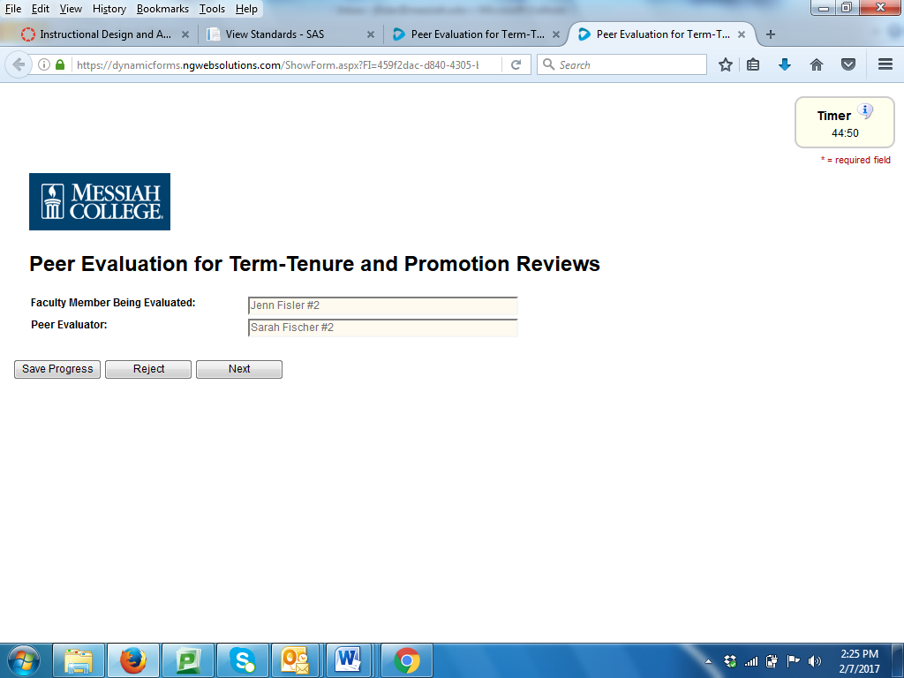

NOTE: Each screen has a 45 minute time limit. If you need additional time or need to take a break while working on the form, click Save Progress. Then click Continue. See Screenshot below.

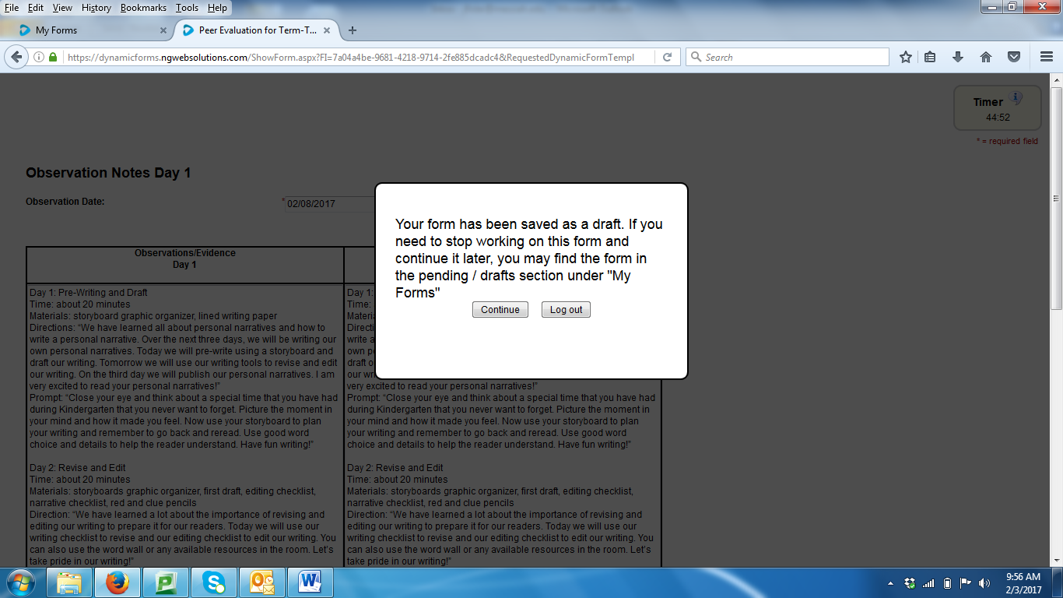

- The next screen will be the pre-observation questionnaire (see questions on page three of this document). You will also upload your course syllabus and other supporting materials that are relevant to the class periods the evaluator will observe.

- Once you complete the questionnaire, click Next on each of the subsequent screens (those are for the peer evaluator to complete) until you see the screen shown below. On this screen, type the name and email address of the evaluator to whom this questionnaire should be sent. This will be the same name as the person on the first screen listed as the evaluator.

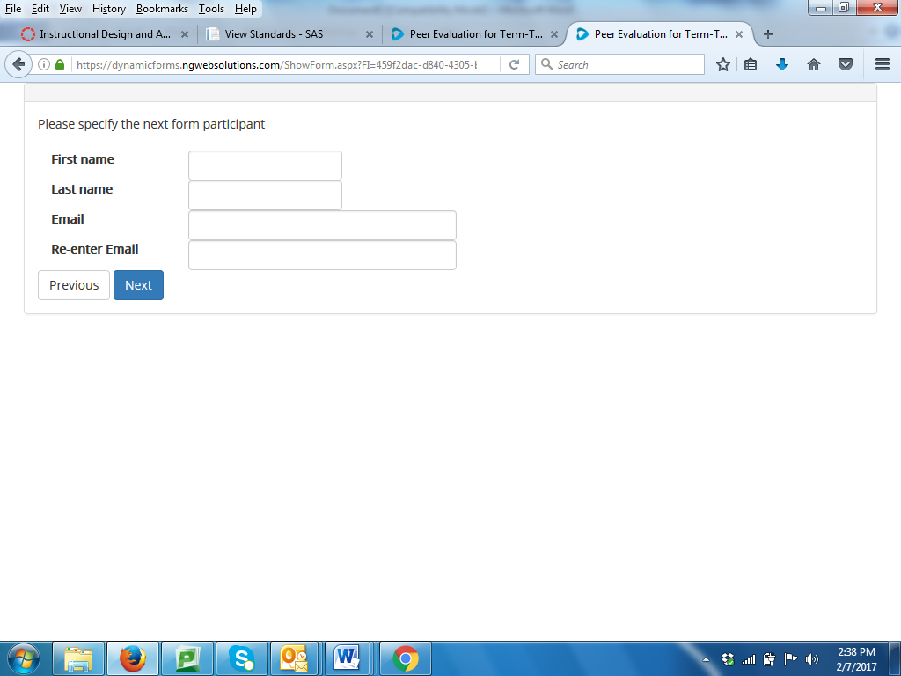

- Click Next and electronically sign the form by typing your name (see screenshot below). The questionnaire will automatically be sent to the respective evaluator.

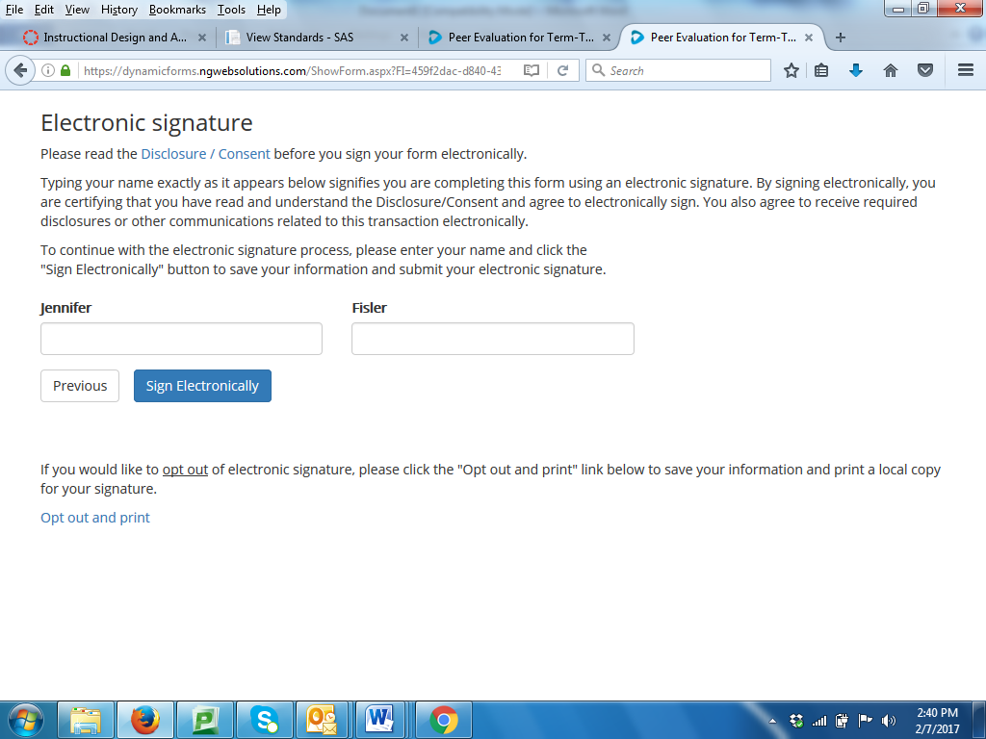

- After the observations, your evaluator will submit the completed observation form to the Provost’s Office. You will also receive a copy. You should then contact your evaluator to schedule a post-observation conference.

Observation by chair/director/dean

- The process for chair/director/dean observations is nearly identical to that of the peer evaluators with the following exceptions related to the way you will be notified of classes and dates to be observed.

- Watch for communication from chair/dean to determine the courses to be observed and dates for the observations.

- Accept Outlook Calendar appointments for the following three events:
  - Pre-observation conference (set for a few days prior to the first observation; may also be conducted via email)
  - First observation date/time/class location
  - Second observation date/time/class location (usually the next class period, but not necessarily)

- Watch for an email message from forms@messiah.edu. This email will include a link to the form that will be used for the class observation. Use the link from the email to complete the pre-observation conference questionnaire. Follow the remaining steps outlined above in #4 and continuing.
Pre-observation Conference Questionnaire (to be completed using Dynamic Forms)
Top of Form
* = required field
Faculty member being evaluated:* | Peer evaluator:*
Course being observed:* | Number of students:*
Pre-observation conference date:* | Primary Meeting location:*
Bottom of Form

Class location:*
Observation Protocol
- Peer evaluators are identified by the Provost- one from within the faculty member's school and one from outside the faculty member's school.
- Peer evaluator and faculty member follow TTP policy in identifying the classes/times for the observation.
- Peer evaluator and faculty member schedule the observations, conduct the pre-observation conference and complete the questionnaire (typically within a couple days of the observation).
- Peer evaluator conducts two class observations and completes the observation form.
- Peer evaluator submits final observation form to Provost's Office.
- Peer evaluator and faculty member meet for a post-observation conference to discuss the observations.
Pre-Observation Conference Questionnaire (completed by the faculty member being evaluated prior to the pre-observation conference)
1. Who are the students (year(s), major(s), etc.)? | *
2. What has been happening in the class to this point? | *
3. What are your goals for the class session(s)? | *
4. What teaching and learning activities will you use to meet the goals? | *
5. What will the students have done in preparation for class? | *
6. In addition to your syllabus, what materials are you sharing with the reviewer? | *

File Uploads:

