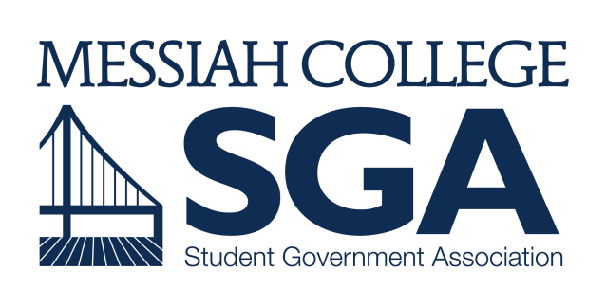
Please email this form to sgavp@messiah.edu by April 11th by 4pm for review by the Finance and Organizations Committee.

2017-2018 Capital Purchase Request Form

What is an SGA Capital Purchase? In some years, SGA Clubs and Organizations as a whole do not spend all of their funding. When this happens, unspent funds are remitted to the SGA Capital Purchases Fund. This money can be spent to purchase long-term, physical assets that will benefit the general Messiah College populace.
Name and Position of Requester:

Messiah Staff/Faculty Partner (if requester is a student):

Amount of Request: $
Attach additional financial documents as needed

Description of Item(s):

Explanation of Need:

Please include any other appropriate information.

