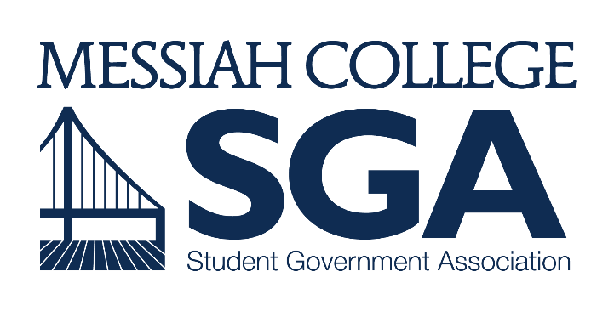
STUDENT REVIEW BOARD APPLICATION FORM

Responses to Page 1 must be submitted electronically to sga@messiah.edu with the subject line “SRB Application”

Petition forms on Pages 2 and 3 must be completed with hand-written signature endorsements of your candidacy from 75 current Messiah College students and delivered under the door to the SGA Office in Larsen Student Union 202

Both components are due by 11:59pm on September 13th, 2018

NAME:

CLASS:

This is an election, not a typical job application. Therefore, you will not be required to show past experience, skills/expertise, or any type of resume. Like in any real election, you will put out whatever you want about yourself that you think will help to get you elected. This section below is an essay, and it is your opportunity to “campaign” to your peers. Once the elections start, what you write in this section will be available to the voters. Write whatever you want, and however much you want. Again, the only things required to be allowed to run for this position are having a name and attending Messiah College. Nothing that you write here will affect that. As long as you submit your name, class, and signatures, you will be on the ballot. This essay below should only contain what you want to share with voters.

ESSAY:

Printed Name | Signature
1.
2.
3.
4.
5.
6.
7.
8.
9.
10.
11.
12.
13.
14.
15.
16.
17.
18.
19.
20.
21.
22.
23.
24.
25.
26.
27.
28.
29.
30.
31.
32.
33.
34.
35.
36.
37.
38.

Printed Name | Signature
39.
40.
41.
42.
43.
44.
45.
46.
47.
48.
49.
50.
51.
52.
53.
54.
55.
56.
57.
58.
59.
60.
61.
62.
63.
64.
65.
66.
67.
68.
69.
70.
71.
72.
73
74.
75.

