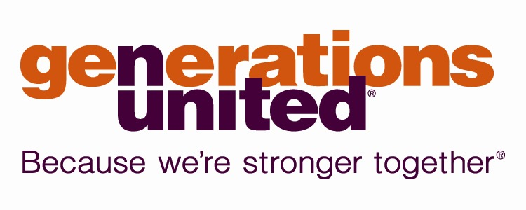
MEDIA CONTACT: Alan King
Generations United, 202.777.0116
aking@gu.org

PRESS RELEASE FOR IMMEDIATE RELEASE
Elder Service Partner Program Designated A Program of Distinction
Designation serves as the U.S. benchmark for intergenerational programs.

(Mechanicsburg, PA) – Generations United has proudly announced that Elder Service Partner Program at Messiah College Department of Human Development and Family Services has been designated a Program of Distinction within the intergenerational community.

“We congratulate Elder Service Partner Program for earning this distinction and their dedication to intergenerational practices,” notes Donna Butts, executive director of Generations United. “The Program of Distinction designation is the U.S. intergenerational community’s ‘seal of approval.’ The application and review process are rigorous. Achieving this recognition is a major accomplishment and says a program employs best practices and effectively serves the surrounding community.”
The mission of the Elder Service Partner Program is to link the lives of college-aged students with those of older adults in an effort to enrich both by building meaningful intergenerational relationships while serving together. Originally implemented in 2000 as a result of grant support from the Association for Gerontology in Higher Education (AGHE) and the University of Pittsburgh’s Generations Together (GT), the Elder Service Partner Program continues to be an integral part of the Sociology of Aging class at Messiah College.

Dr. Raeann Hamon, distinguished professor of family science and gerontology and creator of the program noted, “This designation means so much to me! I value the Elder Service Partners as co-instructors in this course. They teach my students things about aging and living that I could never do in the classroom alone.”
Generations United launched the Program of Distinction designation in 2010, with support from New York Life Foundation, to recognize excellence while celebrating the rich diversity among intergenerational programs. This year, three intergenerational programs from across the nation earned the distinction. Joining Elder Service Partner Program are Grandparent Family Apartments at Presbyterian Senior Services; Intergenerational Place, Permanence and Shared Social Purpose at Bridge Meadows; Opening Minds through Art at Miami university Scripps Gerontology Center; The Intergenerational School; and TimeSlips Creative Storytelling – Creative Trusts.
Grandparent Family Apartments, Presbyterian Senior Services, New York, NY: Presbyterian Senior Services has been a pioneering leader of kinship services since the early 1990’s when it held support groups at its senior centers for grandparents raising grandchildren. Its innovative PSS/WSF Grandparent Family Apartments, one of the first residences for kinship families, opened in 2005. With the Grandparent Family Apartments as its hub, PSS now provides kinship caregiver services in three boroughs of NYC. Our success is because PSS has programs that support both the grandparents and the grandchildren: from “Parenting a Second Time Around” training for grandparents to the Young Adult Success Program (YASP) for kinship youth.
Intergenerational Place, Permanence and Shared Social Purpose, Bridge Meadows, Portland, OR: Bridge Meadows is an intentional intergenerational housing community in North Portland. Serving foster youth, adoptive parents, and low-income elders, Bridge Meadows cultivates permanence and family resilience through integrated onsite support services and therapeutic interventions. Children move from the instability of foster care placements to permanent homes and families. Adoptive families receive essential guidance and social support. Low-‐ income elders combat the deleterious health effects of social isolation by volunteering 100 hours/quarter in the community. Together, our three generations of residents transform individual vulnerability into collective strength, creating a whole that is greater than the sum of its parts.
Opening Minds through Art, Miami University Scripps Gerontology Center, Oxford, OH: Opening Minds through Art (OMA) is an intergenerational art program for people with dementia. It is grounded in person-centered ethics and founded on the fact that people with dementia are capable of expressing themselves creatively. There is a growing body of empirical evidence that creative expression improves their physical and psychological well-being. The mission of OMA is to build bridges across age and cognitive barriers through art. The program is implemented in group sessions: Up to 12 people with dementia with the assistance of 12 trained volunteers working on a one-to-one basis. The art-making sessions culminate in a gallery exhibition celebrating the artists’ accomplishments while educating the public about the creative capacities of people with dementia.
The Intergenerational School, Cleveland, OH: The Intergenerational School (TIS) is a successful community public
school located in Cleveland, Ohio. In this elementary school adults of all ages participate as co-learners in supporting life-long learning and spirited citizenship. The recipient of many local, national and international awards the model is now being replicated in Cleveland (Near West and Lakeshore Intergenerational Schools) and elsewhere. Studies demonstrate the value of the model for both children and elders, including those with cognitive challenges like dementia. The school has developed innovative programs in literacy, environment, health, information technology, and the arts. The school fosters collective wisdom in service of a sustainable future.
TimeSlips Creative Storytelling – Creative Trusts, Milwaukee, WI: This program recruits, trains and coordinates undergraduate students to facilitate creative storytelling sessions with elders with cognitive disabilities in care communities affiliated with the Creative Trust in Milwaukee. Students commit to a semester of storytelling, but commonly continue for the full year. At year’s end, the stories are shared publicly to inspire others to use creative engagement to nurture relationships with people with cognitive disabilities. TimeSlips is used in service learning around the country, but the Creative Trust offers a stable, shared governance of the program that is a national model for collaboration in this important area of need.
###
About Generations United: For nearly three decades, Generations United has been the catalyst for policies and practices stimulating cooperation and collaboration among generations, evoking the vibrancy, energy and sheer productivity that result when people of all ages come together. We believe that we can only be successful in the face of our complex future if generational diversity is regarded as a national asset and fully leveraged. www.gu.org.

