8/20/14
Revision Date:
8/20/14
Reviewed Date:
File No: Vehicle Management Policy Policy Owner: Department of Safety Orig. Date: 09/12/06

Messiah University Vehicle Management Policy

Policy: Messiah University strives to manage its vehicle fleet, leased/rented, and pool as effective and efficient as possible; to be consistent with our mission, to abide by state and federal regulations, insurance, as well as with University policies and procedures. ONLY approved drivers may operate a fleet, lease/rented, or pool vehicle.

Objectives: To provide clear and concise policy guidelines for the use of fleet, pool and/or leased vehicles by approved drivers of Messiah University.

Definitions: Fleet Vehicle – Fleet vehicles governed by this policy are road licensed vehicles owned by the University. These are assigned to departments and/or employees.

Pool Vehicle – Pool vehicles are governed by this policy are road licensed vehicles owned and suitable for providing basic transportation for any approved driver. These vehicles are available, upon scheduling, for any approved driver.

Leased/Rented Vehicle – Leased/rented vehicles governed by this policy are road licensed vehicles leased or rented by the University for specific department and/or a purpose/destination.

Approved Driver – A person who has successfully completed the Safe Driving Program and has authorization/approval by the University to drive University vehicles (fleet, pool or leased) while on official business.

University Employee – Any full-time or part-time faculty, staff member, grad assistant or any student worker employed by Messiah University.

Student – Any enrolled full-time or part-time student.

Responsibility: Facility Maintenance Services, Fleet Services, Department of Safety, University Receptionist

Vehicle Management Policy Approved August 2014

Fleet Management Structure
  - Facility Services / Facility Maintenance Service Manager
    - Day-to-day operations overseen by the Facility Maintenance Service Manager.
    - Authorizes grounding of vehicles due to inclement weather.
    - Responsible for vehicle maintenance and/or repairs.

  - Department of Safety
    - Oversight for the Approved Driver Program.
    - Oversees on-line driver training program.
    - Performs behind the wheel training.

  - University Receptionist’s office
    - Processes applications
    - Maintains the approved driver list.
    - Oversight of pool vehicle reservations.

Policy Standards
  - Approved Driver
    - Must possess a current, valid drivers’ license.
    - An employee or full-time student as defined on page 1 of this policy.
    - Must complete the Approved Driver Application.
    - Must successfully complete the University’s on-line Safe Driving Program.
    - Provide proof of personal automobile insurance coverage currently in place.
    - Complete the MVR Request Form (to obtain driving record for the past 3 years)
      - Students are required to complete the MVR Request annually when reapplying.
      - Employees are required to complete the MVR Request every two years (which is every other year) when reapplying.
      - Approval will be based on the matrix provided within this Fleet Management Policy.
    - Behind the wheel testing is required if needing to drive a 15-Passenger Van. This testing is required once you have been approved through the application and MVR process. This is a one-time test unless deemed necessary by the Safety Department to take it again.
    - Renewal of driving approval required annually on or before September 30.
      - If the driver was approved between April 1 and August 1 in the same year prior to the September 30 deadline, no renewal is necessary.
      - Employees must re-apply every 2 years; the behind the wheel training is not required unless you have been instructed to do so.
      - All students even must renew annually.
    - Revocation/non-approval of approved driver status is dependent upon meeting all criteria of this policy.

  - Pool Vehicles
    - Only used for institutional outreach or University related business; pool vehicles are not for personal use.
    - Student clubs or organizations must be officially recognized by the University and chartered through SGA (Student Government Association).
    - Approval for students may be granted in the event a health related need as specified within the student Care and Medical Transportation Policy.
    - 15-Passenger vans require a behind-the-wheel competency training
    - Messiah University owned or leased 15 passenger vans shall NOT be used at any time to

transport minors of the age of pre-primary, primary, or secondary school students (0 to 17 years of age).
    - The use of a roof rack or similar roof mounted cargo carrier is prohibited.
    - The towing of a trailer behind a University owned and/or leased 15 passenger van is prohibited.
    - Wheelchair Accessible Van requires vehicle familiarization training.
    - Travel to Canada and Mexico mandates additional insurance requirements.
    - A minimum of $25 cleaning fee will be charged if vehicle requires additional clean-up (exterior and interior).

  - Leased/Rented Vehicles
    - Used only if a Pool Vehicle is not available.
    - Vehicles must be leased/rented from an authorized rental agency and may NOT be rented from satellite/kiosk type venues (i.e., hotel lobby, gas stations, etc.).
    - Approved drivers must abide by all age requirements or other restrictions as set forth by the leasing agency.
    - All vehicle rentals for University business must be purchased with a University assigned VISA card. The driver’s name must also appear on the lease agreement, along with additional drivers if any.

All rentals of cars for University business are to waive the Loss Damage.
    - All rentals of 15 passenger vans are strongly encouraged to purchase the Loss Damage with the decision to be made in conjunction with their appropriate Vice President.

The VISA cardholder is responsible to report any accident immediately and provide all required documents as outlined in the attached VISA Corporate Card Benefit document.
    - The University will cover any deductible that VISA does not cover on cars and all deductibles on vans. However, multiple incidents will result in a meeting with the employee’s respective Vice President
    - Travel to Canada and Mexico mandates additional insurance requirements.

  - Fleet Vehicle
    - Dedicated vehicles to a specific individual or department.
    - Employees must pass the 15-passenger van test prior to driving one of the fleet trucks or cargo vans.

E. Personal Vehicles

1. If using a personal vehicle, the vehicle owner’s personal auto insurance is primary coverage for liability, comprehensive and collision damage to the vehicle.
- The use of a personal vehicle is permitted if the traveling distance is within a 30-mile radius of the University. The use of a personal vehicle is also permitted if no University vehicles are available.
- Motorcycles, scooters, mopeds, and/or bicycles are not permitted to be used for University Business Travel.

Insurance
  - Pool Vehicles
    - The University’s automobile liability insurance coverage is primary coverage for approved drivers.
    - University employees and student workers are covered for bodily injuries by Workers’ Compensation insurance.
    - Non-student workers and other passengers are covered for bodily injuries

under their personal automobile insurance policy (per Pennsylvania law).
    - Uninsured passengers’ (those without automobile insurance) would be covered for bodily injury under their healthcare insurance.
    - Travel to Canada and Mexico mandates additional insurance requirements.

  - Leased/Rented Vehicles
    - See above Policy Standards “C” for additional insurance information & requirements
    - Travel to Canada and Mexico mandates additional insurance requirements
    - Automobile liability insurance coverage is provided for approved drivers.

    - University employees and student workers are covered for bodily injuries by Workers’ Compensation insurance.
    - Non-student workers and other passengers are covered for bodily injuries under their personal automobile insurance policy (per Pennsylvania law).
    - Uninsured passengers’ (those without automobile insurance) would be covered for bodily injury under their personal healthcare insurance.

  - Fleet Vehicle
    - The University’s automobile liability insurance coverage is primary for approved drivers.
    - University employees and student workers are covered for bodily injuries by Workers’ Compensation insurance.
    - Non-student workers and other passengers are covered for bodily injuries under their personal automobile insurance policy (per Pennsylvania law).
    - Uninsured passengers’ (those without automobile insurance) would be covered for bodily injury under their healthcare insurance.
    - Travel to Canada and Mexico mandates additional insurance requirements.

  - Personal Vehicle While Used for University Business
    - The vehicle owner assumes all responsibility for liability, comprehensive and collision damage to the vehicle. (Because of this exposure, employees are encouraged to use pool vehicles).
    - University employees are covered for bodily injuries under the University’s worker’s compensation policy.
    - Non-student workers and other passengers are covered for bodily injuries under their personal automobile insurance policy (per Pennsylvania law).
    - Uninsured passengers’ (those without automobile insurance) would be covered for bodily injury under their personal health insurance.

Accidents / Breakdowns
  - Fleet, Pool and/or Leased/Rented Vehicles
    - All accidents or vehicle damage of Fleet, Pool and/or Leased/Rented vehicles occurring on and off campus must be immediately reported to the Dispatch Services office at 717- 691-6005.
    - Drivers must complete an accident report.
    - Photos of all vehicles involved are required. Cell phone photos are ideal.
    - A minimum suspension of 14 days can occur immediately following an
accident, pending an internal investigation for all pool, fleet or leased/rented vehicles.
    - Employees must inform their supervisor immediately of any accident
    - A Safety Officer will inform the student or employee at the time of reporting the accident that their driving privileges are immediately suspended until the investigation is completed. Employee suspensions will be handled by the Vice President for Operations

in cooperation with the immediate supervisor or area Vice President as to the length of an appropriate suspension.
    - Accidents determined to be attributable to the driver may carry personal financial (insurance deductible) responsibility for the driver of a Fleet, Pool, and/or Leased/Rented vehicle.

If vehicle is rented and the CDW/LDW was declined, the VISA cardholder is responsible for reporting the damage to VISA, along with all required documentation.
    - If 15-passenger van is rented and CDW/LDW was declined, driver must also report this accident to the Office of the Vice President for Operations.

  - Vehicular / Mechanical Breakdown
    - Driver will immediately contact the Department of Safety/Dispatch Services at 717-691-6005 upon any mechanical problem or breakdown for Pool Vehicles.

Miscellaneous
  - Safety
    - All drivers and passengers must wear seat belts at all times.
    - The number of passengers may never exceed the number of seat belts in the vehicle.
    - Windshields (front & back) and other windows must be completely cleared of all ice and snow prior to driving.

The hood and roof of all vehicles must be cleared of all snow and ice prior to driving.
    - Cell phone use while driving is prohibited.
    - All drivers must follow the speed limit and all other laws.

  - Revocation of Privileges
    - Failure to disclose to the Department of Safety, any revocation and/or suspension of license by governing agency.
    - Arrest and/or subsequent conviction for DUI, DWI, underage drinking, cited for reckless driving or other serious vehicular offenses committed either on or off-campus in a University vehicle or personal vehicle.

  - Drivers are personally responsible for paying the cost of all fines (including court costs, late fees, penalties, etc.) for traffic violations, speeding citations, parking citations or EZ-Pass violations received while operating a University fleet, pool, and/or leased/rented vehicle. Drivers are required by this policy to immediately report such instances of violation to the Department of Safety. Failure to do so may result in the suspension or permanent revocation of driving privileges.

Approval Signatures:

Kathy Gates, University Receptionist

Brad Markley, Dir. of Facilities Services

Cindy Burger, Dir. of Safety & Dispatch Services

Approval Signatures Cont’d.:
Dan Smith, Facility Maintenance Service Manager

Steve Kennedy, Fleet Services Mechanic

Sean Paddock, Asst. Dir. of Safety, Patrol & Operations

Kathrynne G. Shafer, V.P. for Operations

Driver Acceptability Matrix - Messiah University

 | Number of Accidents Within the Past 3 Years |  |  |  | Number of Major Violations within the Past 3 Years
Number of Moving Violations within the  Past 3 Years | 0 | 1 | 2 | 3 | 1 or More
0 | ✓ | ✓ | ?
1 | ✓ | ✓ | ?
2 | ✓ | ?
3 | ?
4
5

Major | - DUI | - Speeding >21 mph over limit
Violations
consist of but
 | - License Suspension | - Possession of Illegal Drugs
not limited
to:

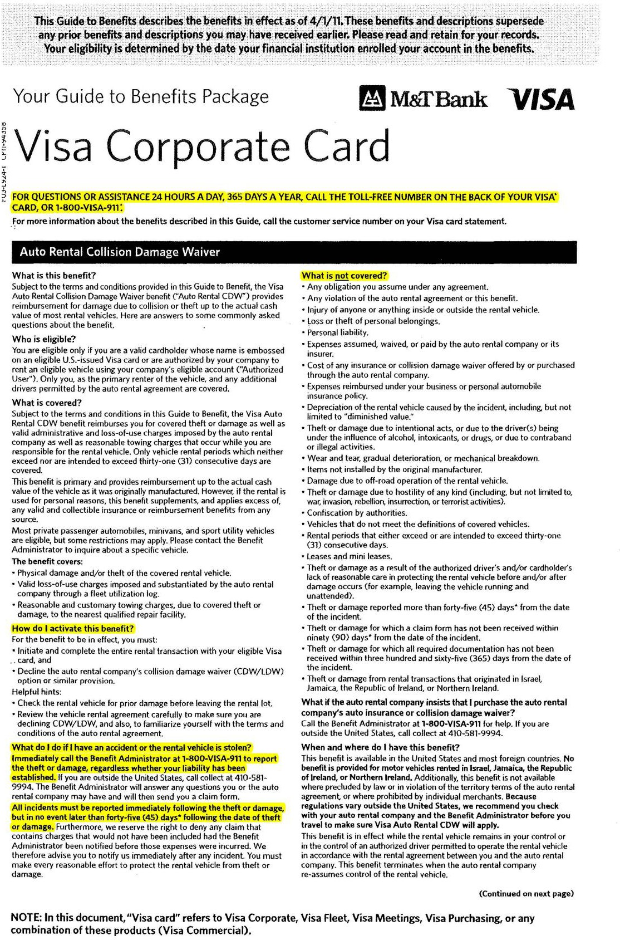

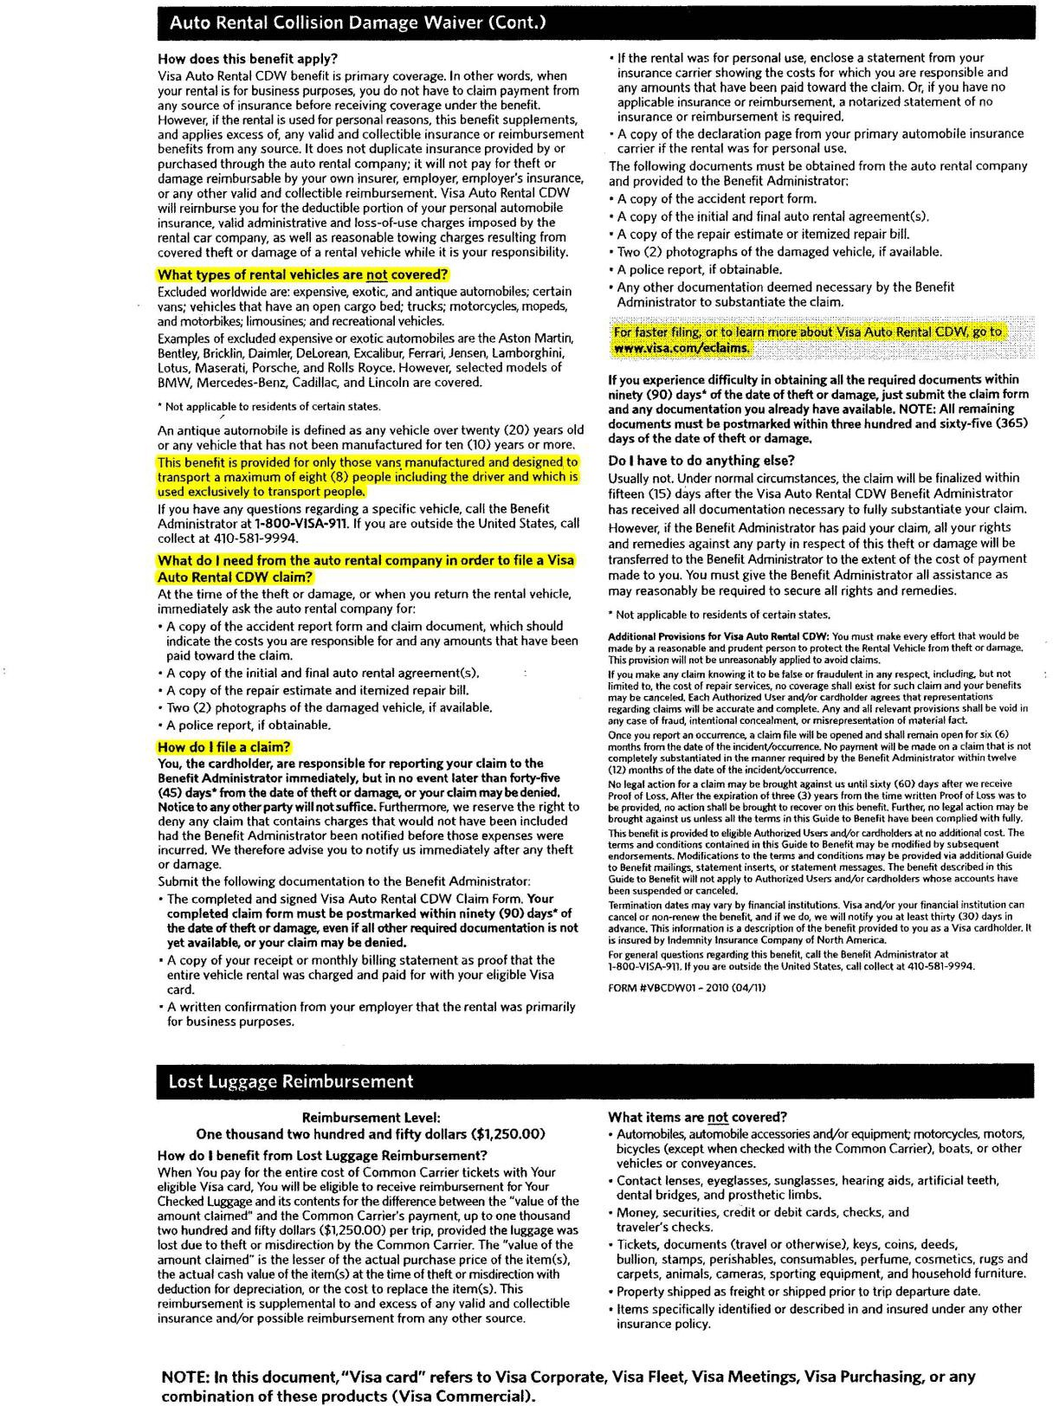

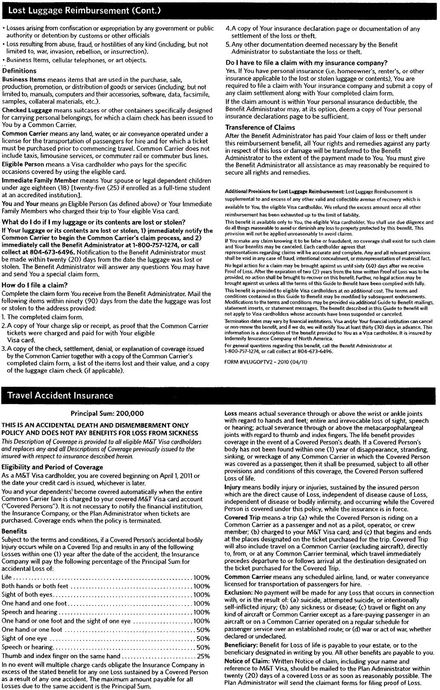

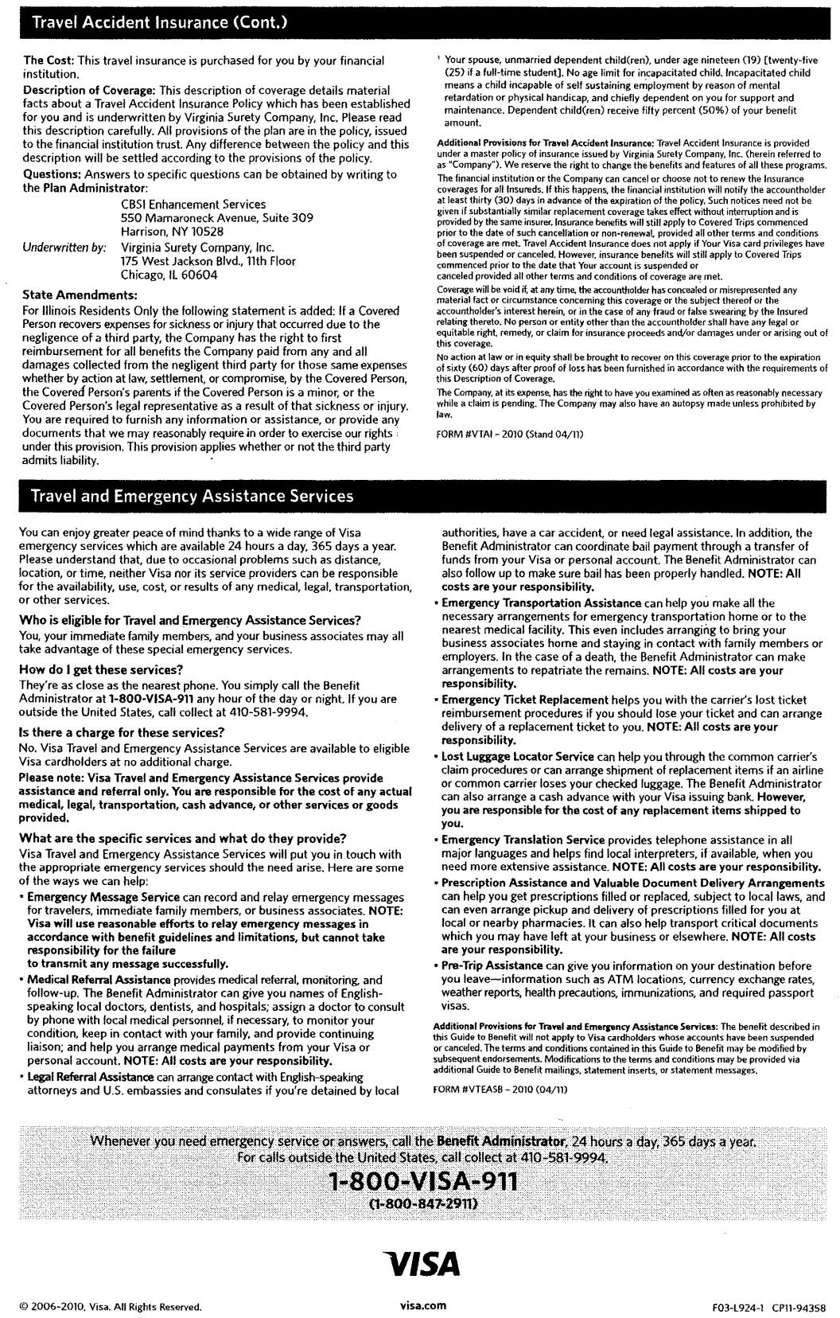

Messiah University
Vehicle Management Procedures-Addendum

- I. Obtaining Approved Driver Status
  - Car and/or Mini Van
    - Must be an employee or full-time student as defined on page 1 of this procedure.
    - Must possess a current, valid drivers’ license
      - Foreign academic student employees may apply to obtain a learner’s permit and driver’s license from PennDOT
http://www.dmv.state.pa.us/teenDriversCenter/obtainingLearnersPermit.shtml
    - Complete the following forms found on Department of Safety website:
      - Approved driver application
      - Complete the on-line Safe Driving Program
      - MVR Request Form http://www.messiah.edu/info/20570/safety_training/820/University_fleet_driving_services
    - Provide proof of personal automobile insurance coverage currently in place including any restrictions imposed by your personal auto insurance (a declarations page or other documentation indicating coverage and/or restrictions)
    - Send complete driver application, MVR Request Form and proof of personal automobile insurance to the University Receptionist
    - Notification of MVR will be provided within 2 weeks.
    - Upon confirmation of approved driver status, complete the Safe Driver on-line training found on Department of Safety Website: http://www.messiah.edu/info/20570/safety_training/820/University_fleet_driving_services

  - 15-Passenger Van and/or Facility Services Truck(s)
    - Follow procedures for car and/or mini van
    - Upon MVR approval, schedule and complete additional behind-the-wheel testing with the Department of Safety. This is a onetime test unless deemed necessary by the Safety Department to take it again.
    - Notification will be provided within 2 weeks.
    - Facility Employees may be required to train on specific vehicles within the Facilities Department.

  - Wheelchair Accessible Mini Van
    - Follow procedures for car and/or mini van
    - Schedule and complete additional training with the Department of Safety
    - Notification will be provided within 2 weeks

II. Reserving a Pool Vehicle
  - Reservations
    - Pool vehicles are reserved through the University Receptionist
    - See below website for policies: http://www.messiah.edu/info/20570/safety_training/820/University_fleet_driving_services
    - Reservations are made through McSquare under Employee Forms / Operations / University Vehicle Request Form.

  - Pool Vehicle Pick-up
    - Driver must pick-up keys and present their current driver’s license and University ID
    - University Receptionist will provide:
      - Keys

      - Invoice / inspection form
      - Fuel card (tank must be replenished if gauge is ¾ or less)
    - Vehicles are housed at the Lenhert Building, South Entrance of Campus
      - BEFORE removing vehicle from lot
        - Driver must inspect the exterior and interior and note any damage (i.e., small scratches, stone chips, etc.) on the reverse side of the invoice/inspection form.
        - Windshields (front & back) and other windows must be completely cleared of all ice and snow prior to driving. It is Pennsylvania Law that snow and ice be removed from the top of a vehicle to prevent damage/injury to other vehicles/persons. This offense carries a fine to the driver that ranges between $200 & $1,000.

  - Fuel Cards
    - Accepted at most major gas stations
    - A four digit authorization number and vehicle’s odometer reading must be provided at the time of fuel purchase
    - Drivers must obtain a receipt for each fuel purchase

  - Pool Vehicle Return
    - Return vehicle by time indicated on your reservation form. If you are overdue on the return time, please contact Dispatch Services at 717-691-6005
    - Fuel must be replenished if the gauge displays ¾ of a tank or less; if it is not, refueling the tank will be charged to the respective department.
    - Return vehicle to location where it was picked up unless involved in an accident (see accident Section III)
    - BEFORE exiting vehicle, driver must record the ending mileage on the invoice/inspection form
    - Driver must remove all trash and any personal belongings. A minimum cleaning fee of
$25 will be assessed if vehicle requires additional clean-up
    - Return keys, invoice/inspection form, and fuel card with receipts to the University Receptionist immediately upon your return.
    - Verbally report any damage or mechanical problems to the University Receptionist.

Canada or Mexico Travel
  - Requirements
    - Due to the stipulations imposed by Canada and Mexico, vehicles taken across these borders carry additional insurance requirements. Canada requires a special insurance card and Mexico requires a separate policy. For both instances, the driver must contact the office of the Vice President for Operations to obtain the necessary paperwork. Please allow one (1) week for processing these requests.

IV. Accident / Damage
  - All Vehicles - General Information
    - All accidents (with or without damage) must immediately be reported to the University Dispatch Office at 717-691-6005.
    - There is an accident information kit in each vehicle’s glove compartment.
    - Upon return to campus, immediately go to Dispatch Office in the Eisenhower Campus Center to report the accident/damage to the Safety Department.
    - Never leave the scene of any accident or damaged property.
    - If it’s a minor accident involving an unoccupied vehicle and/or property, try to locate the owner, and/or leave a note with your contact information and place on windshield under the wipers.

    - If accident involved property damage, locate property owner and exchange information
    - All accidents will be investigated by the Department of Safety. A minimum suspension of 14 days will occur immediately following an accident, pending an internal investigation for all pool or leased/rented vehicles.
    - Employees are required to report any accident immediately to their supervisor.

  - All Vehicles - Major Accident
    - If possible, move involved vehicles from the roadway. If not, then vehicle occupants should exit the vehicle and move to a safe location off of the roadway.
      - Check for injuries.
      - Call 911 for Police, Fire/Rescue or EMS.
      - If trained, provide first aid care
      - Never leave the scene of any accident (e.g. unattended vehicle) or damaged property. Always contact and report the incident to the Police.
      - Take photos of all vehicles involved and of all damages
    - Await police arrival
      - Provide Police with the following
        - Your driver’s license
        - Vehicle registration card (in glove compartment)
        - Vehicle insurance card (in glove compartment)
      - Obtain a copy of the Police’s completed preliminary investigation form. Be certain the following information is on the form:
        - Location (address) of accident and or damage property
        - Name, address, and phone numbers of all parties involved
        - Insurance company name, policy umber and phone number
        - Driver’s license number and state of other driver
        - Vehicle Identification Number (VIN) of other vehicle
        - Vehicle license plate number and state of all vehicles involved

  - All Vehicles - Minor accident (fender bender)
    - Call 911 (depending upon territory, police may not respond)
    - Obtain the exact location of accident, address if possible; if not, obtain route numbers, and note surrounding businesses
    - Exchange information with other driver(s)
      - Driver’s Name, address, and phone numbers of all parties involved
      - Insurance company name, policy umber and phone number
      - Driver’s license number and state of other driver
      - Vehicle license plate number and state of all vehicles
      - Vehicle Identification Number (VIN) of other vehicle(s)
      - Obtain any witnesses names, addresses, and phone numbers
    - Take photos of all vehicles involved, including all damage

  - All Vehicles - Upon returning to campus
    - Proceed directly to the Dispatch Services office in Eisenhower Campus Center
    - A Safety Officer will collect the following:
      - Accident report documentation
      - Any photos for downloading
      - Written driver and/or witness statements
      - Take additional photos if necessary

  - Rented/Leased Vehicles
    - Renter must notify VISA IMMEDIATELY upon any accident or damage the rental vehicle has sustained. See Visa information at the end of these procedures.

  - Revocation of Approved Driver Status
    - Any driver involved in a vehicular accident with a Pool vehicle will immediately have their approved driver status suspended for a minimum of 14 days pending the accident investigation
    - Approved Driver status will be reinstated at the discretion of the Vice President for Operations.

Safety

  - All drivers and passengers must wear seat belts at all times
  - The number of passengers may never exceed the number of seat belts in the vehicle
  - Windshields (front and back) and all other windows must be completely clear of all ice and snow prior to driving. Also, all snow and ice must be removed from the roof and hood of the vehicle.
  - Cell phone use while driving is prohibited
  - All drivers must follow the speed limit and obey all other laws

