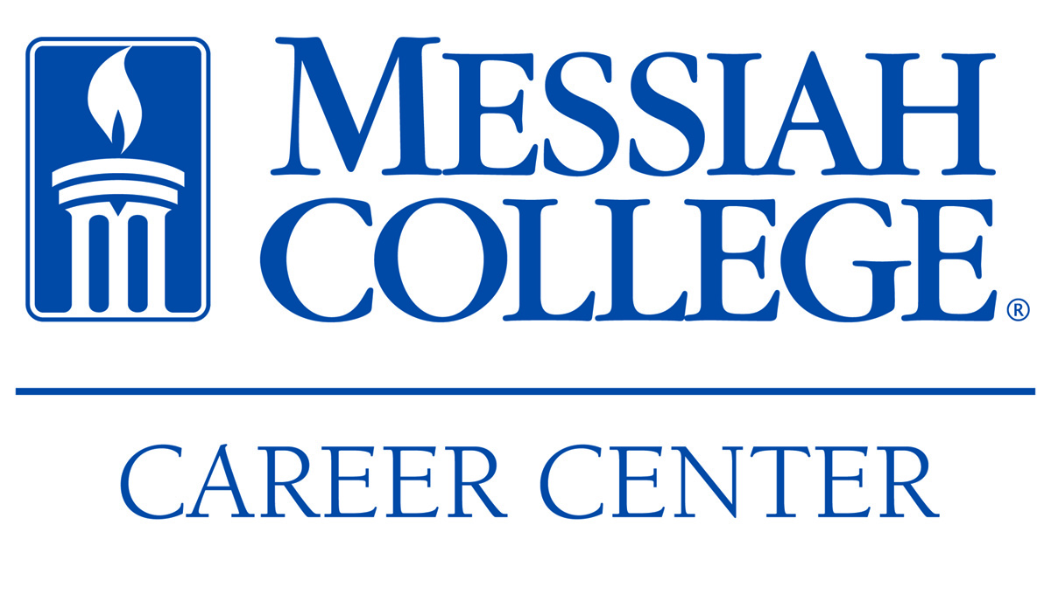
PROGRAMS & EVENTS | 2012-2013
FALL 2012
SEPTEMBER  Career Center Open House – 9/11/12  Meet the staff and learn about our services and events  Accounting Night – 9/19/12  Annual job fair targeting accounting or related majors  Graduate School Advising Luncheon – 9/25/12  Co-sponsored with Academic Advising; information session for students considering graduate school  Pizza with the Pros: INTERNATIONAL JUSTICE MISSION 9/21/12 @ Noon  Featuring Emily Rainville, ’04, Foundations Prog. Mgr.  Graduate School Practice Test Drives – 9/22/12  Free practice tests for students planning to pursue graduate school admission. Practice tests include: GRE, GMAT, MCAT, and LSAT | OCTOBER  Rezumania – 10/3/12, 10/16/12, 10/18/12  Drop-by résumé critiques with Career Center staff  “Into the City”– 10/10/12 – 10/12/12 (Boston)  2-day career immersion program exposing students to living, working, and connecting in an urban context through company site visits, panel presentations, and a networking reception. Involves alumni, parents, and friends of Messiah.  Career & Graduate School Expo – 10/22/12  Largest on-campus job and graduate school fair of the year | NOVEMBER  “Writing Personal Statements & Essays for Graduate School” – 11/5/12  Workshop for those who are applying to graduate or professional school  “Into the City Mini"– 11/8/12 (Martin’s Famous Pastry Shoppe)  A “mini” version of the Into the City program. Students will meet with Scott Heintzelman, ’89, VP of Finance and Administration and Messiah College Board of Trustee member, along with other executives and Messiah alumni employed at the organization. Program involves company tour, panel presentation, and a networking dinner.  Mock Interview Day – 11/9/12  Practice interview sessions with Career Center staff.
SPRING 2013
FEBRUARY  Rezumania - 2/7/13, 2/12/13  Drop-by résumé critiques with Career Center staff  Cumberland Valley Consortium (CVC) – 2/13/13  & Central PA Employment Consortium (CPEC) Job Fairs – 2/19/13  Job and internship fairs co-sponsored by the Career Center  Graduate School Practice Test Drive – 2/23/13  Free practice tests for students planning to pursue graduate school admission.  Networking and Etiquette Dinner – 2/26/13  Students will learn essential professional skills while interacting with alumni. | MARCH  Camp Days -3/5/13 & 3/7/13  Recruiters on campus for summer positions with camps across the country  Teacher Recruitment Day - 3/21/13  Job fairs for education majors co-sponsored by Messiah College Career Center | APRIL  “Into the City”– 4/11 – 4/12/13 (location TBD)  2-day career immersion program exposing students to living, working, and connecting in an urban context through company site visits, panel presentations, and a networking reception. Involves alumni, parents, and friends of Messiah.  Mock Interview Day with Messiah Alumni – 4/26/13  Practice interview sessions with guest alumni interviewers.

