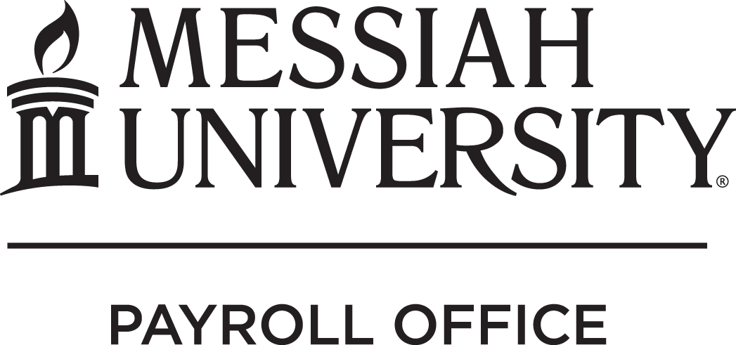

Leave Policy Disclaimer

Messiah University policy, as defined in the Policy and Procedure Manual, is to provide leave-eligible employees with access to vacation, sick, and personal time at the beginning of his/her employment and continue to accrue leave annually at the beginning of each fiscal year—as outlined in the Manual. Leave-eligible employees are defined to be those employees—excluding faculty—who work a minimum of 1,000 hours per fiscal year.

Upon termination of employment, Messiah University has the policy of deducting payment for any vacation, sick, or personal hours taken but not yet earned. In other words, while employees are given all leave time at the start of employment and each subsequent fiscal year, this time given assumes the employee will complete the year of service.

By returning this disclaimer form, vacation, sick, and personal leave may be used before it is actually earned within the current fiscal year. However, in the event of termination of employment, I hereby authorize Messiah University to deduct payment for all vacation, sick, and personal leave hours taken but not yet earned. The employee will be responsible for any monies that could not be recovered from an employee’s final paycheck(s).

I have read and understand this policy.

Employee Name:

Employee Signature: Date:

