A
SSESSMENT OF
S
TUDENT

L
EARNING
M
ANUAL

A Guide to Assessment

Third

Edition

Table of Contents
Overview ....................................................................................................................................... 3
What Does the University Expect? ................................................................................................ 6
Academic Departments ............................................................................................................. 6
QuEST: Qualities Essential for Student Transformation ............................................................ 7
Student Affairs .......................................................................................................................... 9
What is the University’s Policy on Assessment Plans and What Programs Do We Assess? ........ 11
Academic Programs ................................................................................................................. 11
Policies ........................................................................................................................... 12
When are Departments Expected to Complete Assessment Activities? ..................................... 13
Appendix ..................................................................................................................................... 14
Assessment Rubric .................................................................................................................. 14
Student Success Assessment Manual ..................................................................................... 19

Overview

What is the assessment of student learning at Messiah?
The assessment of student learning is a process of
- Creating clear, measurable expectations of the knowledge, skills, and beliefs our students should gain by completing the required curriculum;
- Ensuring that we give our students adequate instructional opportunities that will help them achieve these outcomes;
- Executing a plan to gather, analyze, and interpret evidence of student learning to determine how well their performance meets our expectations;
- Using this information to take strategic action to improve student learning. (Suskie, Assessing Student Learning, 2004)
Who does it?
All Messiah University educators should be aware and involved in the assessment of student learning, and we play various collaborative roles to ultimately ensure our students are achieving the outcomes we expect from a Messiah education. Specifically,
- Department chairs and program directors lead curricular and co-curricular educators in creating departmental/program assessment plans, collecting and analyzing annual assessment data, and setting and executing action plans to improve student learning.
- School deans ensure their departments/programs are maintaining effective assessment plans and practices by co-scoring an annual assessment rubric for each major housed in their school, as well as helping department chairs prioritize and execute strategic improvements in student learning outcomes assessment.
- The assistant dean of general education works with all educators teaching in the QuEST curriculum to report assessment outcomes on QuEST course objectives each semester. The office of general education aggregates and reports results on outcomes annually.
- The assessment of student learning committee (ASLC), with broad representation from educators across campus, educates committee members on assessment best practices, develops strategic plans to improve campus assessment efforts, and approves assessment plans accompanying curricular proposals.
- The director and assistant director of assessment provide resources and education to deans, chairs, and educators in order to support the ongoing improvement of assessment efforts. The director produces an annual report on assessment efforts and works with the Provost’s Cabinet to make strategic improvements.

How does assessment relate to your department’s curriculum and to the institutional mission?
Each academic department maintains curricular requirements, which students complete in order to earn majors, minors, and concentrations in an academic field of study. While individual instructors gain helpful information about learning gains in their own courses, departmental assessment of student learning answers the question, “How do we know students are achieving the outcomes we expect from the required curriculum?” Departments find answers to this question by ensuring that they
- articulate clear program level learning objectives that express the knowledge and skills that a graduate of the program/major should be able to achieve
- identify curricular requirements in which students have adequate opportunities to gain the stated learning outcomes (curriculum mapping)
- select representative samples of the learning within the curriculum (i.e. assessment measures) that provide evidence of the learning
- collectively review evidence of learning, interpret the results, and make strategic plans to improve learning outcomes by making changes in instruction, assignments, or curriculum
- ensure the actions we take result in meaningful improvements in student learning
Likewise, students gain essential knowledge and skills by completing the QuEST general education curriculum and by participating in student success programming. It is critical to know what students gain from their educational experience as a whole, and it is critical for educators to understand how their contribution relates to the other components of a Messiah education and our institutional learning outcomes. As a result, we ensure that all program level learning outcomes (in academic majors, QuEST, and Student Success) contribute in specific ways to our stated institutional learning outcomes. The undergraduate learning outcomes (ULOs) are as follows, and pages 3-8 of the Assessment Resource Handouts provides a matrix explaining the specific contributions of majors, general education, and student success to these outcomes.
- Foundations for Learning: Students will develop skills common to the liberal arts and sciences: research, analysis, reflection, and communication
- Breadth and depth of knowledge: Students will develop knowledge common to the liberal arts and sciences in the fields of arts, humanities, natural sciences, and social sciences. Students will also develop specialized knowledge and disciplinary expertise
- Faith knowledge & application: Students will develop informed and mature convictions about Christian faith and practice
- Specialized skills and scholarship: Students will become proficient in the scholarship of their discipline and demonstrate specialized skills needed to pursue a career and/or graduate school
- Self-Awareness: Students will gain awareness of identity, character, and vocational calling
- Social responsibility: Students will demonstrate a commitment to service, reconciliation, and justice, and respond effectively and ethically to the complexities of an increasingly diverse and interdependent world.
Upon completion of their degree, Messiah University graduate students will achieve the following Graduate Learning Outcomes (GLOs):
- Exhibit mastery of specialized knowledge
- Perform scholarly activities informed by professional standards.
- Demonstrate mastery of competencies required in their field of study
- Articulate how Christian faith and principles inform their vocation
- Apply ethical principles relevant to their profession
- Demonstrate intercultural competence

What Does the University Expect?

Academic Majors
The University expects every academic major to develop a plan for assessing student learning, and to work toward improving learning outcomes on an ongoing basis alongside other important department goals. Department assessment expectations are outlined in the assessment evaluation rubric (Appendix A), and this rubric is used to evaluate department assessment annually. The rubric sets the standard for assessment plans and processes, and it evaluates department progress in the following areas:
- Process: The department is expected to maintain a complete assessment plan, and to collect assessment data as prescribed by the plan. The department is also expected to revise the plan in accordance with any curricular changes that affect program learning outcomes or any measures within the plan.
- Engagement: The department should aim to engage all relevant stakeholders (educators, students, employers, alumni) in the creation/revision, implementation, analysis, and/or improvement processes associated with the assessment plan.
- Program Learning Objectives: Program learning objectives should lead with an active, measurable learning verb, and state clearly the knowledge and skills a graduate of the major should be able to attain as a result of program completion. Departments should have about 5-7 program learning objectives.
- Measures: Each program learning objective should be assessed using multiple measures (actual evidence of student achievement) that assess student learning at various points within the curriculum. The measures should align well with the stated learning objective (for instance, if students should be able to “describe” content, we should assess the objective using a measure in which students demonstrate their ability to describe). Departments also benefit from the strategic use of indirect measures, such as a senior survey, alumni or employer advisory board. Each assessment plan should incorporate a variety of assessment measures, rather than relying heavily on one measure or one type of measure.
- Targets: Targets are meant to set a bar for expected student achievement; they should be challenging yet achievable. Targets should not be arbitrarily chosen, but instead should reflect past student achievement and professional standards. Targets should be set in order to inspire program improvement.
- Timeline: Timeline refers to the frequency with which departments collect and analyze assessment data. Departments should collect all assessment data prescribed by the assessment plan at least once within a three-year period, and the year and semester of data collection should be clearly documented in the assessment plan.
- Use of student learning data from prior academic year: Departments are expected to develop action plans to improve student learning on an annual basis, and then work throughout the year to execute those plans, i.e. close the loop. Action plans should be driven by evidence of learning outcomes, they should be specific, and they should be feasible. Plans need to be recorded in the University’s assessment management system and included in department annual goals. The department should evaluate the effectiveness of the action plans it implements in order to assess whether its efforts improved learning outcomes.
- Dissemination: The department retains records of assessment results and changes made as a result of assessment findings, and results are entered in the assessment software system. Assessment results and improvements are publicly posted and shared proactively with faculty, prospective students, employers and alumni in ways that facilitate their discussion.

QuEST: Qualities Essential for Student Transformation
(General Education)
Each year the Office of General Education and Common Learning establishes the objective faculty will assess for each course and communicates that information to all faculty during May development week. The expectation is that faculty teaching in General Education will assess and share the resulting data for each QuEST course they teach. Faculty select the assessment measure most suited to their course: paper, assignment, test question, etc. All faculty (both FT and adjunct) teaching QuEST courses assess the objective as assigned in May Development. The Office of General Education and Common Learning emails reminders to QuEST faculty about the expected assessment data in the beginning, middle and end of the semester.
All new QuEST faculty are required to attend a training at the beginning of their first semester where the assessment objective, tool and timeline are communicated.
A current list of the QuEST objectives can be found on our messiah.edu/quest homepage under the curriculum tab or you can click here.

Curriculum Mapping for QuEST

Foundations for Learning
1:
:
Abilities of the Liberal Arts
1:
foster students who discern and
communicate effectively (9hrs)
FYS (3)
CCC* (3)
Oral Comm (3)
Breadth and depth of
2:
knowledge
Knowledge of the Liberal
1:
Arts
promostes students' grasp of
the larger picture (35hrs)
Math/Natural Sci (9)
Social Sci/History (6)
Humanities/Arts (9)
Langues/Culture (9)**
Faith knowledge and
3:
application
Christian Faith
3:
(6
hrs
)
Bible (3)
Christian Beliefs (3)
Self
5:
-
Awareness
6:
Social responsibilty
4:
Social Responsibilty
)
(6
hrs
Health and Physical Fitness (3)
Engaging a Pluralistic World (3)
Non
-
Western (2
-
3)

ULOS

QuELOs

Courses

*CCC also provides content foundation for QuELO 4: Social Responsibility
**CCS also provides content foundation for QuELO 4: Social Responsibility

Student Success and Engagment
Division of Student Success and Engagement
The Division of Student Success and Engagement involves assessment of the following departments: Agape Center, Athletics, Career and Professional Development Center, University
Ministries, Engle Health and Counseling Center, Intercultural Office, Residence Life, Academic Accessibility, Student Involvement and Leadership Programs, Student Conduct and Fitness Center.
Program-Level Outcomes and Annual Goals
Student Success has six student outcomes (dig deep, be rooted, be cultivated, branch out, be strong, bear fruit) that nest within Messiah’s Undergraduate Learning Outcomes. Each of the six Student Success outcomes connects aspects of Messiah University’s mission, our Undergraduate Learning Outcomes, and the Council for the Advancement of Standards in Higher Education (CAS). Each Student Success department has established specific student learning outcomes that connect up to the undergraduate learning outcomes and the student success outcomes for each educational program housed in Student Success. The Division of Student Success collects, analyzes, and publishes data annually to inform improvements for student learning and the student experience.
A list of Student Success outcomes and the most recent Student Success Annual Report can be found on our messiah.edu Student Success homepage under the student learning outcomes tab or you can click here.

Mapping for Student Success Outcomes
# | Student Success Outcome | Description of Outcome | University Mission | Foundational Values | Undergraduate Learning  Outcomes | CAS
1 | Cognitive  Development  DIG DEEP | Critical thinking, reflective thinking, effective reasoning,  intellectual flexibility,  emotional/cognition integration, identity/cognition integration | Maturity of Intellect | 1 | Foundations for Learning  (1) | 1,2
2 | Identity  Development and  Spiritual  Formation  BE ROOTED | Formation of a maturing sense of self, personal attributes such as identity, self esteem, confidence, ethics and integrity, maturing sense of self in relationship to God resulting in spiritual practices, characterbuilding, reconciliation, service, and intentional growth | Maturity of Christian faith and character | 1,2,4,5 | Faith  Knowledge &  Application  (3) | 3
3 | Cultural  Competence  BE CULTIVATED | Understand, value and appreciate human differences, develop cultural competency, understand and pursue reconciliation | Reconciliation in church and society | 2,3,5 | Social  Responsibility  (6) | 5
4 | Leadership and  Civic Engagement  BRANCH OUT | Sense of civic responsibility, commitment to service, effective in leadership, commitment to living in community | Maturity of character, preparation for lives of service and leadership | 3,4,5 | Self  Awareness (5) | 4,5
5 | Interpersonal and  Intrapersonal Competence  BE STRONG | Realistic self appraisal and self understanding, personal goal setting, meaningful  relationships, interdependence, collaboration, ability to work with people different from self | Maturity | 2,3,4 | Self  Awareness (5) | 3,4
6 | Practical  Competence  BEAR FRUIT | Effective communication, capacity to manage one's personal affairs, economic selfsufficiency and vocational competence, maintain personal health and wellness, prioritize leisure pursuits, living a purposeful and satisfying life | Preparation for life in church and society | 2,4 | Self  Awareness (5) | 6

What is the University’s Policy on Assessment Plans and What Programs Do We Assess?

Academic Programs
- General principle: When program development is incremental: assessment grid development will be incremental as well, comparable to level of program development.
- Approval Protocol
  - Department chair/program director works with the dean to develop assessment plan, in conjunction with the Director of Assessment and the Director of Curriculum/Assistant Director of Assessment.
  - ASLC scores assessment plan and submits to Director of Assessment. The assessment plan must earn a 3 in each of the relevant areas before it can be moved on to the curriculum Committee, specifically: learning objectives, measures, targets, and timeline.
  - If the score is less than a 3 in any of the relevant areas, the Director of
Assessment works with the Dean and chair/director to improve the plan.
  - Once the Director of Assessment verifies that the necessary changes have been made and the plan earns a 3 in each of the relevant rubric criteria, the plan becomes a part of the full proposal that is approved by the Dean and sent on to the Curriculum Committee/Graduate Council.
- The process for determining the need for revisions in assessment plan for the revision of current programs.
  - Each major/graduate program has an assessment plan. The assessment plan should adequately evaluate the learning gains students achieve as a result of completing the required curriculum, as well as account for variations in learning outcomes (e.g. tracks, concentrations). Therefore, some curricular revisions to existing majors/programs may have an impact on assessment plans.
  - Department chair/program director and dean review curricular changes to evaluate impact on the assessment plan. Proposed curricular changes not accounted for by the existing assessment plan or changes to courses serving as assessment measures will be discussed with the Director of Curriculum. In these situations, revised assessment plans are submitted to ASLC for review and approval. Changes to measures are for informational purposes only, to update HelioCampus.
  - ASLC scores the assessment plan and submits to Director of Assessment. A plan must be assessed as at least a 3 in each of the relevant areas (i.e. objectives, measures, targets, timeline) before it can move on to the curriculum Committee.
  - If the score is less than a 3 in any of the relevant areas, the Director of Assessment works with the dean and chair to improve the plan.
  - Once the Director of Assessment verifies that the necessary changes have been made, the plan becomes a part of the full proposal that is approved by the Dean and sent on to the Curriculum Committee/Graduate Council.
- What are the “programs” we assess?
  - Messiah University assesses each program reported to Middle States
Commission on Higher Education. Middle States defines programs on the basis of IPEDs award levels. At Messiah, this includes undergraduate degrees, graduate degrees, and certificates.
  - Each undergraduate major/graduate program will have an assessment plan and annual scored rubric for every undergraduate major/graduate degree.
  - Certificates may be assessed within major/program assessment plans if certificate learning outcomes represent a subset of the learning outcomes for the major/program. If certificate learning outcomes differ from the major/program, they will maintain a separate assessment plan.
  - The size, complexity, and any variations in learning outcomes (e.g.
tracks/concentrations) should be reflected in the assessment plan in a way that is proportionate to those variations.
  - Given the current status of minors institutionally, deans have the discretion to determine if an assessment plan is required for a minor depending on the number of students in the minor, or whether the minor does not have a related major (e.g. statistics).

Policies
Messiah’s contracted workload expectation for Ranked Faculty involves responsibilities in
Teaching, Institutional Service, and Scholarship. Assessment falls under the categories of Teaching and Institutional Service through Student Learning and Institutional Effectiveness respectively. Below is an excerpt from the COE Handbook Section Six—Personal Policies: Ranked Faculty, Part IV: University-Wide Definitions for Teaching, Institutional Service and Scholarship.
Student Learning: The most important indicator of teaching effectiveness is student learning. Faculty need to be identifying and implementing assessments in their courses that provide useful information about the extent to which students are achieving the full range of assigned course learning objectives in their courses. These assessments need to be high quality in terms of their relevance to course objectives (validity) and their ability to yield trustworthy (reliable) information about student learning. Because a primary purpose of classroom assessment is to inform and improve instruction, faculty need to demonstrate that they are using assessment results to guide their teaching practices.

Institutional Effectiveness involves activities that enhance other departmental, school, or University-wide efforts. Representative examples include:
- Chairing one’s department
- Serving on a departmental or school-wide committee
- Writing a departmental review or accreditation report
- Helping to design and implement a program-level assessment plan

* Refer to the COE Handbook Section Six—Personal Policies: Ranked Faculty, Part III and part IV to read the full policies.

When are Departments Expected to Complete Assessment Activities?

The University operates on an annual assessment cycle. The table below details required assessment activities, who is responsible to complete the activities, and the deadlines for each activity.

Assessment Cycle Timeline
When | Who | What
June/July | Director & Assistant Director | Summarize rubric results and May development work from the Annual Assessment Plan and Findings data collection  Prepare Annual Assessment Report  Meet with Deans to discuss HelioCampus assessment data and the Annual Assessment Plan and Findings
August/September | Deans and  Chairs/Program Directors | Meet to confirm action plans and other goals for academic year related to student learning
September-April | Chairs | Execute any action plans that resulted from the analysis of the previous academic year’s assessment data
Each term | Chairs and Faculty | Link and enter scores for Canvas assignments used as assessment measures through HelioCampus by the end of each term
Each term | General Education Faculty | Link and enter scores for Canvas assignments used as assessment measures through HelioCampus by the end of each term (one course objective per academic year)
May | Department Faculty,  Chairs/Program Directors | Meet to review assessment results, develop and enter action plans to improve student learning in Annual Assessment Plan and Findings in HelioCampus
June | Deans | Approve program end of year assessment submissions and score annual assessment rubric

Appendix

Assessment Rubric
Criteria | 1 | 2 | 3 | 4
Process  Is the plan being implemented faithfully and revised as needed? | Assessment plan is not implemented. | Most aspects of plan are being implemented or all aspects are implemented to some degree. | Assessment plan is fully implemented. | Plan is faithfully executed and modified/evaluated as needed.
Explanations:
Engagement  Are all relevant parties are meaningfully involved in the creation/revision, implementation, analysis, interpretation and learning improvement process? | Limited involvement beyond chair/director | All educators contributing to the curriculum are aware of process and results | All educators contributing to the curriculum participate in conversations regarding the use of assessment data to improve student learning | All relevant stakeholders (students, employers, alumni) are meaningfully involved in the creation/revision, implementation, analysis, interpretation, and/or improvement processes associated with this assessment plan.
Explanations:

Criteria | 1 | 2 | 3 | 4
Program Learning Objectives  Are the program learning objectives clear,  measurable, aligned with ULOs/GLOs, and  representative of the range of learning for that major/program? | Objectives are problematic  (vague, abstract, not aligned with ULOs/GLOs) or missing. | Objectives are clear, mostly measurable, partially aligned with ULOs/GLOs. | Objectives are clear, measureable, aligned with ULOs/GLOs, and represent an overview of the knowledge, skills, beliefs, and values that are important for a graduate of this major/program, accounting for variations in learning outcomes due to  tracks/concentrations | Objectives are clear, measurable, aligned with ULOs/GLOs, and  representative of the range of learning that is important for this program.  The learning objectives provide a comprehensive view of the knowledge, skills, beliefs, and values that are important for a graduate of this major/program and accounting for variations in learning outcomes due to tracks/concentrations
Explanations:

Criteria | 1 | 2 | 3 | 4
Measures  Are the instruments used  to assess learning relevant for the objective? Do measures yield information/data you can use to drive improvement? | Not all objectives have a measure identified.  OR  Measures do not directly connect to the objectives. | All objectives have at least one direct measure.  Measures connect to learning objectives superficially or tangentially and/or include learning other than stated objectives.  Relies almost exclusively on the same form of assessment (survey, exam, project).  Relies almost exclusively on data from a single source  (course, program, activity). | All objectives have at least one direct measure.  Some objectives have multiple measures.  Measures clearly connect to learning objectives.  And two of the following four criteria:  - Objectives measured more than one point in time (formative).  - Indirect measures are used strategically.  - Plan incorporates different forms of assessment (survey, exam, project).  - Plan incorporates data from a variety of sources (course, program, activity). | Measures meet all of the following criteria:  All objectives have at least one direct measure.  Some objectives have multiple measures.  Measures clearly connect to learning objectives.  Objectives measured more than one point in time (formative).  Indirect measures are used strategically.  Plan incorporates different forms of assessment (survey, exam, project).  Plan incorporates data from a variety of sources (course, program, activity).
Explanations:

Criteria | 1 | 2 | 3 | 4
Timeline  Is the timeline for data collection manageable with sufficient data points to effectively inform decision making and program review? | Not identified clearly for all measures. | Clearly states semester/year for each objective/measure.  Data analysis delayed from data collection.  Time between collection points may not facilitate informed decision making. | Clearly stated and manageable schedule.  At least two data points for each objective per review cycle. | Timeline for data collection is manageable and allows for continuous improvement with timely and meaningful decision making even before program review.
Explanations
Targets Some targets are missing. Targets are arbitrarily chosen Targets are challenging and Targets are challenging and or reflect minimal achievable based on prior achievable.
Are the targets based on expectations. data, and reflect the level of
professional standards performance a novice Targets are based on
and/or experience with professional knows/can do. professional standards and/or
student work? Are prior data and experience
targets challenging and with student work and reflect
achievable? the level of performance a
novice professional knows/can do.

Targets are set at a level to
inspire program improvement.
Explanations:

Criteria | 1 | 2 | 3 | 4
Use of student learning data from prior academic year  Is the department effectively examining and using assessment data to revise curriculum and pedagogy to support student learning? | Assessment data not collected/analyzed/used for decisions and/or results not documented in HelioCampus. | •Data collected, documented and discussed by department. •Department reviewed confidence in measures and data as sufficient indicators of student performance. •If data indicated changes were needed, action plans were developed in consultation with dean (e.g. improving outcomes, measures, targets, curriculum or pedagogy). | •Data collected, documented and discussed by department.  •Department and dean confirmed confidence in measures and data as sufficient indicators of student performance.  •Action plans (e.g. improving outcomes, measures, targets, curriculum or pedagogy) developed in consultation with dean.  •If prior year data warranted action plans, the department implemented the changes. | •Department collected and discussed follow-up data after the implementation of action plans in order to determine whether changes resulted in improvement or whether additional action is necessary, and/or  •Data confirms effective curriculum and pedagogy for learning outcomes.  *Score of 4 should be assigned only if objectives, measures, targets and timeline all score a 4.
Explanations:
Dissemination  Is the department communicating learning objectives, results and improvements related to student learning to a wide audience? | No record of assessment results and changes made as a result of assessment findings. | The department/program retains records of assessment results and positive changes made as a result of assessment findings, and results are entered in assessment software system. | The department/program retains records of assessment results and changes made as a result of assessment findings, results are entered in assessment software system, and assessment results and improvements are publicly posted. | The department/program retains records of assessment results and changes made as a result of assessment findings, and results are entered in assessment software system. Assessment results and improvements are publicly posted and shared proactively with faculty, prospective students, employers and alumni in ways that facilitate their discussion.
Criteria | 1 | 2 | 3 | 4
Explanations:

A Conceptual Framework for
Assessing Institutional Effectiveness

Preparation, Implementation, and Final Report for Program Reviews

Student Success and Engagement

Prepared by the Office of Student Success and Engagement

November 2017
20

Preparation, Implementation, and Final Report Student Success and Engagement

- The Nature and Purpose of the Program Review Process
Every seven years, each educational unit will go through the periodical review process. At this time, units review their performance to ensure that the purpose, performance, and effectiveness of each unit are in line with professional standards and Messiah’s mission, goals, and expectations and to identify areas and strategies for self-improvement. Each program review is a part of Messiah University's institutional assessment plan as described in the Conceptual Framework for Assessing Institutional Effectiveness. All units should acquaint themselves with this document before they begin their program reviews.

- Program Review Calendar/Timeline [See Attachment A]
  - The calendar/timeline for a review involves (1) preparing for the review, (2) conducting the review, and (3) completing and submitting a final report.
  - All program reviews will have a completion date of either October 1 or February 1, and the Design Plan for each review must be approved no later than one year prior to the completion date. Within these two parameters, departments are free to develop their own timelines that fit the departmental rhythms, personnel/personalities, and other departmental responsibilities (e.g., accreditation/selfstudies, etc.).

- Preparing for the Review ─ The Design Plan [See Attachment B]
  - Program reviews do not exist in a vacuum. Program reviews are an evaluative and developmental summation of the department’s activities, assessment and planning in the previous seven years. Moreover, the program review exists in the context of broader institution goals and strategic planning as well as broader changes in the broader society and culture.
  - Before a Program Review can begin, the department must prepare and submit a Design Plan for approval. An approved Design Plan indicates that the department is prepared to begin the seven-year
Program Review. [See Attachment B for the Design-Plan checklist]
  - The Provost and Vice Provost/Dean of Students will meet with the director and must approve the final Design Plan before the review can officially begin.

- Conducting the Review [See Attachment C]
  - Program reviews are scheduled to take place over a 12-month period, beginning and ending either in October or in February.
  - In the review the department addresses questions related to Purpose, Programming, Process and Planning.
  - Each review will involve input from outside consultant
  - The review results in identification of the unit’s strengths and weaknesses with both unit-specific and University-specific recommendations.
  - The conclusions of the program review will provide the department direction for its next seven years and provide input to the University’s ongoing planning and resource allocation process.

- The Final Report [See Attachment D]
  - The final report should be no longer than 20 doubled spaced pages with supporting materials exhibited in appendices.
  - See Attachment D for a template for the final report.

- Institutional processing of the final report [See Attachment E]
  - Guidelines for processing the final report are provided in Attachment E
21

Attachment A
Typical Calendars for Program Reviews:

Two Options

Option 1: October Due Date (preferred)

J a n | F e b | M a r | A p r | M a y | J u n | J u l | A u g | S e p | O c t | N o v | D e c | J a n | F e b | M a r | A p r | M a y | J u n | J u l | A u g | S e p | O c t | N o v | D  e c
Planning and Preparing for Program Review |  |  |  |  |  |  | Design Plan |  |  | Conducting the Review: Consultant, Analysis, Assessment, Drawing Conclusions, Writing |  |  |  |  |  |  |  |  |  | Final Report | Institutional Processing:  Dean/Provost/University Council

Option 2: February Due Date

S e p | O c t | N o v | D e c | J a n | F e b | M a r | A p r | M a y | J u n | J u l | A u g | S e p | O c t | N o v | D e c | J a n | F e b | M a r | A p r
Planning and Preparing |  |  | Design Plan |  |  |  | Conducting the Review: Consultant, Analysis, Assessment, Drawing Conclusions, Writing |  |  |  |  |  |  |  |  | Final Report | Institutional Processing:  Dean/Provost/University Council

22

Attachment B
The Design-Plan Checklist

Purpose of the Design-Plan

•The purpose of the Design Plan is to document that the department is ready to begin its review.

•The Design Plan does not constitute an additional layer of work. In essence, the Design Plan is primarily a compilation of preliminary and necessary reflection and decisions that prepares a department for its upcoming review. It pulls together and summarizes material that the department has already developed and should have been maintaining.

•The following checklist indicates the items that need to be finalized prior to the launching of a department review.

Design-Plan Checklist

 The department’s mission, student learning outcomes/goals and program assessment grid are in place and updated. (see Attachment C)

 In consultation with the Vice Provost/Dean of Students and Provost, any department-specific questions relative to the five assessment dimensions (purpose, programming, process, personnel, and planning) have been identified. This is a crucial step in that it ties the review directly to identifying relevant needs, opportunities and goals in the department and the University.

 The principles and parameters in the Foundational Educational Documents have been identified (e.g.,
Principles for the Cocurriculum, etc.)

 Department-specific benchmarking/peer groups, professional standards, and other relevant evaluative and comparative standards have been identified or established

 In consultation with the Vice Provost/Dean of Students, an external reviewer has been identified, and how the reviewer will be used in the process has been determined and approved by the Vice Provost/Dean of Students.

 The leadership for the review has been identified, and specific tasks have been assigned to members of the unit.

 A department-specific calendar (working timetable) for the review has been developed (i.e., who will be doing what, and when will they be doing it?).

 The budget for the review has been developed and approved by the Vice Provost/Dean of Students.

The completed checklist along with the supporting materials compiled in a folder or notebook is submitted to the Vice Provost/Dean of Students. The Vice Provost/Dean of Students (in consultation with the Provost) is ultimately responsible for determining whether the department is ready to begin its review.

23
Attachment C

Student Success Student Outcome Grid

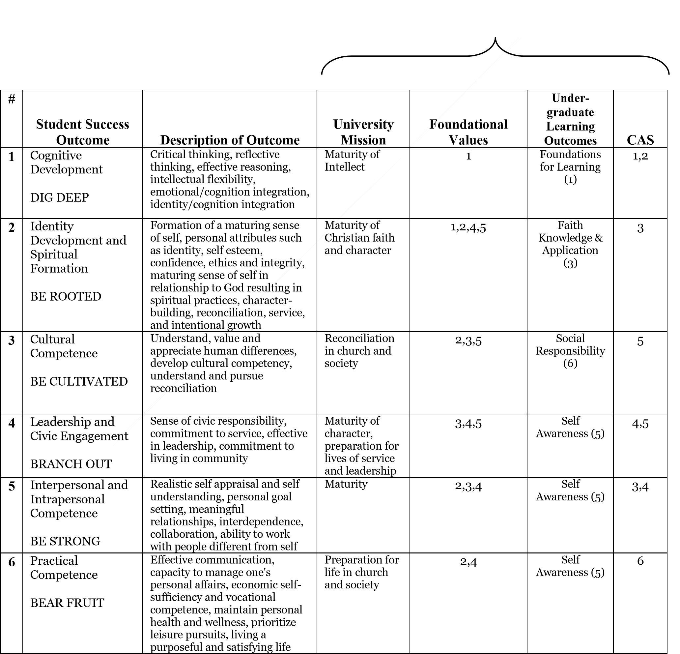
The Division of Student Success has established six student outcomes. Each of these outcomes encompasses some aspect of the mission of Messiah University, University-Wide Educational Objectives, and CAS standards. In addition, each department within Student Success has established specific student learning outcomes (SLOs) for each educational program they deliver. Annual goals are determined to help departments meet their SLOs. Annual goals are informed by 1) external feedback (another department has indicated a need, i.e., safety reports increased vandalism and seeks our help in reducing this), 2) demographic and student satisfaction data has shown areas of weakness or need, or 3) SLO data has indicated a need to adjust a program/service in order to better attain the outcome. Goals are also established for each service delivered.
Primary Connections to
Attachment C Student Success Assessment Flowchart

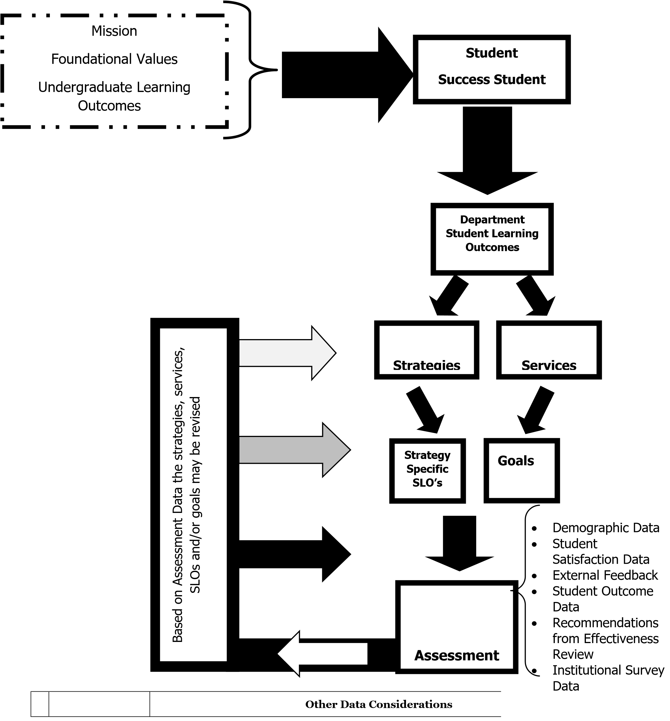

* | Student  Satisfaction | In the context of an environment committed to the holistic development of students, it is desired that students are generally satisfied with the content and delivery of programming. Satisfaction data serves the departmental function of informing planners of the perceived reaction to programming initiatives. Data becomes part of a feedback loop that helps shape program elements (delivery style/format/content, etc.). Student satisfaction with programs themselves serves as one piece of assessment.
* | Demographics | It is desired that Student Success provide a variety of programming that serves a diverse student body. It is critical that the majority of programming not be focused on and attended by one single group. Demographics (attendance figures; information about those attending) provide information to planners regarding whether the target audience of programming is being reached, and whether or not more attention needs to be given to advertising, use of inducements, content and style of programming in order to correct imbalances or other weaknesses in the demographics. Demographics should help inform decisions on whether to discontinue or enhance a given program.
* | External Factors | It is important to recognize that sometimes events that occur outside the regular rhythm of the academic year in the University community, the nation, or the world will inform programming (i.e., the national elections)
* | Student Success Division Wide  Assessment  Results | Annually the student success assessment committee will present data related to one specific Student Success learning outcome. This data will allow us to reflect as a division on student learning and determine whether or not we need to make some programmatic adjustments.
* | Institutional  Survey Data | Each year the institution participates in institutional surveys that provide information about participation, satisfaction, behaviors and to some extent student learning. It is important for us to consider that data and adjust programming or services accordingly
* | Effectiveness  Review | Each department conducts an effectiveness review on a seven-year cycle. Unit managed recommendations usually are a result of the review. These recommendations are important to consider while planning.

Mission and General Department Goals

Each department has an established mission and student learning outcomes that both justify and guide the department’s activity. This mission and the accompanying SLO’s should be linked to the University’s mission, foundational documents, Undergraduate Learning Outcomes and CAS standards. That is achieved through the student affairs outcomes. Below is a generic grid that departments should use in (1) identifying the student success outcomes, (2) identifying the dimension of the outcome that is specific to that department, (3) establishing student learning outcomes (SLOs) and (4) developing strategies for achieving these SLOs. This grid will remain fairly static over time, serving as a guide for planning anchored in student learning.

Attachment C-4
Generic Assessment Grid

1 | 2 | 3 | 4
Student Success Student Outcome | Description of Outcome | Department Student Learning Outcomes | Strategies

Description:
Column 1: List the student success student outcome
Column 2: Include a description of the student success outcome (Found on Student Success Student Outcome Grid page 2)
Column 3: Identify the student learning outcomes for your department related to a specific student success outcome (through the lens of your department) (for example, students will be able to write a professional resume).
Column 4: List the strategy for attaining each SLO. What educational experience will be offered to encourage students to attain the learning outcomes? (For example, resumania)

Educational Plans

Each strategy will use an Educational Plan to direct the planning and assessment of the strategy. An Educational Plan template has been provided below. Educational plans should be completed for each strategy and evaluated and updated annually.

Educational Plan Template

Strategy______________________________________________________________________________________ (Column 4 on Assessment Grid)

Program Facilitator Name & Department:
____________________________________________________________________________________________

Collaborating Partners and Departments:

_____________________________________________________________________________________________

_____________________________________________________________________________________________ Student Affairs Outcome(s):
Only check relevant outcomes (Column 1 on Assessment Grid)
- #1 Dig Deep: Cognitive Development
- #2 Be Rooted: Identity Development
- #3 Be Cultivated: Cultural Competence
- #4 Branch Out: Leadership and Civic Engagement
- #5 Be Strong: Interpersonal Competence
- #6 Bear Fruit: Practical Competence

Purpose
Department Student Learning Outcome

(
Column 3 on Assessment Grid
)
N/A for collaborative programs

Br
ief description of what you hope to accomplish through this strategy

Strategy Specific Student Learning Outcome(s):

Clearly articulate the learning outcome for this strategy

Include extra goals not directly
associated with one of the six Outcomes (i.e., demographics, satisfaction,

Additional Intended Goals attendance)

Resources
Include any materials, facilities, budget, or other resource considerations

Agenda
A detailed list of instructions for the facilitator to accomplish the intended goals/outcomes. This list should be a detailed plan that you would be able to hand to a student or educator executing the educational program. It includes a schedule/timeline of events, talking points, etc.

Assessment Methods
A plan for how learning and effectiveness of the strategy will be assessed. Assess learning outcomes, and other intended goals

Assessment Results
Describe the assessment results

Recommendations:
Given the assessment results, what do we learn about the effectiveness of our programming/services?
What do we learn about our learning outcomes, educational programming, and assessment strategies?
What changes are recommended to improve attaining our SLOs? What changes were made to meet other goals?

Artifacts:
Attach any relevant artifacts, i.e., hall poster
A space to include notes for future programming, lessons learned, etc.

Column 6:

Identify the
assessment method
to be used to determine whether or not

SLO/goals have
been met.

Column 7:

Compile assessment data related to student learning, demographics, and student satisfaction.

Column 8:

Analyze date and make
recommendations

for changes in programming /strategies.

Assessment:

1.

Mission
Assessment
:

Is the department’s mission consistent with the
University
’s Foundational Documents?

What do our benchmarking institutions or best practices inform us about our mission?

What do standards from professional organizations or accreditat
ion groups inform us about
our mission?

Notes:

B.
a.
b.
c.
- Student Affairs Outcomes (Column 1)
  - Are the outcomes consistent with the University’s mission, foundational values, undergraduate learning outcomes and CAS standards?
  - What do our benchmarking institutions or best practices inform us about our outcomes?
  - What do standards from professional organizations or accreditation groups inform us about our outcomes?
- Department Specific Dimension of the Outcomes (Column 2)
  - Are the department specific dimensions of the student outcomes consistent with the student outcomes and the department’s mission?
  - What do our benchmarking institutions or best practices inform us about department specific dimensions of the outcomes?
  - What do standards from professional organizations or accreditation groups inform us about the department specific dimensions of the outcomes?
- Educational Programs/Services designed to meet the Student Affairs Outcomes (Column 3)
  - Is the programming intentionally linked to the outcomes? Do the services support the mission of the department?
  - What do our benchmarking institutions inform us about our programming?
  - What do standards from professional organizations inform us about our programming?
- SLO/Goals for the Educational Program/Service (Column 4)
  - Are the SLO/goals measurable and designed to accommodate the outcomes?
  - Are the SLO/goals responding to student satisfaction and demographic data?
  - Are the SLO/goals responding to external issues and concerns?
- Strategy (Column 5)
  - Are specific strategies outlined to assist in meeting SLO/goals?
  - Is the strategy realistic and relevant?
- Program Assessment Methods Application and Assessment (Column 6)
  - When applied, what do the Assessment Methods tell us about the adequacy of the educational programming in meeting established SLO/goals (including student satisfaction, demographics and student outcomes)?
  - Are the methods useful and adequate? Are we collecting good data that provides useful and relevant information? C. Planning:
- Results (Column 7)
  - How well did we meet our established SLO/goals? What were the demographics? What was the student satisfaction?
  - Given the assessment results, which strategies were most effective?
- Recommendations (Column 8)
  - Given the assessment results, what do we learn about the effectiveness of our programming/services?
  - What do we learn about our learning outcomes, educational programming, and assessment strategies?
  - What changes are recommended to improve attaining our SLOs/goals?

D. Timing:
- Student Affairs Student Outcomes: At least every seven years
- Mission Assessment: At least every seven years
- Department Specific Dimension of Student Outcome: At least every seven years 4. Program Assessment (Column 3): At least every seven years.
a. Educational Programs/Services Assessment: Ongoing
  - It is not feasible for each department to fully assess every educational program and/or service on an annual basis. Therefore, each department will be expected to assess 3-5 programs/services a year as it relates to the specific outcome focused on that year.
  - The seven-year review will then be an accumulation and analysis of annual assessments and provide an overall report on the effectiveness of the department.

5. Assessment Methods Application and Assessment (Column 6):
- Application: Ongoing
- Assessment: Every seven years

Attachment D-1

Outline of the Final Report
- Introduction

  - Give a brief history and description of the department.

  - Identify the leadership team for program review.

  - Identify unit-specific issues or questions to be addressed by the review.

  - Identify and explain the connection between this review and any accreditation review.

- Assessment of Purpose, Process, and Personnel

  - Purpose
    - Descriptive Analysis
      - What is the stated mission of the department? [Originates within unit; on file within unit]
      - What are the student learning outcomes of the department directly related to
educational programming? [Originates within unit; on file within unit]
        - What are the undergraduate learning outcomes assigned by the University or the Division of Student Affairs to the department?
        - What are the department-specific learning outcomes adopted by the department?
[Developed by the unit; on file within the unit] (3) What are the measurable goals?
{Developed by the unit; on file within the unit]
      - What are the goals involving service/support?
      - What are the goals not directly related to educational programming (e.g., service to the outside community, national recognition, honor society membership, etc.)? [Originates within unit; on file within unit]
    - Evaluation and Assessment
      - To what extent do the mission and outcomes of the department conform to the University’s Mission and Identity Statement and Foundational Values?
      - How do the mission and outcomes of the department compare with professional standards and benchmark/peer institutions? [Evidence gathered by means developed by the unit; on file in the unit]
      - Are the student learning outcomes linked to the mission?
      - Assess and summarize unit-specific issues/questions identified by the department as they pertain to the category of Purpose.
    - Initial Conclusions Related to Purpose:
      - Strengths and weaknesses
      - Unit specific and University-specific recommendations.

  - Programming
    - Descriptive Analysis
      - What programming (educational programming and services) is delivered by the department? [Assigned by the COE and/or approved by the unit; on file within unit]
      - How is this programming linked to the Student Affairs outcomes? [Developed by the unit; on file within the unit.]
` 2. Evaluation and Assessment
      - Are the educational programs and services designed in such a way that they are linked to the outcomes and goals for this programming?
      - How does the programming being offered compare with benchmarking institutions, professional standards and professional best practices?
Outline of the Final Report Attachment D-38

      - Is there evidence that the outcomes and goals of the programming are being achieved?
      - Assess and summarize unit-specific issues/questions identified by the department as they pertain to the category of Programming. 3. Initial Conclusions Related to Programming
      - Strengths and weaknesses
      - Unit specific and University-specific recommendations.

  - Process
    - Descriptive Analysis
      - How productive is the programming? Over the past seven years, describe the development and any developing trajectories in the following areas:
        - How many students are served by the programs within the unit? [Originates in the unit]
        - Student/educator ratios that are tracked
      - What facilities, equipment, technology, library holdings, and other resources are
currently available to deliver the unit’s programming? How have these changed over the past seven years? [Originates in unit; on file in the unit]
      - What is the budget? How has this changed over the past seven years? [Available from the Office of the Provost]
      - What revenue is generated by the unit? How has this changed over the past seven years? [Available from the Office of the Provost]

    - Evaluation and Assessment
      - How does the educational and service programming compare with professional standards and/or identified benchmark/peer institutions? [Data gathered by means developed by the unit; on file in the unit]
      - How does the unit compare with professional standards and/or identified benchmark/peer institutions on relevant process factors? [Data gathered by means developed by the unit; on file in the unit]
      - Assess the efficiency and appropriateness of the above environmental factors identifying strengths, weaknesses, challenges, and opportunities.
      - Assess and summarize unit-specific issues/questions identified by the unit as they pertain to the category of Process (i.e., curriculum, resources, budget, etc.).

    - Initial Conclusions Related to Process
      - Strengths and weaknesses
      - Unit specific and University-specific recommendations.

  - Personnel
    - Descriptive Analysis
A. Over the past seven years,
        - What has been the level of staffing in the unit? [Available from the Office of the Provost]
        - What is the ratio of full-time to part-time employees? [Available from the Office of the Provost]
      - What is the general profile of full-time educators and staff (e.g., age, training, experience, advanced degrees, disciplinary expertise, diversity, etc.)? [Originates within unit; on file within unit]
      - What is the profile of part-time personnel? [Originates within unit; on file within
unit]
Outline of the Final Report Attachment D-39

      - How has the full-time fte and effort been distributed among teaching, advising, scholarship, institutional service, department administrations, and other University assignments? [Originates within unit; on file within unit]
      - What is the level of support staffing (staff/administrative support, student workstudy)? [Originates within unit; on file within unit]

    - Evaluation and Assessment
      - How does the unit compare with professional standards and/or identified benchmark/peer institutions on the identified personnel factors? [Evidence gathered by means developed by the unit; on file in the unit]
      - Assess appropriateness and effectiveness of the above personnel factors identifying strengths, weaknesses, challenges, and opportunities. In particular, assess the overall quality of teaching, institutional service, scholarship, and advising. [Evidence from University instruments and evidence generated by the unit; on file in the unit]
      - Is there a fit between the personnel profile and fte allocation to the unit’s objectives and priorities?
      - Assess and summarize unit-specific issues/questions identified by the unit as they pertain to the category of Personnel

    - Initial Conclusions Related to Personnel
      - Strengths and weaknesses
      - Unit specific and University-specific recommendations.

  - Planning
    - What the major findings? What are the strengths and distinctives of the department? What are the challenges and weaknesses? Is there evidence that student learning outcomes are being met? Are service goals being met?

    - What are the recommendations?
      - Unit-managed recommendations: What specific actions undertaken by the
department will preserve or enhance the program’s strengths and address the department’s weaknesses and challenges?
      - University-managed recommendations: What specific actions by the University will
preserve or enhance the program’s strengths and address the department’s weaknesses and challenges?

    - What are the recommended steps and time-line for the department and the University in addressing these recommendations?

    - How will these recommendations impact the department’s annual and strategic plan in anticipation of ongoing planning and assessment within the department?

Attachment E
Completing the Review Report – The Link to Institutional Planning

Program review is a central component of the planning within the program units and the University’s institutional strategic and financial planning. Regularly scheduled program reviews serve as a basis for strategic and financial planning to assure the further development effectiveness of University programming. A program review is only valuable if it has meaningful implications for the institution. Thus, once completed, the review results must be integrated into the institutional governance process so that the results of it can have an impact on the institution. The following is the protocol for processing educational program reviews.

- The unit director (or chair) submits the final report along with an executive summary to the Dean. The executive summary should be no more than two pages and summarize all the other sections of the report. It should be sure to include key findings, unit-manageable recommendations, Universitymanageable recommendations and projected timelines for implementing both categories of approved recommendations.

- Upon receipt, the Dean reviews the report. If the Dean has significant questions, concerns, or disagreements with the report, he/she may request several possible actions including: revision of the report, discussions with the unit or director, addition of supplemental materials, etc.

- Upon acceptance of the report, the Dean will write an assessment of the strengths and weaknesses of the unit’s review process and final report in the form of a cover letter. The letter will also indicate the Dean’s level of support for both unit-managed and University-managed recommendations and timelines.

- The Dean will forward the final report, the executive summary, and the cover letter to the Provost. The Provost will review these materials in relation to the strategic planning in the Provost’s area. The Provost will meet with the Dean and the unit director (or chair) to review the Provost’s analysis. After this meeting, the Dean and unit director will develop a working plan to implement the unit managed recommendations approved by the Dean and reviewed by the Provost.

- The Provost will take the executive summary and the Dean’s cover letter along with the Provost’s comments to University Council for review.

- University Council will review this material and determine how it relates to the institutional strategic and annual planning processes.

- The executive summary of the report along with a summary of the results of the University Council discussion will be taken by the Provost to the Committee on Education of the Board of Trustees for information and review.

