Procedure for using Self-Service Budget Query

- Select “Self-Service Main Menu” found on Falconlink.

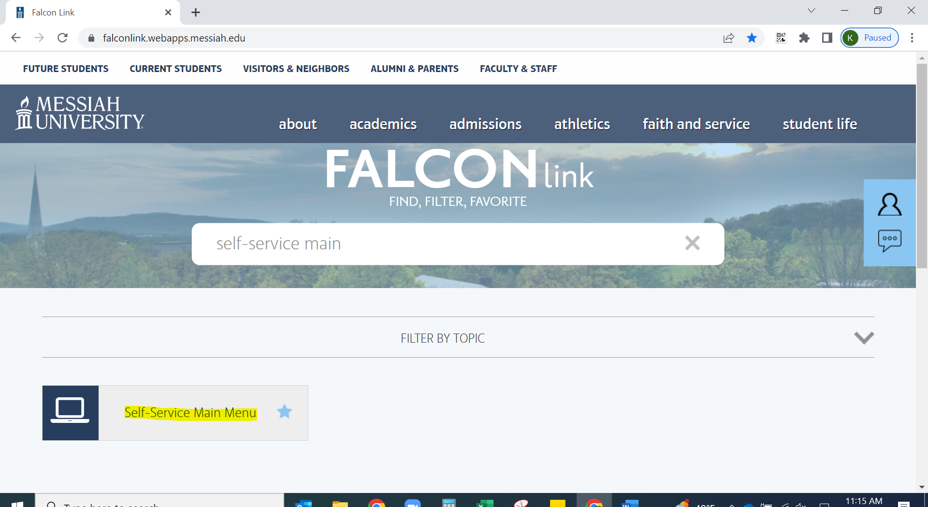

- Select the “FINANCE” tab.

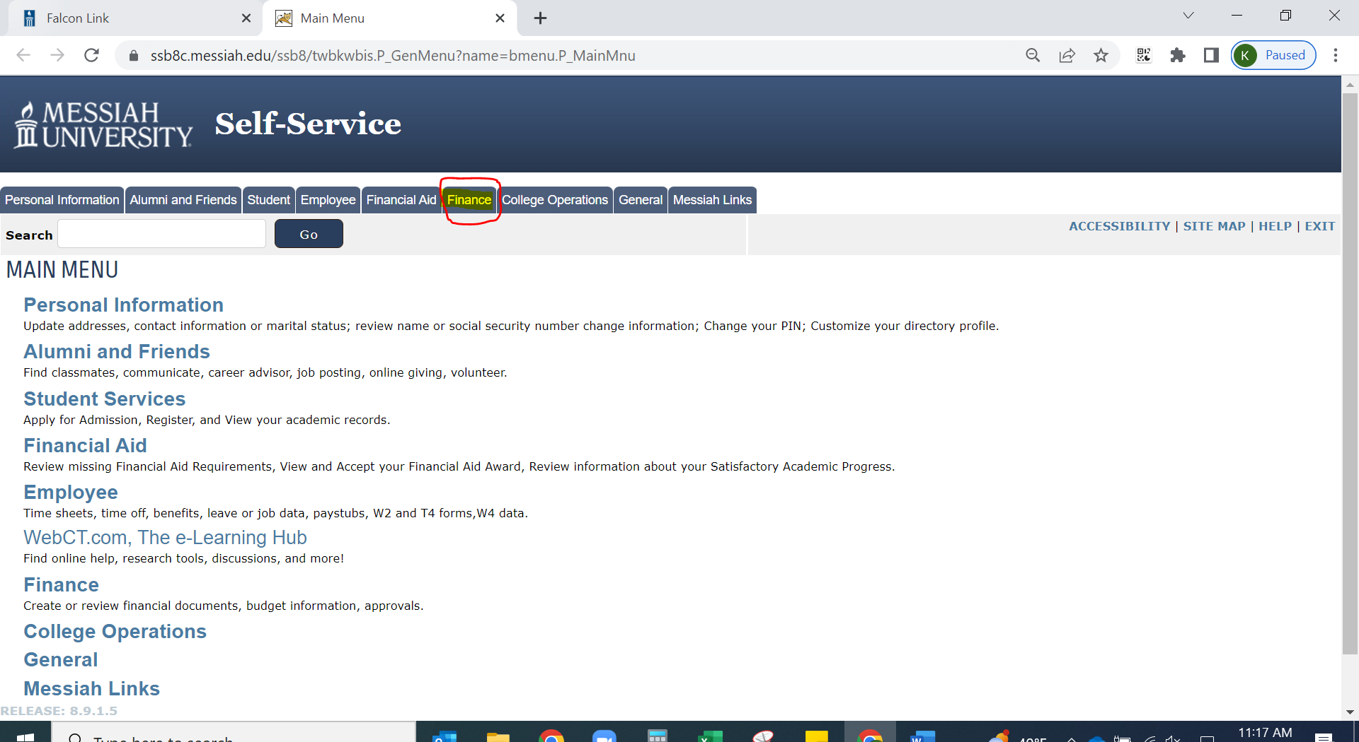

- Select “BUDGET QUERIES”.

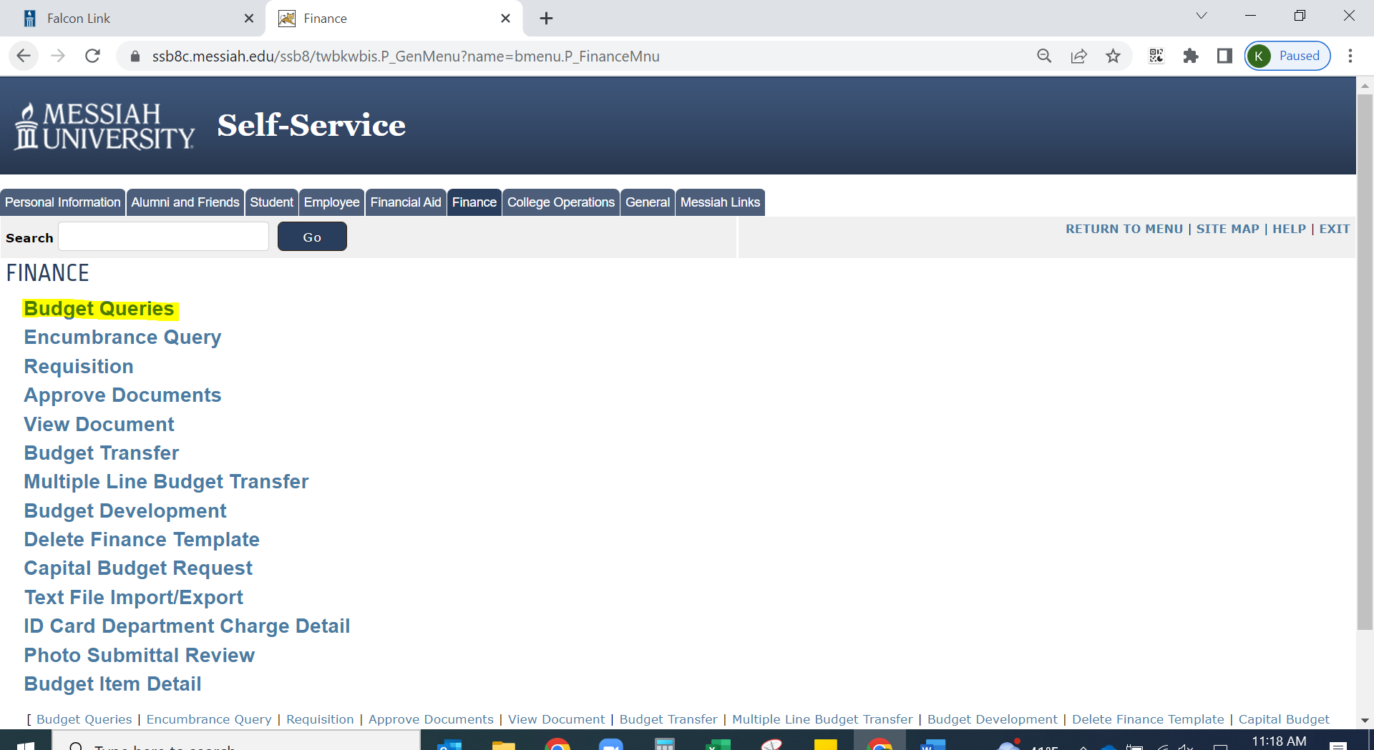

- Create a New Query: In the drop-down box next to “Type”, there are 3 types of queries. The most frequently used is the “BUDGET STATUS BY ACCOUNT”. This is the example used in this guide (feel free to experiment with the others). Choose “BUDGET STATUS BY ACCOUNT” and click on the “CREATE QUERY” block.

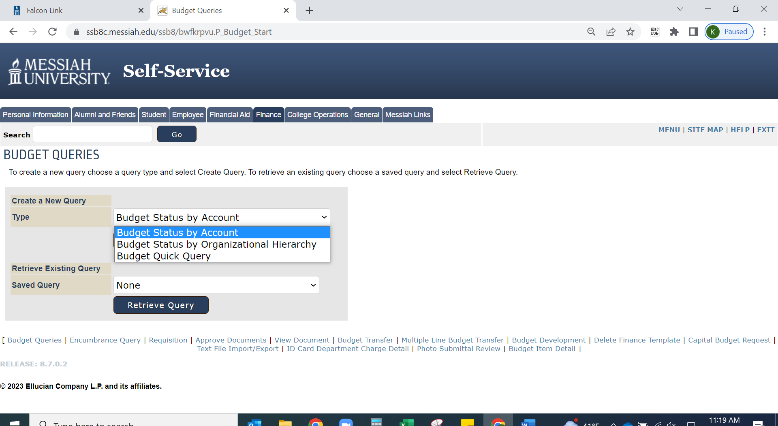

5. This view establishes the columns that will be displayed on the final report. The most common columns are:
- Adjusted Budget: displays the original Adopted Budget that was rolled into Banner on July 1 plus any fall Budget Adjustments
- Year To Date: the actual year to date expenses and revenue that has posted
- Encumbrances: if purchase orders are used, please select this column of data.
- Available Balance: a calculated figure representing the Adjusted Budget column minus the sum of (Year to Date plus Encumbrances.)
Once completed, select “CONTINUE”.

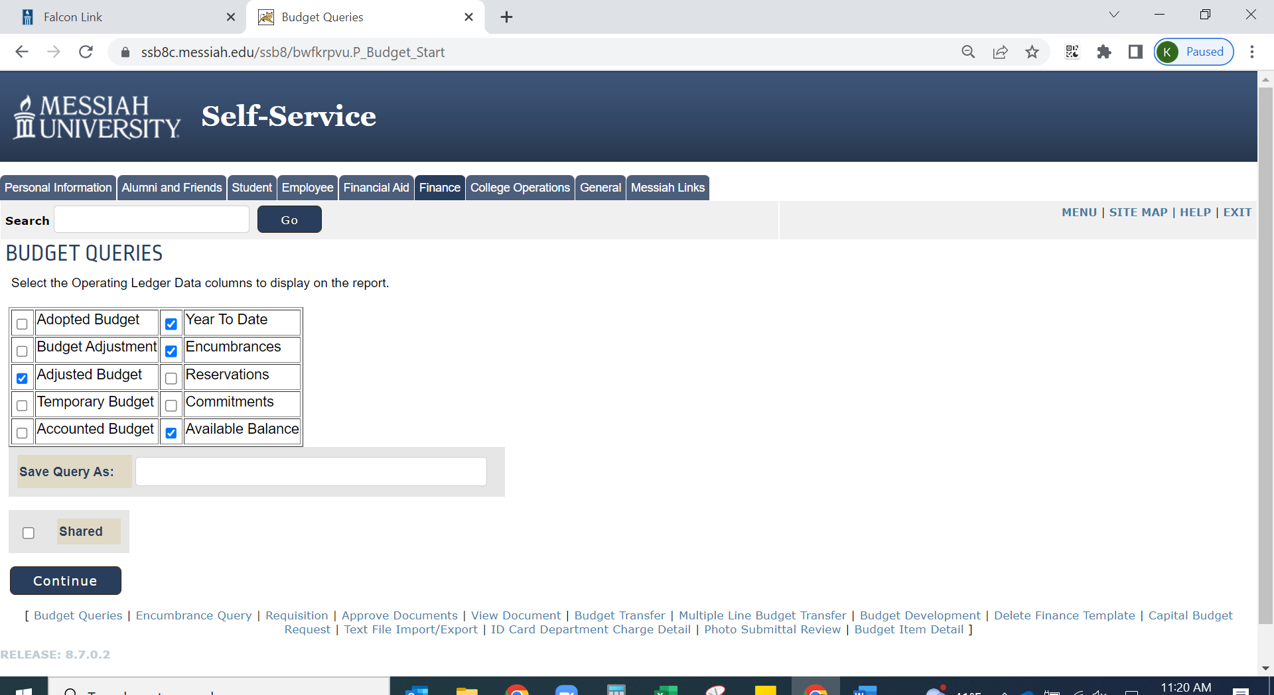

6. The screen shot below sets the parameters for the report. In this example, we use the inputs below:
- Fiscal Year: 2023
  - This is typically the current fiscal year but can be a previous year.
- Fiscal Period: 14
  - This shows the totals for the fiscal year through the month selected (July is month 1, October is month 4, January is month 7, etc…). Fiscal period 14 will show the entire fiscal year, July 1 - June 30.
- Comparison Fiscal Year: 2022
  - This field is not required but can be used if the user wants to compare fiscal years.
- Commitment Type: ALL
- Chart of Accounts: Enter 1.
- Index, Fund, and Activity: Leave blank.
- Organization: Enter the ORG # the user wants to view (this is the four-digit department #).
- Location, Grant, and Fund Type: Leave blank.
- Account: Optional - enter the account line item the user wants to review. If this field is left blank, all revenue and expense accounts that have data will be queried.
- Check the box to “Include Revenue Accounts”.
- After all data is entered, click on the “SUBMIT QUERY” box.

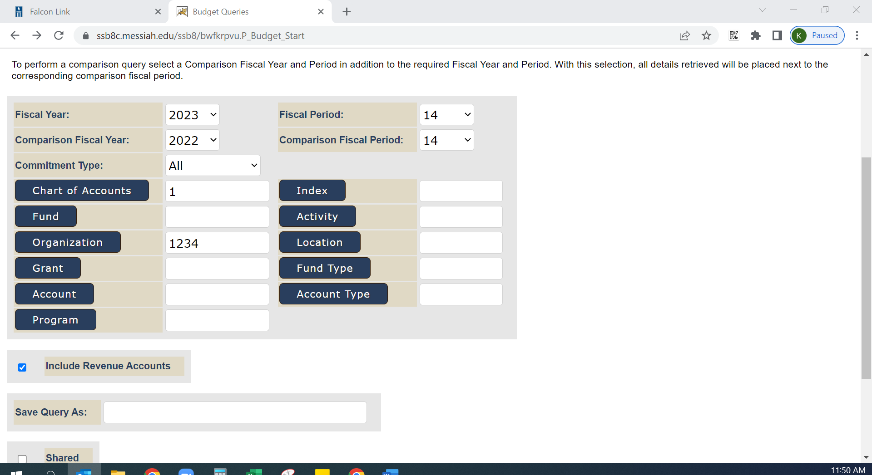

7. The screen shot below shows the information that was queried based on the parameters selected in the previous screen. Any data in BLUE is a hyperlink that can be used to drill down for further detail.

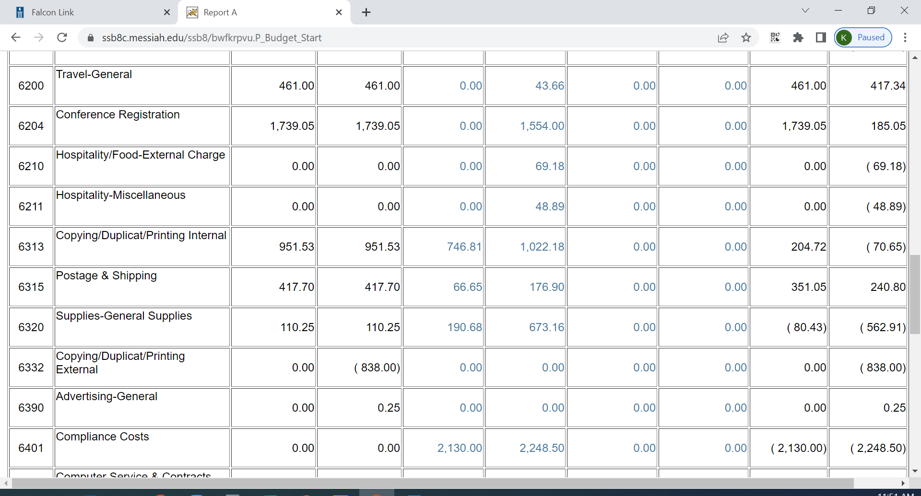

**Additional Options and Functionality**

1.) Calculations: At the bottom of the completed query, there is a section where the user can create a computation. This is very similar to Excel logic. For example, using the data just queried, add a column that will give a % of what budget is available to be spent.
- In Column 1, using the drop-down arrow, select the data “FY22/PD14 AVAILABLE BALANCE”
- In Operator, using the drop-down arrow, select the “DIVIDED BY”
- In Column 2, using the drop-down arrow, select the data “FY22/PD14 ADJUSTED BUDGET”
- In “Display After Column”, using the drop-down arrow, select where the new column will appear on the report. For this example, select the data “FY22/PD14 AVAILABLE BALANCE”
- In Description, type in the name of the new column. For this example, type in “% of Budget Available”.

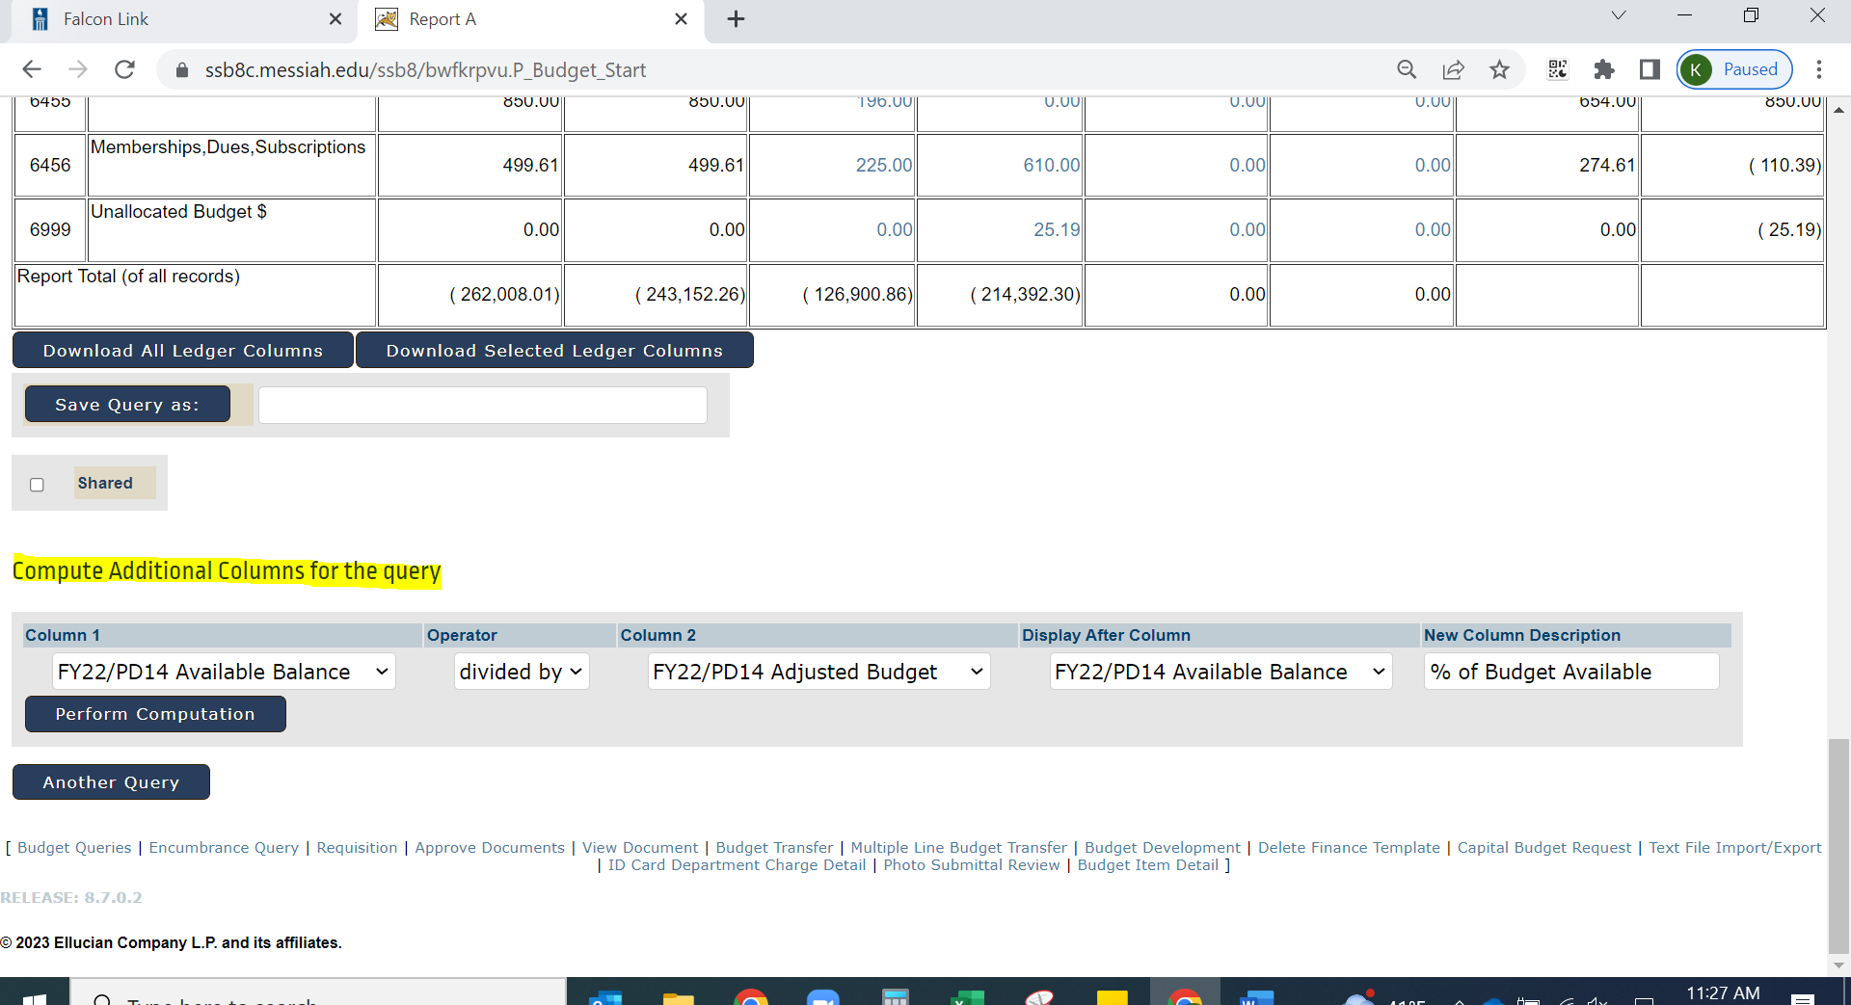

- After all columns are defined, click on the “Perform Computation” box. The new column should be added.

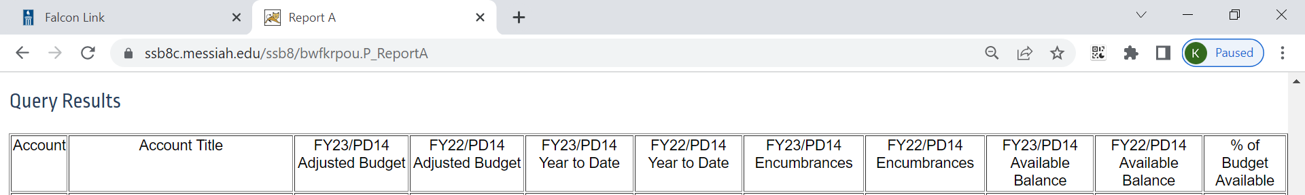
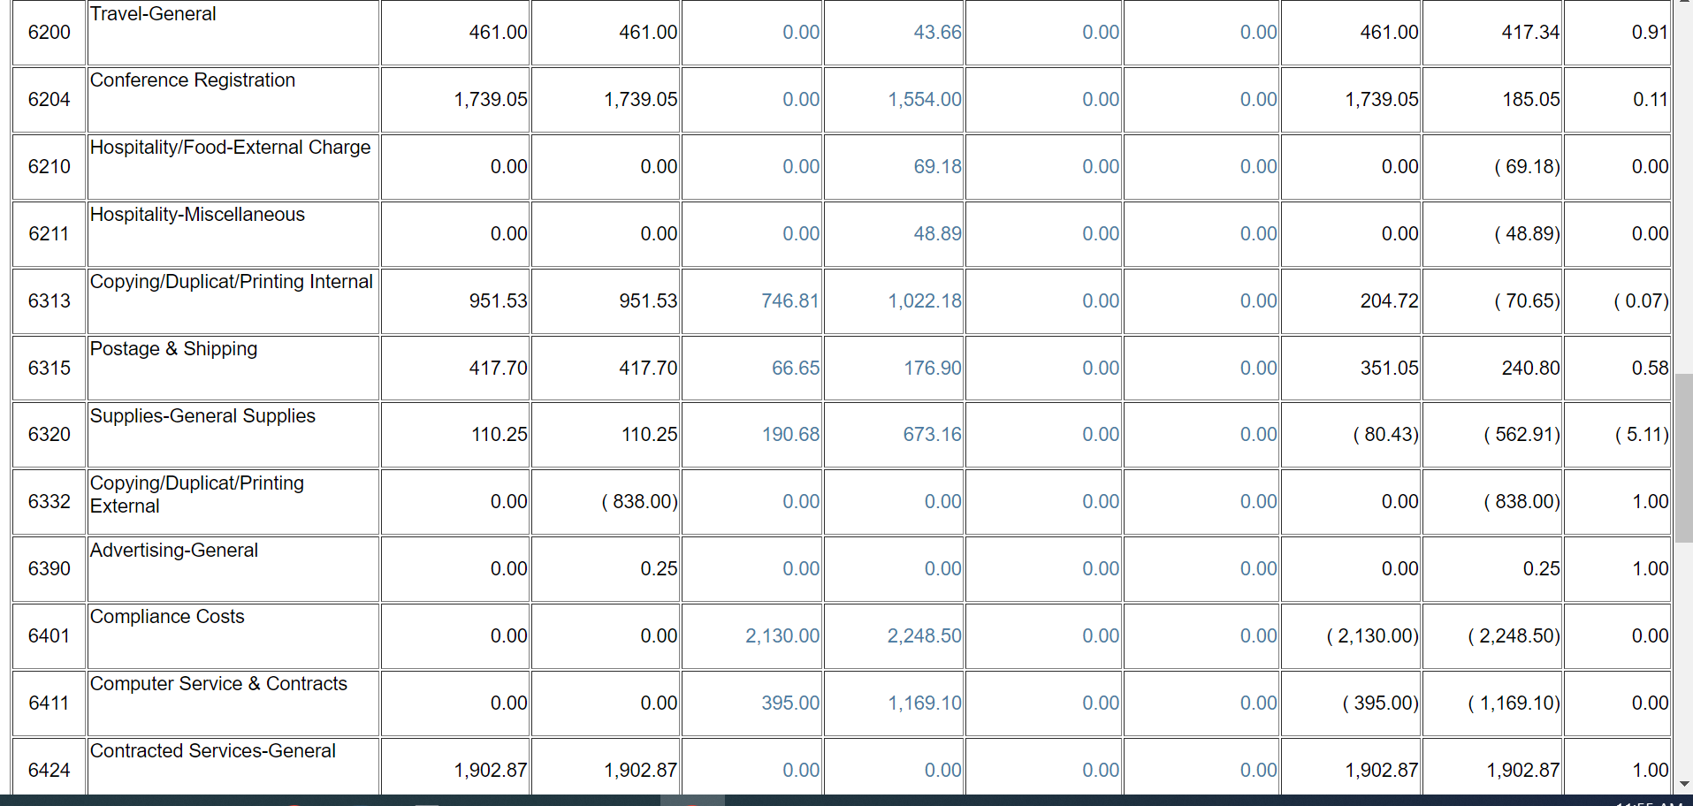

- Wildcard: Banner uses the % symbol as a wildcard. Can be used in the ORG or Account.
- Download: The information can be downloaded to an excel file for further analysis.
- Drill Down Feature: Any item in blue can be drilled down to another layer of detail.
- Save a Query: At various screens in SS the user has the option to save queries. At this time the Accounting Office does not recommend saving any queries. All queries saved are accessible to everyone across campus and are not specific to the user.
- FUND—Fund 1000IN does not contain any Salary & Wage information. All Salaries & Wages are contained in Fund 1000IM. These lines are not available to everyone.

This is an overview of the functionality of Self-Service Budget Query. Feel free to experiment with different parameters and information. Self-Service is read-only, and in no way can a user accidentally change any of the raw data.

If you have any questions, please feel free to contact: accounting@messiah.edu.

